WOTD #6
Date | Ecology Word of the Day
11/15, 11/16 | FWARPS- An acronym to remember the resources necessary for all living organisms to survive multiple generations.  FOOD, WATER, AIR, REPRODUCTION, PROTECTION, SPACE
11/17 | Natural Selection- The process by which individuals with certain heritable characteristics tend to survive and reproduce more successfully than other individuals because of those characteristics.
11/27 | Bioaccumulation- A progressive increase in the concentration of a substance in an organism’s body over its lifetime
11/28, 11/29 | Trophic levels- A way to organize how species obtain energy, and organized in order of how one group feeds on the other (starting with producers)
12/4 | Deciduous- a tree or shrub that sheds its leaves annually
12/5, 12/6 | Evergreen- A plant or shrub that retains green leaves throughout the year
12/6, 12/7 | Conifer- A tree that bears cones and evergreen needlelike or scale-like leaves
12/8 | 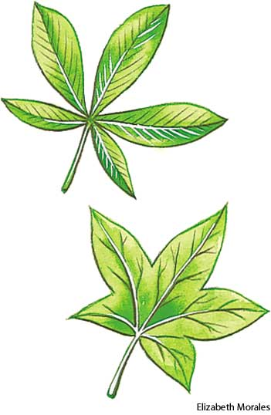  Palmate- A leaf having several “lobes” (typically 5-7) that all radiate from one point.
12/11 | Pinnate- Resembling a feather with a central vein up the middle, with peripheral veins branching off. 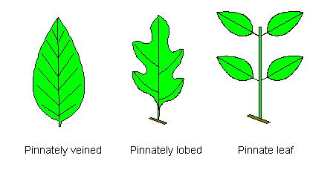
12/12, 12/13 | Acclimate- Respond physiologically or behaviorally to a change in a single environmental factor
12/13, 12/14 | 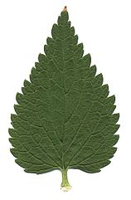  Serrated- Have a jagged or sawlike edge
12/15 | 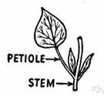  Petiole- The stalk that joins a leaf to a stem
½, 1/3 | Succession- natural, gradual changes in the types of species that live in an area; gradual replacement of one plant community by another through natural processes over time
1/3, ¼ | Primary Succession- beginning from an abiotic environment following a catastrophic disturbance.
1/5 | Secondary Succesion- Beginning after a major disturbance, but all forms of life are NOT destroyed
1/8 | Symbiotic- Involving interaction between two different organisms living in close physical association

