Endangered Species Act
The Endangered Species Act (ESA) of 1973 is a key legislation for both domestic and international conservation. The act aims to provide a framework to conserve and protect endangered and threatened species and their habitats.
By providing States with financial assistance and incentives to develop and maintain conservation programs the Act serves as a method to meet many of the United States’ international responsibilities to treaties and conventions such as the Convention on International Trade of Endangered Species of Wild Fauna and Flora (CITES) and the Western Hemisphere Convention. The multinational species conservation acts function as amendments to the ESA and grant the division the authority to providing funding for projects that aim to conserver and protect these species.

Species
Approximately 2,270 species are listed as endangered or threatened under the ESA. Of these species, about 650 are foreign species, found only in areas outside of the U.S. and our waters.
We have jurisdiction over 151 endangered and threatened marine species, including 57 foreign species. We work with U.S. Fish and Wildlife Service (USFWS) to manage ESA-listed species. Generally, we manage marine species, while USFWS manages land and freshwater species.
A "species" is considered:
- endangered if it is in danger of extinction throughout all or a significant portion of its range
- threatened if it is likely to become an endangered species within the foreseeable future

CITES
The Convention on International Trade in Endangered Species of Wild Fauna and Flora (CITES) entered into force in 1975, and became the only treaty to ensure that international trade in plants and animals does not threaten their survival in the wild. A State or country that has agreed to implement the Convention is called a Party to CITES. Currently there are 181 Parties including the United States.

CITES in the United States
Under the Endangered Species Act (ESA), the U.S. Fish & Wildlife Service has been designated to carry out the provisions of CITES through the Division of Management Authority and the Division of Scientific Authority. We work with numerous partners including federal and state agencies, industry groups, and conservation organizations.

U.S. CITES Implementation and Biennial Reports
CITES requires each Party to regularly submit reports on how they are implementing the Convention. These reports may contain information on legislative and regulatory changes, as well as law enforcement, permitting, communications, and administrative matters. The reporting process is a valuable assessment of our program, allowing us to identify successes as well as areas for improvement.
Wild Bird Conservation Act
The WBCA was enacted on October 23, 1992, to ensure that exotic bird species are not harmed by international trade and encourages wild bird conservation programs in countries of origin. The U.S. Fish & Wildlife Service (Service) may issue permits to allow import of listed birds for scientific research, zoological breeding or display, or personal pet purposes when the applicant meets certain criteria.
The Service may approve cooperative breeding programs of WBCA-protected birds, and subsequent import permits under such breeding programs. The WBCA also encourages wild bird conservation programs in countries of origin. For example, wild-caught birds may be imported into the United States if they were produced in accordance with Service-approved management plans for sustainable use of the species.

Species Listed under WBCA
- Most bird species listed under the Convention on International Trade of Endangered Species of Wild Fauna and Flora (CITES) are listed under WBCA, with the following exemptions:
- Birds native to the 50 States and the District of Columbia
- Two parrot species: budgie (Melopsittacus undulatus) and cockatiel (Nymphicus hollandicus)
- Birds in the following families:
  - Anatidae (ducks, swans, and geese)
  - Cracidae (guans and currasows)
  - Dromaiinae (emus)
  - Gruidae (cranes)
  - Megapodidae (megapodes)
  - Numididae (guineafowl)
  - Phasianidae (pheasants and quails)
  - Rheidae (rheas)
  - Struthionidae (ostriches)
- In addition, permits are not required for approved captive-bred birds.
Federal Register Notices
The Service publishes notices of receipt of applications to approve cooperative breeding programs. We do not publish such notices for the receipt of applications for import permits under approved cooperative breeding programs. To find a notice, search by applicant name.
The Service also announces availability of other WBCA documents in the Federal Register Notices page.

Multinational Species Conservation Acts
The Multinational Species Conservation Acts play a significant role in the Division of International Conservation’s Wildlife Without Borders program. These Acts, enacted by the U.S. Congress, grant the Division the authority to establish the Multinational Species Conservation Funds and provide grants to projects benefiting elephants, rhinos, great apes and marine turtles in their natural habitats. The passage of the African Elephant Conservation Act of 1988 marks the first of these Multinational Acts. It was followed by the Rhino and Tiger Conservation Act of 1994, the Asian Elephant Conservation Act of 1997, the Great Ape Conservation Act of 2000, and most recently, the Marine Turtle Conservation Act of 2004.
The Multinational Species Conservation Fund Semipostal Stamp Act of 2009 was enacted as a way to provide the general public with a convenient way to contribute to the Multinational Species Conservation Funds. The Save the Vanishing Species Stamp was released in spring of 2011 and has generated over $1.3 million in proceeds that are equally divided among the five Conservation Funds.

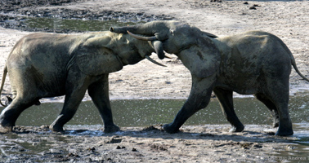
African Elephant Conservation Act of 1988
Enacted in 1988 as an amendment to the Endangered Species Act, the African Elephant Conservation Act aims to protect African elephant species in the wild. A major threat to African elephants' survival comes from the illegal trade of ivory, which is derived from an elephant’s tusks. Additionally, many nations in Africa that have African elephant populations lack the necessary resources to protect, manage, and conserve their elephant populations. The act grants the Service the authority to establish the African Elephant Conservation Fund to provide funding for projects that benefit African elephant through research, conservation,and management of the species and its habitat.

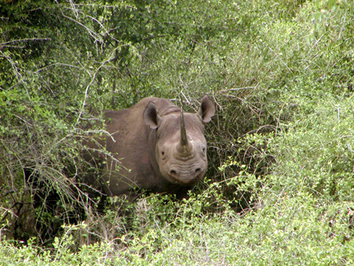
Rhinoceros and Tiger Conservation Act of 1994
The Rhinoceros and Tiger Conservation Act of 1994 builds upon the Endangered Species Act and works to protect and conserve all subspecies of tigers and rhinos. These species are threatened by illegal trade of rhinoceros horns and tiger body parts. In compliance with the Convention on International Trade in Endangered Species of Wild Fauna and Flora (CITES), the Rhinoceros and Tiger Conservation Act aims to reduce the illegal trade of animal parts and promotes projects that help manage and conserve these species in nations that both directly and indirectly affect these species. The Act grants the Service the authority to establish the Rhinoceros and Tiger Conservation Fund to provide grants and funding for projects that help conserve these endangered species through research, species management, and education. Additionally, the 1998 amendments to the Act prohibit the sale, importation, or exportation of products intended for human consumption containing, or labeled or advertised as containing, any substance derived from a species of rhinoceros or tiger.

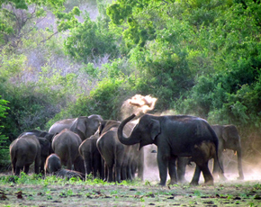
Asian Elephant Conservation Act of 1997
In 1997, Congress passed the Asian Elephant Conservation Act in order to better comply with the Endangered Species Act, and fulfill United States’ responsibility as a member of the Convention on International Trade of Endangered Species of Fauna and Flora. Asian elephants face many threats including, habitat loss and fragmentation, human-elephant conflict, and poaching. In addition to these threats, there is a general lack of resources for Asian elephant conservation in Asian elephant range countries. In order to effectively address these issues, the Act establishes a cooperative method for the U.S., Asian elephant range countries, and the private sector to protect this species. The Act grants the Service the authority to establish the Asian Elephant Conservation Fund to provide funding for projects that protect and conserve the species through conservation and habitat management, research, improved law enforcement, conflict resolution initiatives, and community education and outreach.

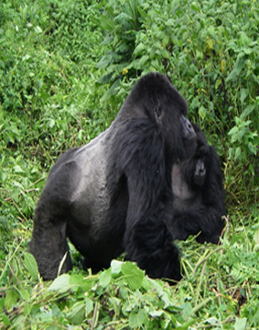
Great Ape Conservation Act of 2000
The Great Ape Conservation Act of 2000 was established to protect and conserve the great ape species listed in both the Endangered Species Act and the Convention on International Trade of Endangered Species of Fauna and Flora. These species include the chimpanzee, gorilla, bonobo, orangutan, and gibbon. Currently these species face threats from habitat loss due to human encroachment and logging, as well as threats from population fragmentation, hunting for the rapidly expanding bushmeat trade, and disease transmission between humans and apes. Effective conservation of these species will require cooperative efforts between the U.S., countries within the range of great ape species, and the private sector. This Act grants the Service the authority to establish the Great Ape Conservation Fund to provide funding for projects that aim to conserve great apes throughlaw enforcement training, community initiatives, and other conservation efforts.

Marine Turtle Conservation Act of 2004
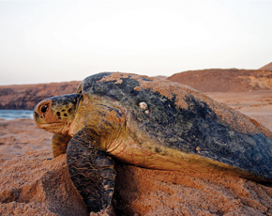
The Marine Turtle Conservation Act of 2004 was established to support conservation projects that protect and conserve global marine turtle species. These species include loggerhead, green, olive ridley, leatherback, Kemp’s ridley, and hawksbill turtles. These turtles face major threats from illegal trade of meat, eggs, and shells, loss of nesting beaches due to infastructure development, and climate change. Additionally, this species is especially vulnerable to these threats because they are long-lived, mature late, and are highly migratory. Due to the global nature of marine turtles, Eeffective conservation of this species requires cooperation between the United States and countries that have marine turtle nesting beaches. The Act grants the Service the authority to establish the Marine Turtle Conservation Fund to provide funding for projects that conserve marine turtles through cooperative efforts to protect, restore, and manage nesting sites.

Lacey Act
Under the Lacey Act, it is unlawful to import, export, sell, acquire, or purchase fish, wildlife or plants that are taken, possessed, transported, or sold: 1) in violation of U.S. or Indian law, or 2) in interstate or foreign commerce involving any fish, wildlife, or plants taken possessed or sold in violation of State or foreign law.
The law covers all fish and wildlife and their parts or products, plants protected by the Convention on International Trade in Endangered Species of Wild Fauna and Flora (CITES) and those protected by State law. Commercial guiding and outfitting are considered to be a sale under the provisions of the Act.
In 2008, the Lacey Act was amended to include a wider variety of prohibited plants and plant products, including products made from illegally logged woods, for import.
When the Lacey Act was passed in 1900, it became the first federal law protecting wildlife. It enforces civil and criminal penalties for the illegal trade of animals and plants. Today it regulates the import of any species protected by international or domestic law and prevents the spread of invasive, or non-native, species.
Marine Mammal Protection Act
The Marine Mammal Protection Act (MMPA) was enacted on October 21, 1972. All marine mammals are protected under the MMPA. The MMPA prohibits, with certain exceptions, the "take" of marine mammals in U.S. waters and by U.S. citizens on the high seas, and the importation of marine mammals and marine mammal products into the U.S.
Jurisdiction for MMPA is shared by U.S. Fish and Wildlife Service (Service) and the National Marine Fisheries Service (NMFS). The Service’s Branch of Permits is responsible for issuing take permits when exceptions are made to MMPA.
In general, exceptions may be made for:
- Pre-MMPA specimens taken before December 21, 1972
- International Agreements entered into by the United States before December 21, 1972
- Alaska natives
- Scientific research, public display, enhancing the survival or recovery of a species, and incidental take in commercial fisheries
- Waivers granted by the U.S. Government

MMPA and CITES
All cetaceans (whales, dolphins, and porpoises), all sirenians (manatees and dugongs) and several marine carnivores (seals, otters, walrus, and polar bears) are protected under the Convention on International Trade in Endangered Species of Wild Fauna and Flora (CITES).
CITES applies to international shipments of listed species. It does not apply to activities conducted solely within the United States. The Service issues CITES permits for all marine mammals protected by CITES. For permitting information for marine mammals, visit our Permits page.
For more information on MMPA, visit the National Oceanic and Atmospheric Administration (NOAA).

Pelly Amendment
Section 8 of the Fishermen’s Protective Act, also known as the Pelly Amendment, was added to this 1954 statute by P.L. 92-219 (85 Stat. 786).
The section originally required the Secretary of Commerce to report to the President when he or she determines that nationals of a foreign country are diminishing the effectiveness of an international fishery conservation program. The President is then authorized to direct the Secretary of the Treasury to prohibit the importation of fish products from the offending nation for such duration as he or she determines appropriate and to the extent that such prohibition is consistent with the General Agreements on Trade and Tariffs.
The Pelly Amendment was expanded by P.L. 95-376 (92 Stat. 714), September 18, 1978, to authorize the President to embargo wildlife products (including all fish not previously covered) whenever the Secretary of the Interior or the Secretary of Commerce certifies that nationals of a foreign country are engaging in trade or taking that diminishes the effectiveness of an international program in force with respect to the United States for the conservation of endangered or threatened species.
The U.S. Fish and Wildlife Service (Service) utilizes the Pelly Amendment when negotiating with other Parties to the Convention on International Trade in Endangered Species of Wild Fauna and Flora (CITES) on the listing of certain species.
Certification of Iceland
On February 6, 2014, the Department of the Interior announced that it had certified to President Obama under the Pelly Amendment to the Fishermen’s Protective Act of 1967 that Iceland’s international trade in whale meat and products diminishes the effectiveness of the Convention on International Trade in Endangered Species of Wild Fauna and Flora (CITES).
For more information on this decision, please refer to our Q&As.
On January 23, 2015, federal agencies and departments submitted a report to the President outlining actions that have been taken to encourage Iceland to halt commercial whaling and international trade in whale meat, and support international conservation efforts since the 2014 certification. Read the report.
Iceland was also certified under the Pelly Amendment in July 2011 by then-Secretary of Commerce Gary Locke who found that commercial whaling activities by Icelandic nationals diminished the effectiveness of the International Whaling Commission conservation program.

