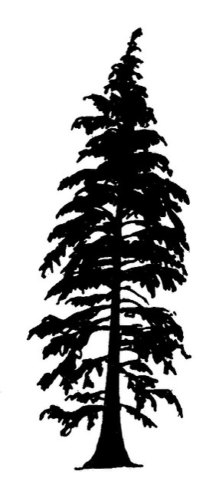
Trees of the Rogue Valley Identification Activity

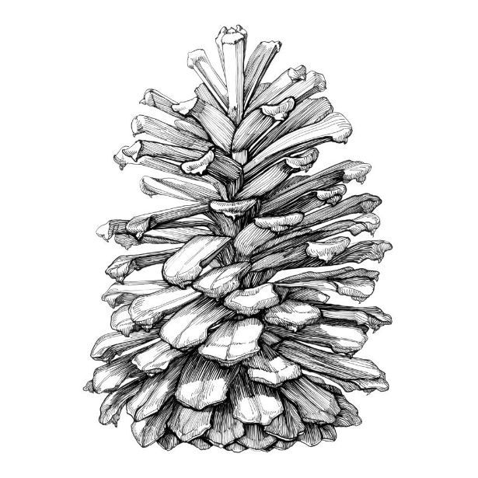
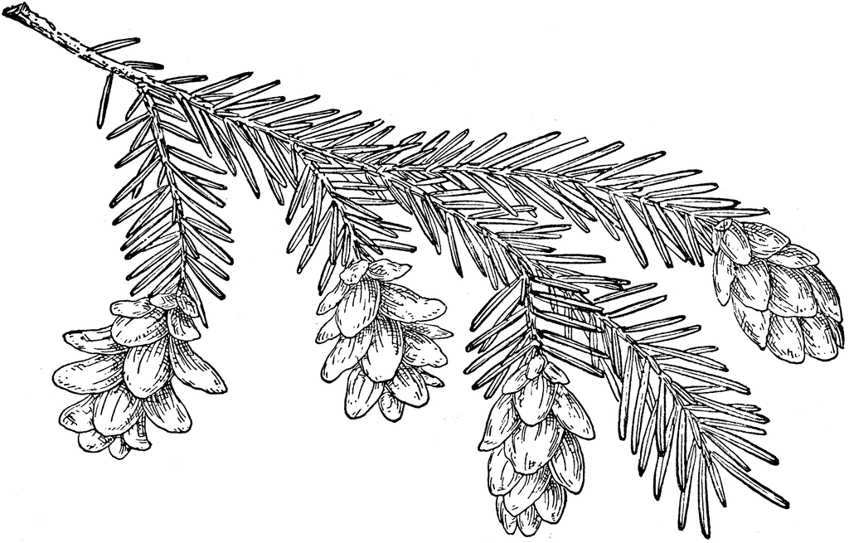

Instructions:
Using a dichotomous key, identify the most common tree species in the Rogue Valley
Specimen Number | Common Name | Scientific Name | Identifying Features
Specimen Number | Common Name | Scientific Name | Identifying Features

