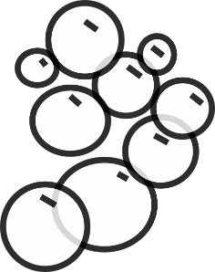
The Cell Membrane Bubble Challenge Lab

Challenge 1: Membrane Flexibility
- Figure out how you can create a film in the straw frame.
- Holding it parallel to the floor, how far can you bounce it up and down without the film breaking? __________________
Challenge 2: Membrane Self- Repair
- Figure out how to pass a finger or hand (extra challenge!) through the membrane WITHOUT POPPING THE FILM.
- How’d you do it? _______________________________
___________________________________________

Challenge 3: Organelles Within the Cell
- Figure out how to get a bubble within a bubble. How many can you get in one bubble? (you may use a clean straw) ____
Challenge 4: Membrane Proteins Create Pores
- Figure out how to use a piece of yarn, tied in a circle, to get a DRY finger through the bubble membrane WITHOUT BREAKING THE MEMBRANE (and without soap).
- How’d you do it? ______________________________________________________________________________________
The Cell Membrane Bubble Challenge Lab

Challenge 1: Membrane Flexibility
- Figure out how you can create a film in the straw frame.
- Holding it parallel to the floor, how far can you bounce it up and down without the film breaking? __________________
Challenge 2: Membrane Self- Repair
- Figure out how to pass a finger or hand (extra challenge!) through the membrane WITHOUT POPPING THE FILM.
- How’d you do it? _______________________________
___________________________________________

Challenge 3: Organelles Within the Cell
- Figure out how to get a bubble within a bubble. How many can you get in one bubble? (you may use a clean straw) ____
Challenge 4: Membrane Proteins Create Pores
- Figure out how to use a piece of yarn, tied in a circle, to get a DRY finger through the bubble membrane WITHOUT BREAKING THE MEMBRANE (and without soap).
- How’d you do it? ______________________________________________________________________________________

