Ecology Warm Ups

3/7, 3/8 | What are some treatment considerations with hypothermic patients?  Be gentle, don’t apply direct heat, warm slowly in hypowrap, remove wet clothing, insulate body from the ground
3/8, 3/9 | Regarding layering system of clothing, what are the 4 types of layers and in what order?  Base layer, Mid-layer, Insulation layer, Hard shell/ waterproof layer
3/14 | What kind of adaptations to the snow do snowshoe hares have?  Hind feet large like snowshoes, white fur for camouflage, smaller ears for less heat loss
3/20, 3/22 | How many Oregon tree species can you name? Talk to a neighbor and write down your list.  Douglas Fir, Ponderosa Pine, Oregon Ash, California White Oak, Spruce, Redwoods, Noble Fir, Grand Fir, Big Leaf Maples, Western Hemlock, Madrone, Manzanita
3/23 | What is the leaf arrangement of this plant?  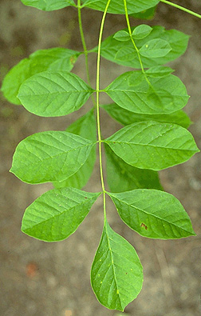  What species of tree is this?

