Semester 2 WOTD #4
Date | Ecology Word of the Day
4/9 | Invasive species- 1. Non-native to the ecosystem under consideration; 2. Whose introduction causes or is likely to cause economic or environmental harm or harm to human health
4/10, 4/11 | Symbiosis- interaction between two differen organisms living in close physical association, typically to the advantage of both
4/11, 4/12 | Mutualism- symbiosis that is beneficial to both organisms involved
4/12 | Commensalism- association between two organisms in which one benefits and the other derives neither benefit nor harm
4/13 | Parasitism- the relationship between two organisms where one benefits while the other is harmed
4/16 | Littoral Zone- intertidal zones above water at low tide and underwater at high tide  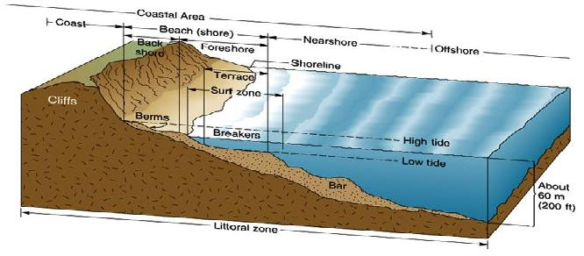
4/17, 4/18 | Splash Zone- the supralittoral zone extends from the highest reach of spray and storm waves to the average height of the high tides. Usually dry and relatively few types of organisms that can live there.
4/18, 4/19 | High Tide Zone- This zone includes the area from the average high tide to just below the average sea level. Species found here may include: acorn barnacles, hermit crabs, shore crabs, black turban snails, aggregating anemones
4/24, 4/25 | Low Tide Zone- This zone is closest to the sea and is submerge the majority of the time. Species found here include: sea stars, sea urchins, anemones, nudibranchs
4/25, 4/26 | Dessication- State of extreme dryness;  What are examples of how tidal zone organisms are adapted to prevent this?
4/27 | Keystone Species- A species on which other species in an ecosystem largely depend, such that if it were removed, the ecosystm would change drastically.
4/30 | Trophic Cascade- A change in the rate of consumption at one trophic level that results in a series of changes in sepcies abundance or composition at lower trophic levels (must affect at least 3 trophic levels)  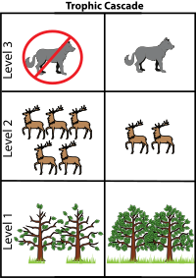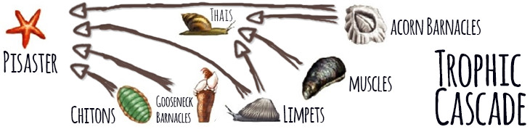
3rd Lab Groups | Tucker  Maddie L  Jayden | Claire  Joleen  Lindsay | Maddie F  Raina  Kayana | Emily  Genesis  Alex | Hien  Shaydie  Skyla | Makaiah  Kirsten  Jada | Dayton  Jay  Dawson | David  Giselle  Gabe  Mason
5th Lab Groups | Grace  Mollie  Aubrey | Chloe  Orange  Sam | Lily  Bailey  Nikki | Jaden  Ali  Kate | Autumn  Mario  Trinity | Steve  Thomas  Bea | Frank  Kyle N  Michelle | Kyle B  Kendall  Keighlee
5/1, 5/2 | Carrying capacity- The number of people, other living organisms, or crops that a region can support without environmental degradation
5/2, 5/3 | Extremophile- A microorganism that lives in conditions of extreme temperature, acidity, alkalinity, or chemical concentration.
5/4 | Salinity- The concentration of dissolved salts in water (“The salinity of tidal pools changes as water evaporates throughout the day”)
5/7 | Marine Ecology- Interactive science studying the biotic and abiotic interactions in marine ecosystems.
5/8, 5/9 | Upwelling- When cold, nutrient rich water from the bottom of the ocean moves to the surface
5/9, 5/10 | Outwelling- Occurs when nutrient-rich estuartine water moves out to sea

