Semester 2 WOTD #3
Date | Ecology Word of the Day
3/13, 3/14 | Bathymetric map- Equivalent of an above-water topographic map. Designed to present accurate, measurable description and visual presentation of the submerged terrain  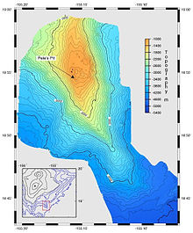
3/14, 3/15 | Oligotrophic- relatively low in plant nutrients and contatining abundant oxygen in the deeper parts
3/16 | Eutrophic- rich in nutrients and supporting dense plant population, the decomposition of which kills animal life by depriving it of oxygen.
4/2 | Phytoplankton- microscopic plants that drift or float in salt or freshwater
4/3, 4/4 | Zooplankton- Plankton (microscopic organism) consisting of small animals and immature stages of larger animals
4/4, 4/5 | Macrophytes- An aquatic plant large enough to be seen by the naked eye
4/6 | Benthos- The flora and fauna found on the bottom, or in the bottom sediments, of a sea, lake or other body of water

