

United States Department of Agriculture

Natural Resources Conservation Service

# Oregon

Basin Outlook Report

January 1, 2017

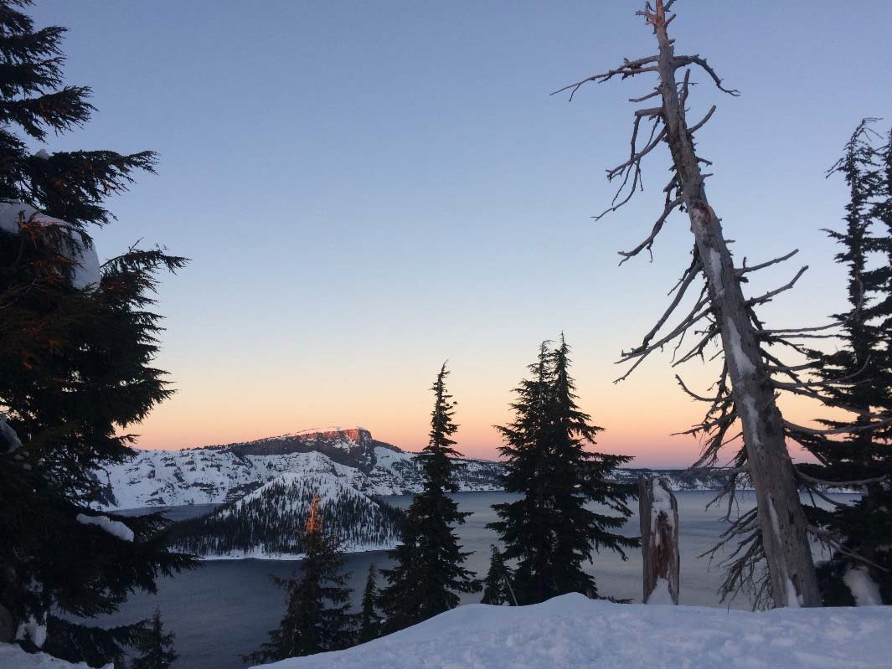

The final sunset of 2016 over Crater Lake

*Photo courtesy of Lauren Austin (Snow Surveyor, Oregon NRCS)*

A healthy snowpack blankets the mountains as 2016’s final rays of sunshine spread colors across the landscape of Crater Lake National Park. NRCS snow surveyors measured 8.5 feet of snow (138% of normal) on January 3rd at Park Headquarters snow course, which had the deepest snowpack measurement in the state. A rainy fall followed by a snowy December has left Oregon’s mountains with above normal snowpacks for the start of the New Year.

General Outlook

January 1st, 2017

# SUMMARY

Record breaking October precipitation provided a great start to the new water year, building hopes of a good snow year to come. The month of December fortified these hopes with sustenance, delivering cold snow storms that blanketed the entire state. Snow levels dropped all the way down to the valley floors in normally rainy locations as snow continued piling up in the mountains. As of New Year’s Day, the snowpack is near normal to above normal throughout almost all of Oregon’s higher elevations. Based on the current conditions, spring and summer streamflow forecasts are projecting near average to above average streamflows for the water supply season. However, there are several months left in the snow accumulation season, which means there is a lot of uncertainty in these first forecasts of the year. Currently, the long term weather outlook from NOAAs Climate Prediction Center is calling for the next three months to bring above normal precipitation across Oregon (<http://www.cpc.ncep.noaa.gov/>). If the rest of winter continues the wet, cold and snowy trend and spring snowmelt rate and timing are normal, then water supplies during the critical spring and summer months will likely be adequate.

# SNOWPACK

A snowy December helped ring in the New Year with near normal to above normal snowpack for almost the entire state. The series of cold wintery storms blanketed the state with snow, providing ample snow coverage throughout the mountains, closing interstates and schools around the state, while also bringing excellent powder for winter recreation opportunities.

As of January 1st, the statewide snowpack is 119% of normal. Overall, the Hood, Sandy and Lower Deschutes basins have the highest snowpack in the state at 136% of normal, while the Klamath basin has the lowest January 1st snowpack at 102% of normal. As always, there’s quite a bit of spatial variability in mountain snowpack, which can be explained by the variability within storm patterns. A few locations, mostly in southern Oregon and in the Wallowa Mountains, are currently storing below normal amounts of snow.

# PRECIPITATION

While most people celebrate the new calendar year on January 1st, the new water year began on October 1st. The mountains celebrated the new water year by experiencing the wettest October on record. Most long-term SNOTEL sites in Oregon received the highest October rainfall in over 30 years, which was two to four times more than the usual rainfall totals in many locations. North Fork SNOTEL in the Bull Run watershed near Portland collected 33.5 inches of rain in October, which was both a record for that site and the highest October precipitation total for a SNOTEL site in Oregon.

Most of the fall precipitation fell as rain, which is ideal for wetting up the soil profiles prior to snow accumulation. By December, precipitation transitioned to snow and quickly brought the snowpack up to near normal levels in the mountains. The water year-to-date precipitation totals range from 105% of average in the Harney basin to 136% of average in the Rogue and Umpqua basins.

# RESERVOIRS

Most reservoirs in the state are currently storing below average amounts of water. Below normal streamflow this past summer and water usage led to below average volumes going into this new season. As of the end of December, the group of reservoirs that are storing the lowest amount in the state is in the Umatilla, Walla Walla and Willow basins at 56% of average and the highest is in the Deschutes and Crooked River basins at 90% of average.

# STREAMFLOW

As of January 1st, most of the spring and summer forecasts are projecting near average to above average streamflow volumes based on the wet fall and near normal to above normal snowpack in Oregon. Last year at this time, the state-wide snowpack was also above normal and continued to hover near normal through April 1st. Rapid and record breaking snowmelt occurred during April which led to below normal summer streamflow. This highlights the uncertainty of early season streamflow forecasts.

This year, we have upgraded the streamflow forecast summary table typically published in this section to a colorful graphical representation, shown below. Previously, the table only listed the 50% chance of exceedance (median) forecast because it is the forecast most commonly used by water users. The new graphic depicts the full range of 5 streamflow forecast volumes that are provided for each station, which illustrates the range of possible streamflow outcomes depending on the future weather. We hope to expand this way of graphically presenting streamflow forecasts in the future and welcome any feedback about this product.

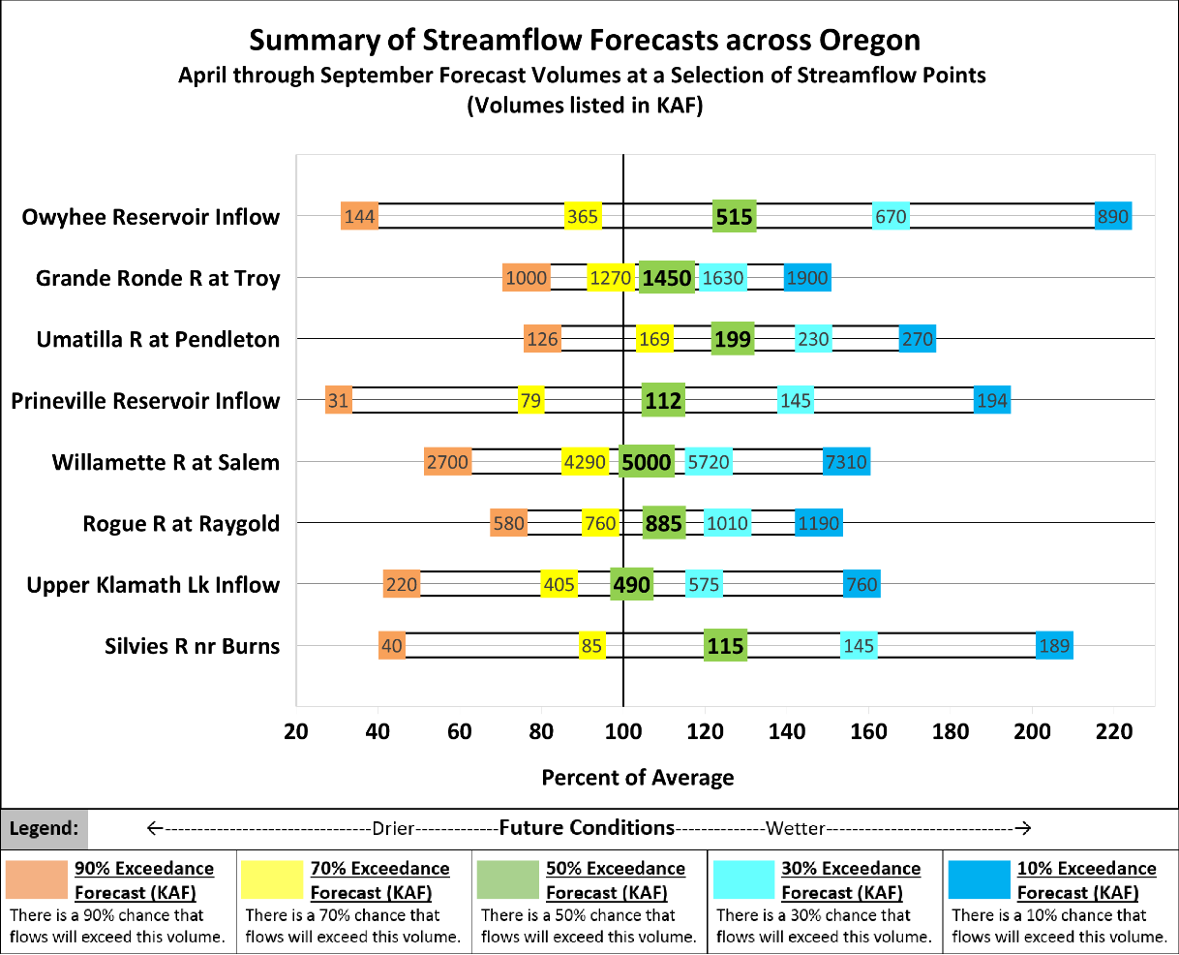

2

To accompany the new forecast summary graphic, here are some helpful reminders about interpreting streamflow forecasts published in this document. For each forecast point, 5 possible streamflow volumes are predicted. Where the observed streamflow occurs within this spectrum depends on the range of future weather conditions. If water users wish to plan conservatively, they may lean toward using the 70% chance of exceedance forecast, or the drier forecast (which may be below average depending on the region). Conversely, if a water user believes future conditions will provide more water to the system, they could choose to use the 30% chance of exceedance forecast (the wetter forecast). These arrays of forecasts are shown in the chart on the previous page and explained in more detail on page 35.

Some of these forecasts assume that normal weather conditions will occur from now to the end of the forecast period. All forecasts are listed with units of 1000 acre-feet (KAF). This report contains data furnished by the Oregon Department of Water Resources, U.S. Geological Survey, NOAA National Weather Service and other cooperators. This report will be updated monthly, January through June.

Note: A select set of streamflow forecasts have been discontinued in the Rogue, Grande Ronde and Willamette basins. Please see each basin section for more information.

Rogue and Umpqua Basins

January 1, 2017

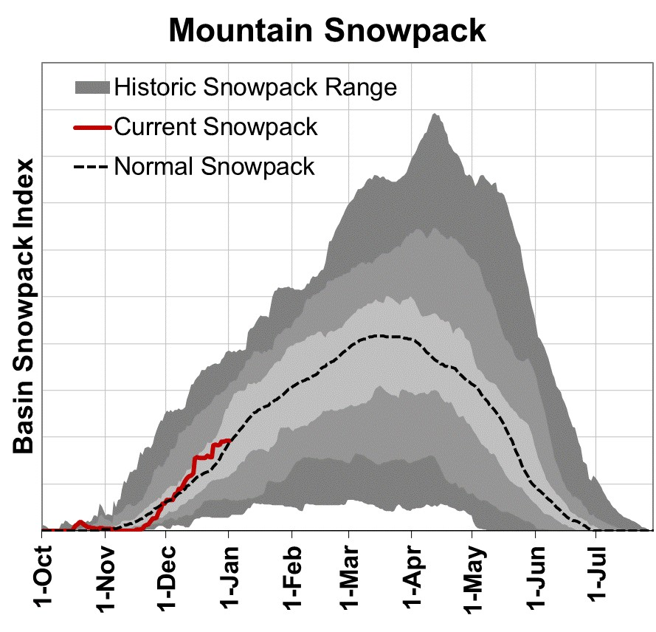

# Summary of Water Supply Conditions

# SNOWPACK

As of January 1, the basin snowpack was 110% of normal. This is lower than last year when the basin snowpack was 169% of normal on January 1, 2016.

# PRECIPITATION

October brought more than three times the normal amount of precipitation to the basin and record rainfall was measured at 8 out of 11 long-term SNOTEL sites in the basin. December precipitation was 96% of average. Precipitation since the beginning of the water year (October 1 - January 1) has been 136% of average.

# RESERVOIR

As of January 1, storage at major reservoirs in the basin ranges from 41% of average at Fourmile Lake to 94% of average at Emigrant Lake.

# STREAMFLOW FORECAST

The April through September streamflow forecasts in the basin range from 107% to 131% of average. If conditions remain similar, water supplies in the basin are likely to be near normal to above normal this summer. Note: As of 2017, the Hyatt Prairie inflow forecast has been discontinued due to streamflow data quality issues and associated low forecast skill.

Rogue And Umpqua Basins Summary for January 1, 2017

|  |  |  |  |  |  |  |  |  |
| --- | --- | --- | --- | --- | --- | --- | --- | --- |
| **Forecast Exceedance Probabilities for Risk Assessment \*** | | | | | | | | |
|  |  | ←-------Drier----------Future Conditions--------Wetter-------→ | | | | | |  |
| **Streamflow Forecasts** | **Forecast** | **90%** | **70%** | **50%** |  | **30%** | **10%** | **Average** |
| **January 1, 2017** | **Period** | **(KAF)** | **(KAF)** | **(KAF)** | **% Avg** | **(KAF)** | **(KAF)** | **(KAF)** |
| South Umpqua R at Tiller | APR-JUL | 117 | 181 | 225 | 117% | 270 | 335 | 193 |
|  | APR-SEP | 126 | 191 | 235 | 118% | 280 | 345 | 200 |
| Cow Ck ab Galesville Reservoir2 | FEB-JUL | 22 | 35 | 43 | 130% | 51 | 63 | 33 |
|  | APR-JUL | 8.0 | 14.1 | 18.2 | 131% | 22 | 28 | 13.9 |
|  | APR-SEP | 9.2 | 15.4 | 19.6 | 131% | 24 | 30 | 15.0 |
| South Umpqua R nr Brockway | APR-JUL | 215 | 370 | 470 | 121% | 575 | 730 | 390 |
|  | APR-SEP | 235 | 390 | 495 | 121% | 600 | 760 | 410 |
| North Umpqua R at Winchester | APR-JUL | 545 | 730 | 855 | 110% | 985 | 1170 | 775 |
|  | APR-SEP | 660 | 855 | 985 | 111% | 1120 | 1310 | 890 |
| Lost Creek Lk Inflow2 | FEB-JUL | 610 | 750 | 845 | 106% | 945 | 1080 | 795 |
|  | FEB-SEP | 720 | 875 | 980 | 107% | 1090 | 1240 | 920 |
|  | APR-JUL | 395 | 490 | 560 | 108% | 625 | 725 | 520 |
|  | APR-SEP | 505 | 615 | 690 | 107% | 770 | 880 | 645 |
| Rogue R at Raygold2 | APR-JUL | 465 | 630 | 740 | 110% | 855 | 1020 | 675 |
|  | APR-SEP | 580 | 760 | 885 | 110% | 1010 | 1190 | 805 |
| Rogue R at Grants Pass2 | APR-JUL | 470 | 665 | 795 | 110% | 930 | 1130 | 725 |
|  | APR-SEP | 580 | 790 | 935 | 111% | 1080 | 1290 | 845 |
| Applegate Lake Inflow2 | FEB-JUL | 113 | 186 | 235 | 121% | 285 | 355 | 195 |
|  | FEB-SEP | 119 | 193 | 245 | 123% | 295 | 370 | 200 |
|  | APR-JUL | 65 | 107 | 135 | 124% | 164 | 205 | 109 |
|  | APR-SEP | 71 | 114 | 144 | 125% | 173 | 215 | 115 |
| Sucker Ck bl Ltl Grayback nr Holland | APR-JUL | 29 | 51 | 66 | 120% | 80 | 102 | 55 |
|  | APR-SEP | 33 | 55 | 70 | 119% | 85 | 107 | 59 |
| Illinois R nr Kerby | APR-JUL | 89 | 168 | 220 | 117% | 275 | 355 | 188 |
|  | APR-SEP | 95 | 175 | 230 | 119% | 280 | 360 | 193 |

* 90%, 70%, 50%, 30% & 10% exceedance probabilities are the chance that observed streamflow volume will exceed the forecasted volume

2) Forecasts are for unimpaired flows. Actual flow will be dependent on management of upstream reservoirs and diversions

Rogue And Umpqua Basins Summary for January 1, 2017

|  |  |  |  |  |  |
| --- | --- | --- | --- | --- | --- |
| **Reservoir Storage** | **Current (KAF)** | **Last Year (KAF)** | **Average (KAF)** | **% of Average** | **Useable Capacity (KAF)** |
| Applegate | 9.4 | 6.8 | 10.2 | 92% | 75.2 |
| Emigrant Lake | 16.1 | 8.0 | 17.2 | 94% | 39.0 |
| Fish Lake | 3.7 | 2.5 | 4.7 | 79% | 7.9 |
| Fourmile Lake | 2.8 | 2.6 | 6.7 | 41% | 15.6 |
| Howard Prairie | 30.0 | 10.3 | 35.5 | 85% | 62.1 |
| Hyatt Prairie | 8.2 | 2.0 | 9.6 | 85% | 16.2 |
| Lost Creek | 125.0 | 126.4 | 137.6 | 91% | 315.0 |

|  |  |  |  |
| --- | --- | --- | --- |
| **Snowpack Summary by Basin** |  | **Basin Snowpack**  **% of Median** | |
| **# of Sites** | **Current Yr** | **Last Yr** |
| Applegate Basin | 2 | 110% | 183% |
| Middle Rogue Basin | 5 | 285% | 600% |
| North Umpqua Basin | 3 | 124% | 176% |
| South Umpqua Basin | 6 | 212% | 422% |
| Upper Rogue Basin | 10 | 107% | 157% |

|  |  |  |  |  |  |  |  |
| --- | --- | --- | --- | --- | --- | --- | --- |
| **Basin Snowpack Measurement Sites** |  |  |  | **Snow Water Equivalent (in)** | | | |
| **Elevation (ft)** | **Date Measured** | **Depth (in)** | **Current SWE** | **Last Yr SWE** | **Median** | **% of Median** |
| Park H.Q. Rev Snow Course | 6570 | 3-Jan | 102 | 28.4 | 35.4 | 20.6 | 138% |
| Caliban (Alt.) Snow Course | 6500 | 29-Dec | 43 | 12.0 | 15.6 |  |  |
| Mt. Ashland Switchback Snow Course | 6430 | 29-Dec | 35 | 9.0 |  |  |  |
| Ski Bowl Road Snow Course | 6070 | 29-Dec | 27 | 7.2 | 13.3 |  |  |
| Big Red Mountain SNOTEL | 6050 | 1-Jan | 35 | 10.4 | 14.6 | 10.0 | 104% |
| Annie Springs SNOTEL | 6010 | 1-Jan | 57 | 16.0 | 21.0 | 17.3 | 92% |
| Fourmile Lake SNOTEL | 5970 | 1-Jan | 33 | 9.2 | 18.7 | 13.4 | 69% |
| Cold Springs Camp SNOTEL | 5940 | 1-Jan | 35 | 10.8 | 16.6 | 14.0 | 77% |
| Sevenmile Marsh SNOTEL | 5700 | 1-Jan | 43 | 12.6 | 15.7 | 12.5 | 101% |
| Summit Lake SNOTEL | 5610 | 1-Jan | 60 | 18.6 | 23.0 | 16.3 | 114% |
| Billie Creek Divide SNOTEL | 5280 | 1-Jan | 35 | 10.9 | 19.9 | 10.4 | 105% |
| Diamond Lake SNOTEL | 5280 | 1-Jan | 30 | 9.2 | 14.4 | 6.6 | 139% |
| Bigelow Camp SNOTEL | 5130 | 1-Jan | 20 | 6.2 | 13.1 | 5.1 | 122% |
| Beaver Dam Creek Snow Course | 5120 | 3-Jan | 28 | 8.9 | 9.4 | 6.3 | 141% |
| King Mountain 1 Snow Course | 4760 | 3-Jan | 30 | 6.8 | 11.0 | 2.2 | 309% |
| Deadwood Junction Snow Course | 4660 | 3-Jan | 22 | 8.0 | 11.1 | 4.2 | 190% |
| Fish Lk. SNOTEL | 4660 | 1-Jan | 20 | 5.0 | 11.8 | 5.1 | 98% |
| Howard Prairie SNOTEL | 4580 | 1-Jan | 8 | 2.3 | 6.6 |  |  |
| Siskiyou Summit Rev. 2 Snow Course | 4560 | 29-Dec | 15 | 3.8 | 9.2 | 2.2 | 173% |
| Red Butte 1 Snow Course | 4460 | 30-Dec | 30 | 9.3 |  | 4.6 | 202% |
| King Mountain SNOTEL | 4340 | 1-Jan | 11 | 3.7 | 9.2 | 1.5 | 247% |
| Red Butte 2 Snow Course | 4050 | 30-Dec | 7 | 1.5 |  | 1.1 | 136% |
| Silver Burn Snow Course | 3680 | 3-Jan | 33 | 6.5 | 12.2 | 5.3 | 123% |
| King Mountain 3 Snow Course | 3680 | 3-Jan | 14 | 1.8 | 5.2 | 0.0 |  |
| Red Butte 3 Snow Course | 3500 | 30-Dec | 4 | 0.6 |  | 0.4 | 150% |
| Toketee Airstrip SNOTEL | 3240 | 1-Jan | 6 | 2.3 | 5.1 | 1.3 | 177% |
| King Mountain 4 Snow Course | 3050 | 3-Jan | 5 | 0.7 | 0.8 | 0.0 |  |
| Red Butte 4 Snow Course | 3000 | 30-Dec | 0 | 0.0 |  | 0.0 |  |

24

Mount Shasta, California Average Snowfall

Mount Shasta has had an average annual snowfall of **91.8 inches** over the last 30 years, which is 310% more than the national average (22.4 inches). **71%** of Mount Shasta's snow fell during the winter months.

The record snowfall was **54.0 inches on February 16, 1959** - 200% more than the national average for snowfall records.

**See all Average 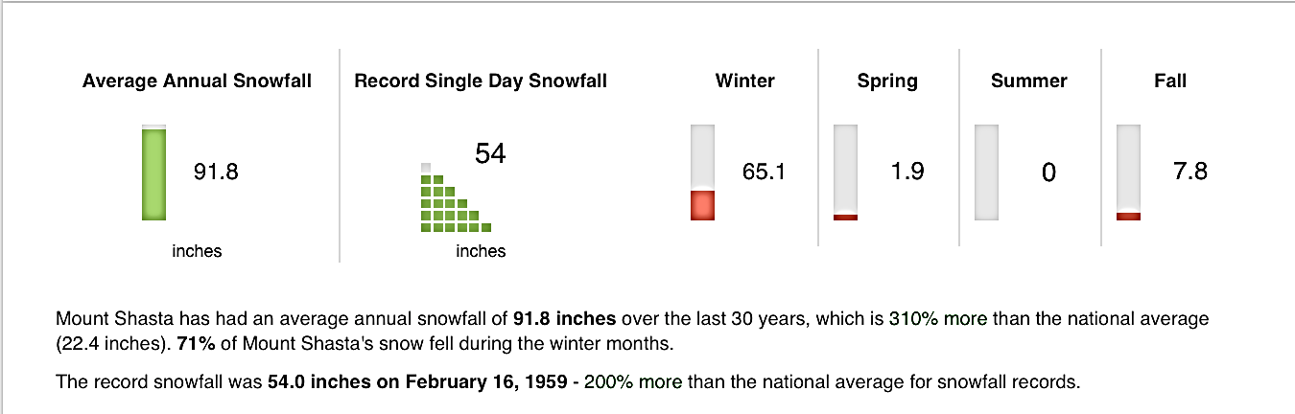Snowfall**

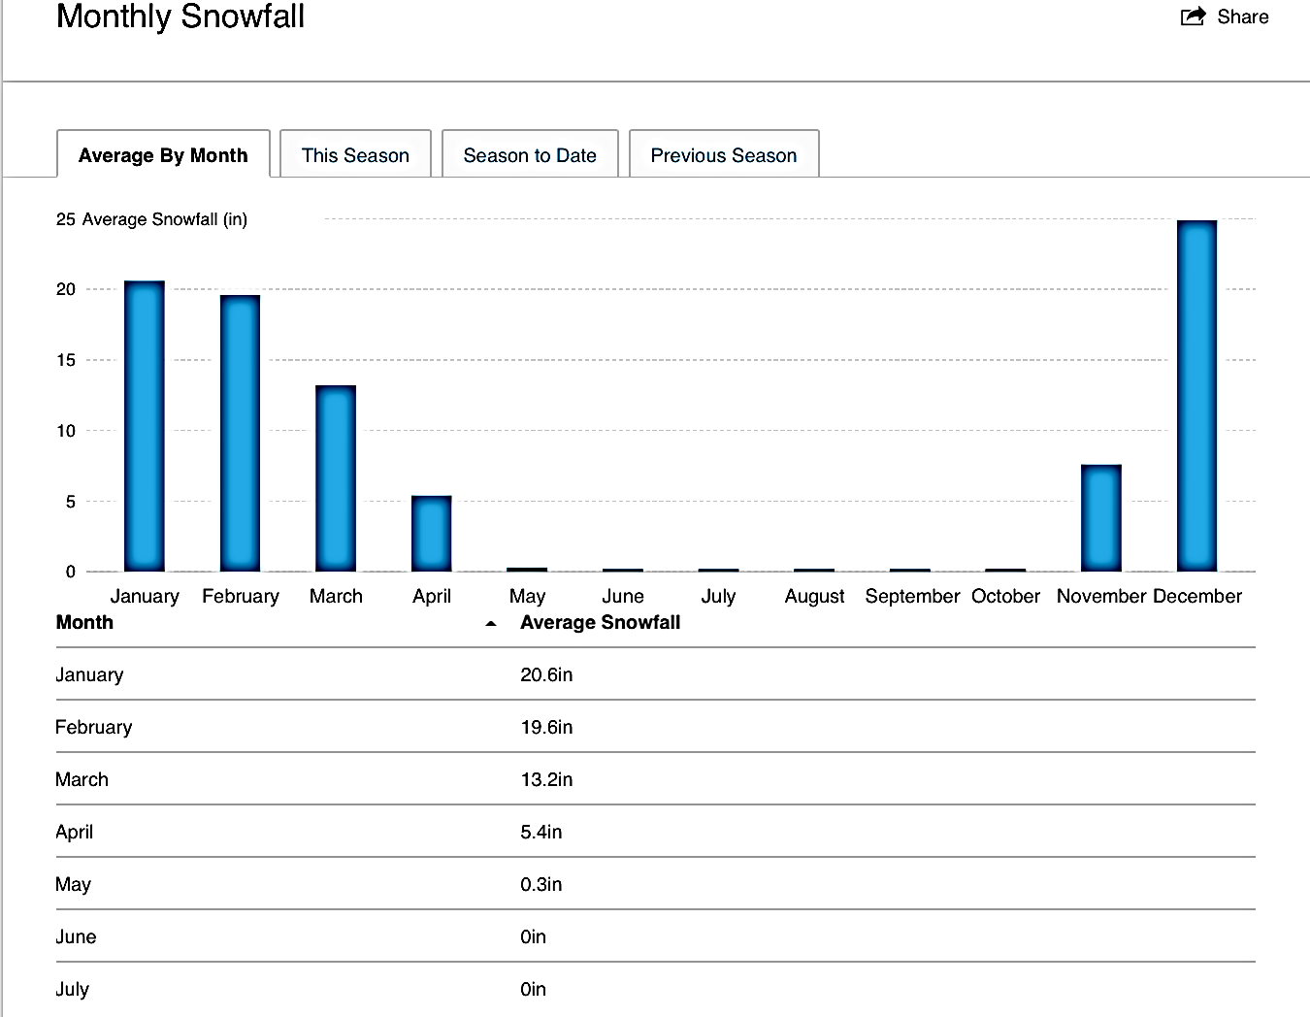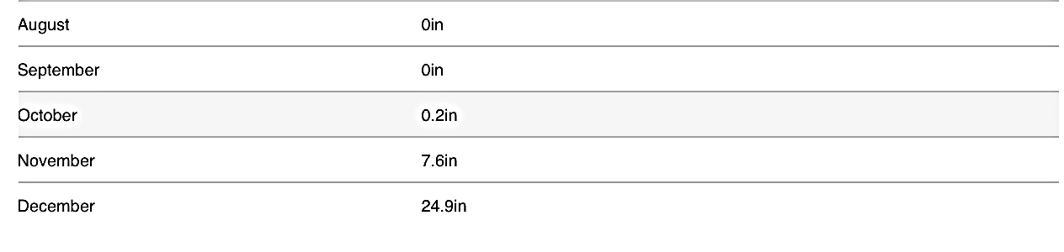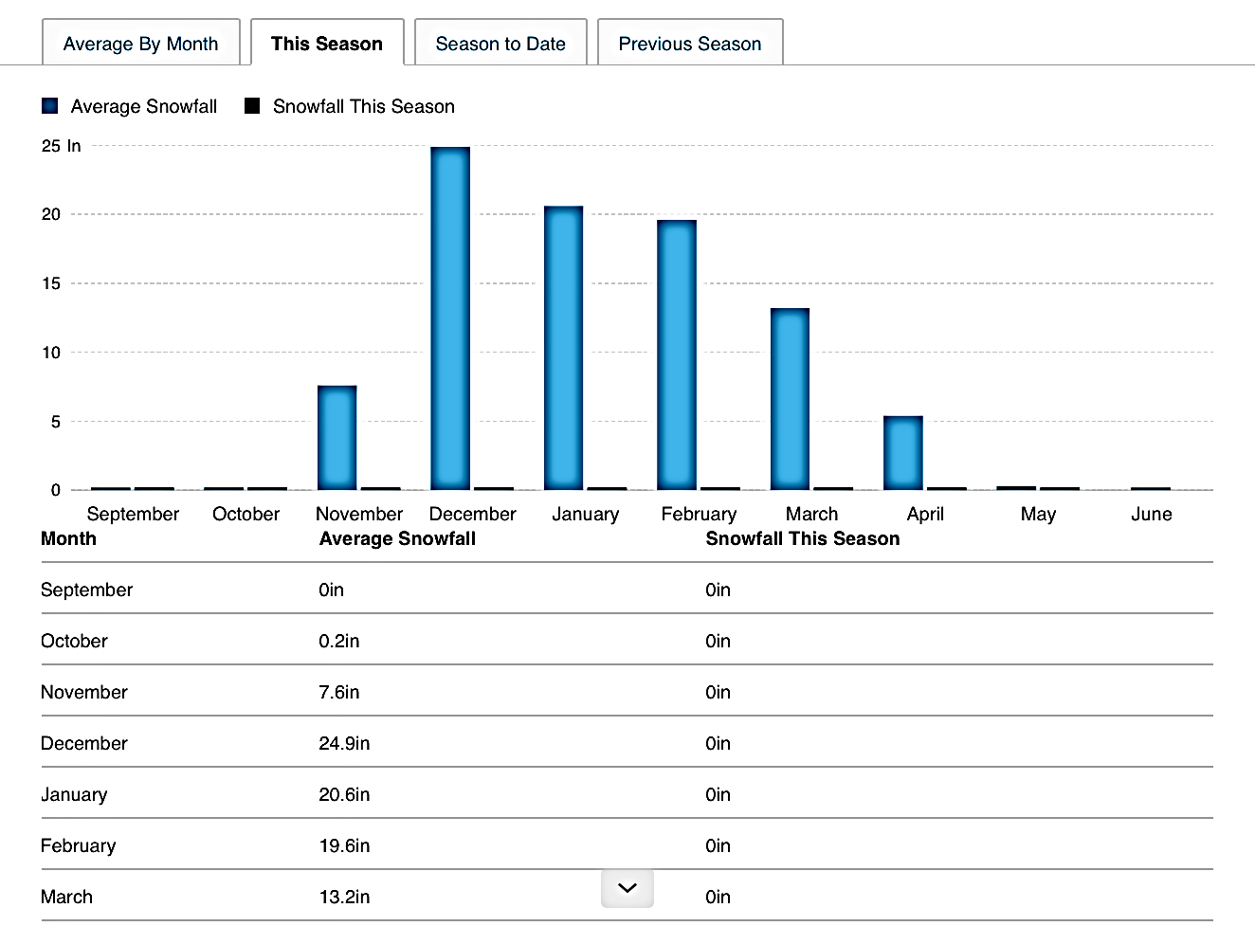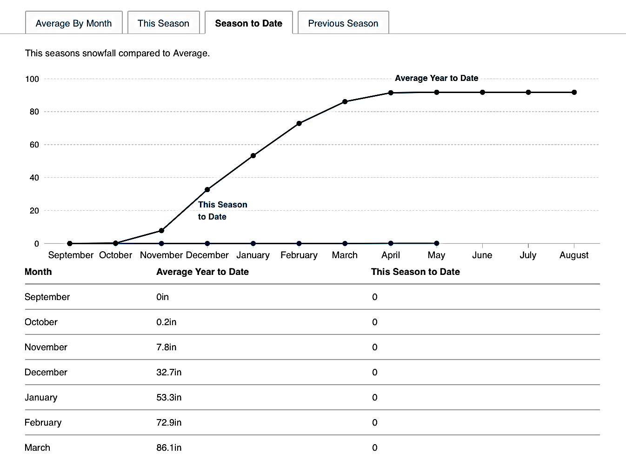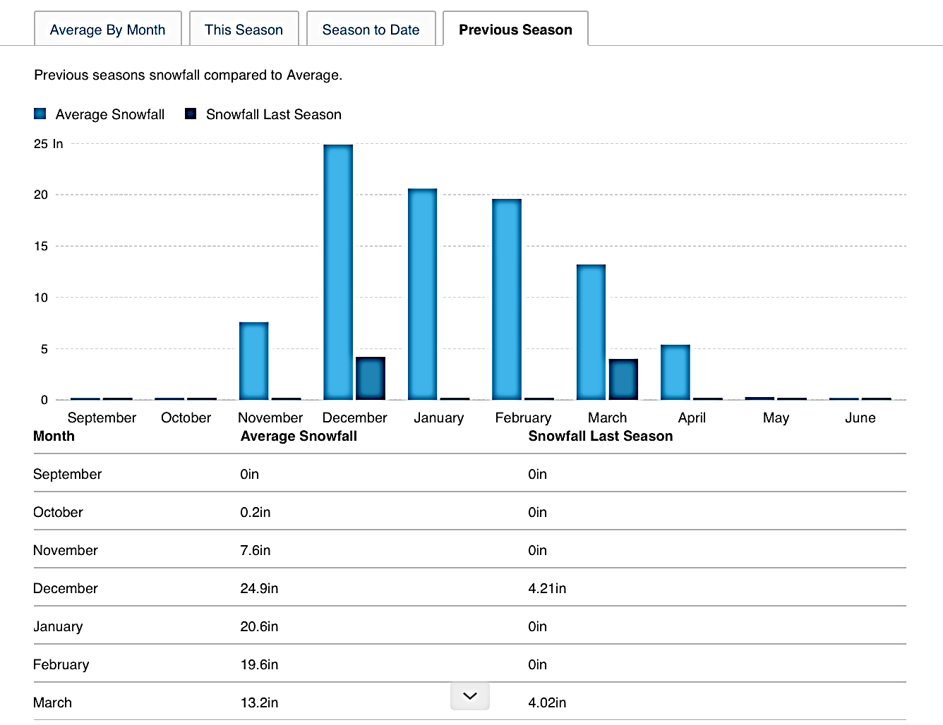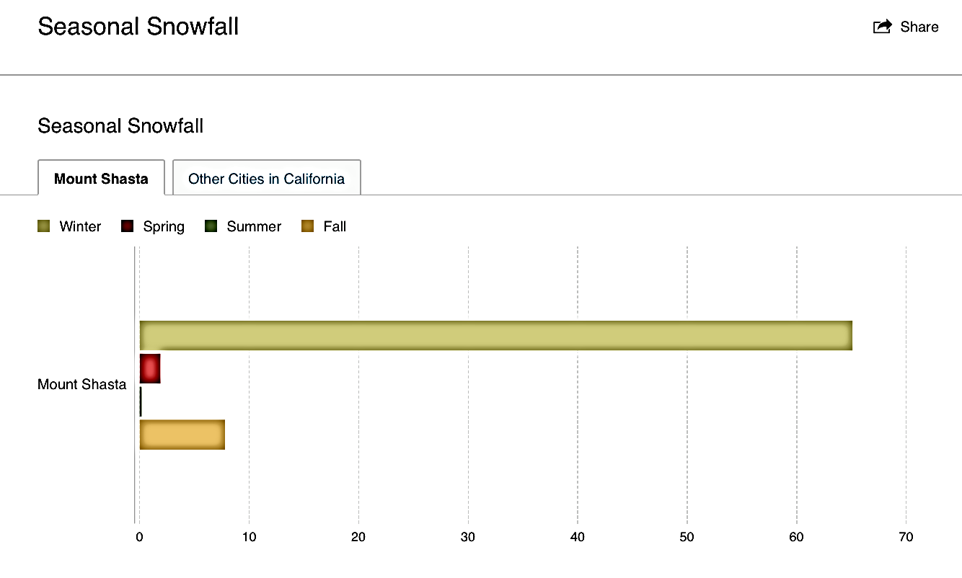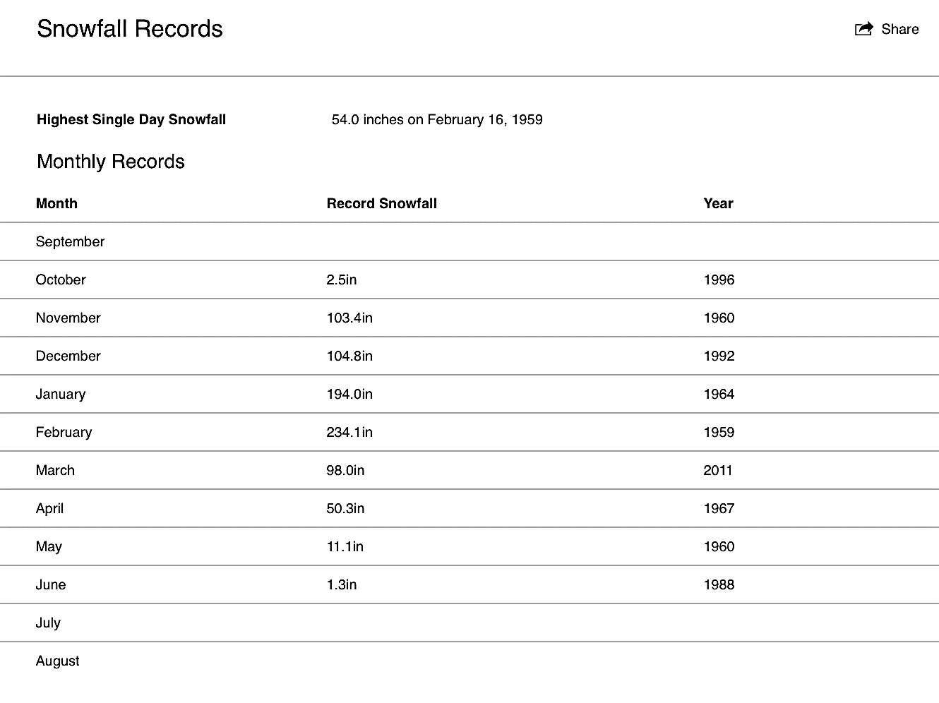

**Mt. Ashland Snow Report**  
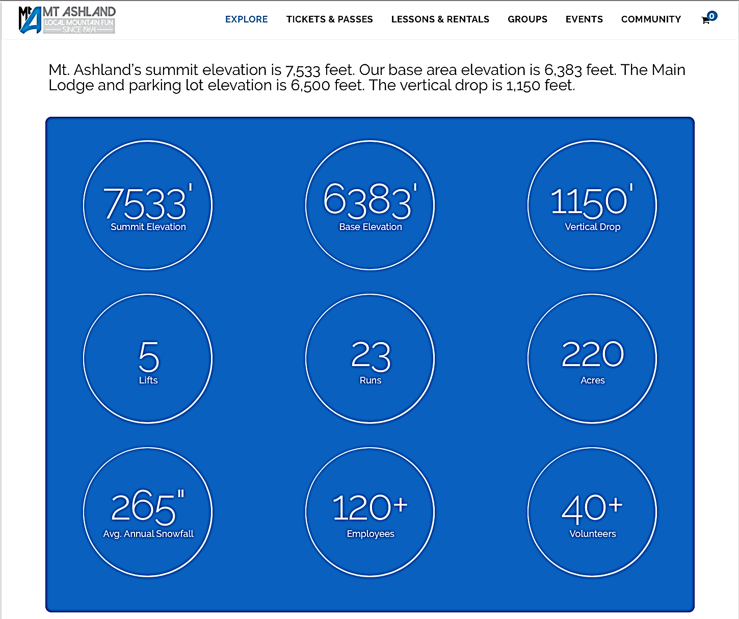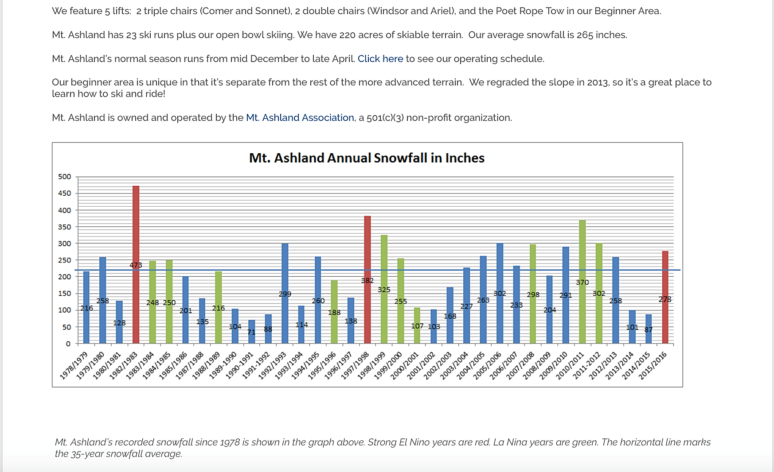



**Crater Lake National Park, Saturday, January 21, 2017**

