**Mitosis Practice**

The diagram below shows six cells in various phases of the cell cycle. Note the cells are not arranged in the order in which mitosis occurs and one of the phases of mitosis occurs twice. Use the diagram to answer questions 1-7.

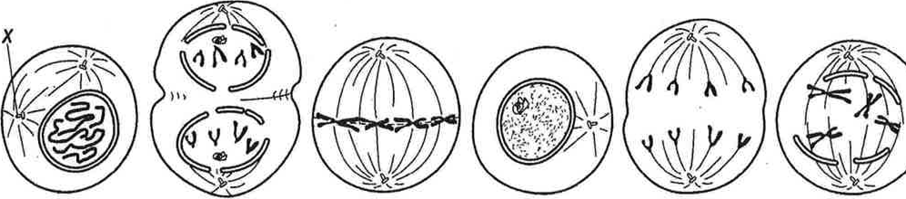

**Phases of the Cell Cycle**

**A B C D E F**

1. Which cell is in metaphase?
2. Which cell is in the first phase of mitosis?
3. In cell A, what structure is labeled X?
4. Write the letter of the diagrams in order from first to last.

1. Are the cells depicted plant or animal cells? Explain your answer.
2. What is the longest phase of the cell cycle?
3. Why is mitosis important?

Phases of Mitosis

# The following diagram shows onion cells undergoing mitosis. Each cell is numbered.

For each cell, identify the phase of mitosis and provide evidence for your answer.



Diagram courtesy of <http://www.biologycorner.com/resources/onionmitosis.jpg>

|  |  |  |
| --- | --- | --- |
| Cell # | Mitosis Phase | Evidence (How do you know?) |
| 1 |  |  |
| 2 |  |  |
| 3 |  |  |
| 4 |  |  |
| 5 |  |  |
| 6 |  |  |
| 7 |  |  |
| 8 |  |  |
| 9 |  |  |
| 10 |  |  |
| 1 1 |  |  |
| 12 |  |  |
| 13 |  |  |
| 14 |  |  |
| 15 |  |  |
| 16 |  |  |
| 17 |  |  |
| 18 |  |  |