The World of Fun Guys and Other Decomposers
What’s their niche?
Draw the Nitrogen Cycle Here.
Life Cycle of a Mushroom
FBIS: | 3 Types of Lichen
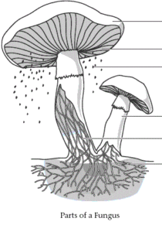

The World of Fun Guys and Other Decomposers
What’s their niche?
Draw the Nitrogen Cycle Here.
Life Cycle of a Mushroom
FBIS: | 3 Types of Lichen

