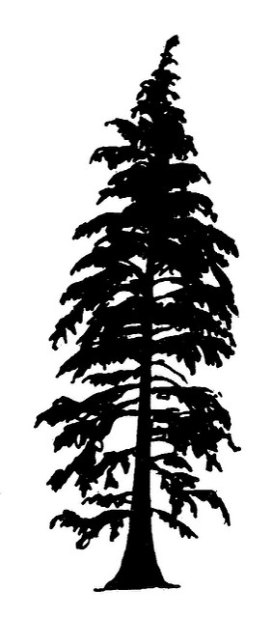
Trees of the Rogue Valley Identification Activity

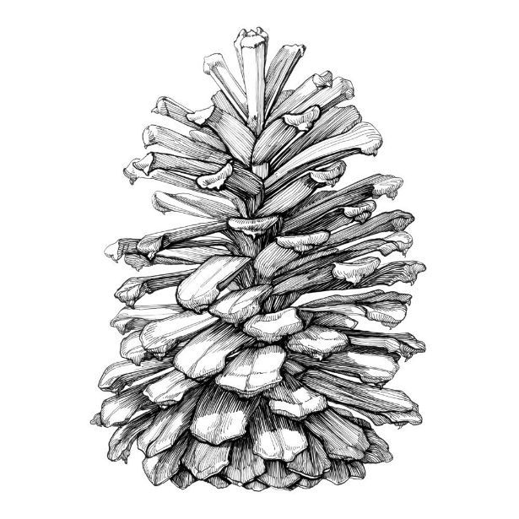
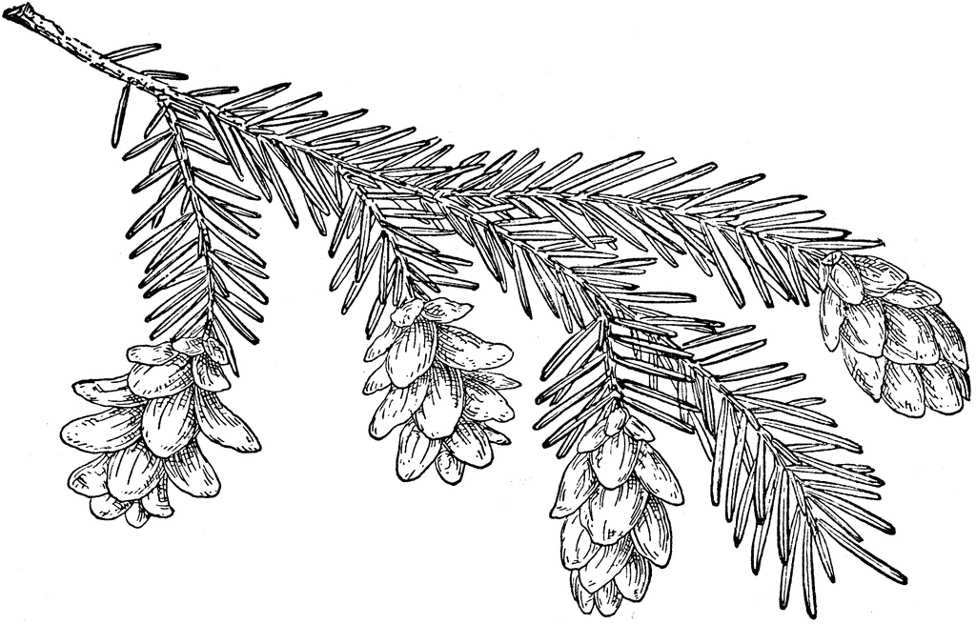

Instructions:
Using a dichotomous key, identify the most common tree species in the Rogue Valley
Specimen Number | Common Name | Scientific Name | Defining Features
 | Western Juniper |  | Bluish scaly leaves, round needles
 | Incense Cedar |  | Green scaly leaves, knobby jointed, flat; peely red bark
 | Ponderosa Pine |  | Bundles of 3; Long (bottlebrush) needles, puzzle piece bark; smell like vanilla
 | Sugar Pine |  | Bundles of 5; Dark-reddish brown bark; largest cones ever
 | Western White Pine |  | Bundles of 5; alligator bark; smaller cones
 | Douglas Fir | Pseudotsuga | Large terminal buds, green on top, 2 white lines underneath; Needles around stem attached with hockey sticks
 | White Fir |  | Widely spaced needles; longer needles, not clustered off stem, Suction cups attachment, small terminal buds
 | Red Fir |  | Mt. Ashland, Hockey stick needles; long; closely packed needles; rounded; branches look like snowflakes
 | Noble Fir |  | White on both sides of needles; Tiny groove down needle; dense needles; grows in Cascades
 | Pacific Yew |  | Needles aren’t clustered; sharp and prickly needles; droopy branches; understory; small berries that are poisonous
 | Mountain Hemlock |  | No bundles; not clustered; short needles; droopy tops
Specimen Number | Common Name | Scientific Name | Defining Features
 | Big Leaf Maple |  | Pointed lobes; palmately lobed;
 | Oregon Ash |  | Terminal leaf; compound; smooth margins; ovate; near water
 | Willow |  | Slender; smooth margins; long and skinny leaves; near water
 | Black Cottonwood |  | Ovate (triangular) shaped leaves; smooth margins; unlobed; near water;
 | White Alder |  | Unlobed; thin leaves; serrated edged; near water
 | Oregon White Oak |  | Pinnately lobed; rounded lobes; acorns
 | California Black Oak |  | Pinnately lobed; pointy lobes; acorns
 | Pacific Madrone |  | Unlobed; rounded edges; toothed edges; whitish underside; leathery; can drink from it; red with peely bark
 | Golden Chinquapin |  | Golden underside; leathery; lance-shaped leaves (similar to willows); slender

