Topic/ Objective:
Introduction to Principles of Ecology
Essential Question:
Questions: | BASIC VOCABULARY:  Ecology: the study of ______________________________ with each other and with the environment  Abiotic: Biotic:  Ex. Ex.  Levels of Organization:  - Species _________________ that can breed with one another  - Population: all the same ______________________ of the ______________________ in an area  - Community: all the difference species ____________________ (fish + zebra mussels + microorganisms)  - Ecosystem: the community plus _________________________ in an area (fish + zebra mussels + water + rope & wood + rainfall + wind)  - Ecoregion: recurring _______________________________ associated with characteristic combinations of soil and landforms that characterize that region  - Biome: large area that has a ________________________ and particular species of plants and animals that live there (rainforest)  - Biosphere: the part of the earth that ____________________  What is the difference between a habitat and a niche?  Things All Organisms Need to Survive  F  W  A  R  P  S  ENERGY FLOW:  Autotrophs (producers): capture energy from ___________________ and convert it into ___________  Heterotrophs (consumers): must ___________________________  Herbivores:  Ex.  Carnivores:  Ex.  Omnivores:  Ex.  Detritivores/ Decomposers:  Ex.  Draw an example of a food web in a lake ecosystem using the following organisms and show the flow of energy with arrows.  Grass, frog, squirrel, fish, fox, coyote, spoted owl, snake, berries, mushroom
Questions: | FOOD CHAINS/FOOD WEBS:  Trophic Levels:  Producer---> Primary Consumer ---> Secondary Consumer --->  Tertiary Consumer  ECOLOGICAL PYRAMIDS  Energy Pyramid: shows how much is produced at each level  When energy is transferred to the next trophic level, typically only _______% of it is used to build new biomass, becoming stored energy (the rest if going to metabolic processes).  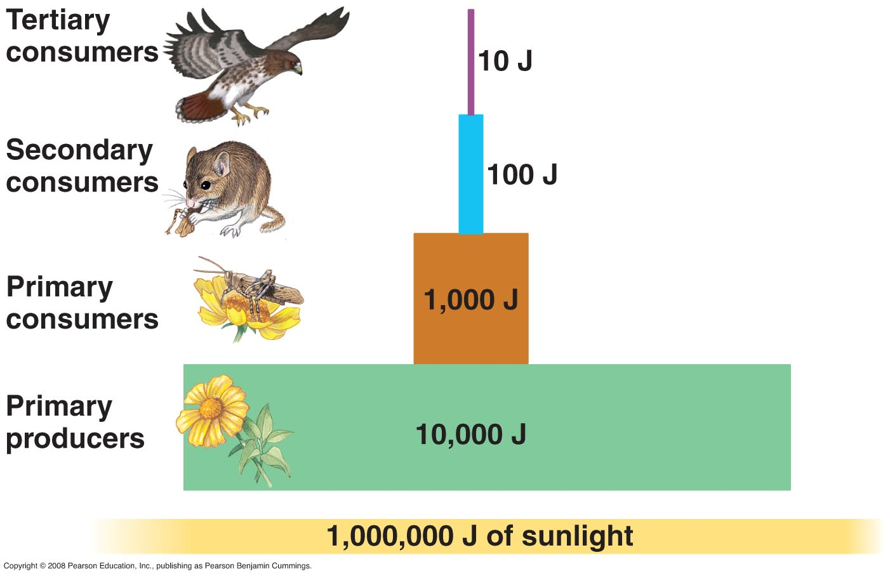  Biomagnification: Increasing ______________________ of a substance such as a toxic chemical, in the tissues of organisms at successively higher levels in a food chain.  Write the story of the Bald Eagle.

