LAB HANDOUT: Cell Cycle Inquiry Lab
Guiding Question (GQ): Do plant and animal cells spend the same proportion (amount) of time in each state of the cell cycle?

Introduction
The cell cycle is an important process, and we need to understand it to appreciate how animals and plants are able to grow, heal, and reproduce. The figure below provides pictures of plant and animal cells in various stages of the cell cycle.

The cell cycle of (a) plant cells and (b) animal cells
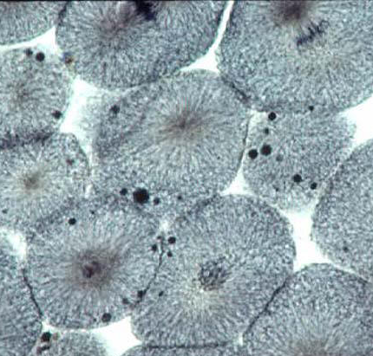
(a) (b)
The picture of the plant cells was taken from the tip of an onion root. The roots of plants are good for studying the cell cycle because they are constantly growing and, as a result, many of the cells in the tip of the root are in the process of dividing. To create the picture in the figure (a) above, a very thin slice of onion root was placed onto a microscope slide. The root was then stained with a dye that made the chromosomes visible. Whitefish blastulae are also provide examples of rapid cell division because the organism is growing very quickly. These photos provide us with a clear view of the various stages of the cell cycle, yet this information tells us little about how long a cell spends in each stage and if the amount of time in each stage is different for plants and animals.
To figure out how long cells spend in each stage of the cell cycle, we need to look at the proportion of cells in a given area that are in each phase. From this information you can then determine the relative amount of time a cell spends in each stage. The portion of cells in each phase should correspond closely with the amount of time spent by each cell in each phase.

Materials available for this lab:
- Prepared slide of an onion root tip
- Prepared slide of a whitefish blastula
- Microscope

Getting Started:
To answer the guiding question, you will need to design and conduct an investigation. You will have slides that you can use to see the cells in the tip of an onion root and in a whitefish blastula. Both slides will have cells in various stages of the cell cycle. To accomplish this task, you must determine what type of data you will need to collect, how you will collect it, and how you analyze it.

You must submit an investigation proposal to me (on the opposite page) before you may begin your lab.
Use these questions to fill out your Investigation Proposal.

To determine what type of data you will need to collect, think about the following questions:
- What type of measurements or observations will you need to record during your investigation?
- How will you record any differences or similarities you observe in the different cells?
To determine how you will collect your data, think about the following questions:
- How will you determine how many cells are in each stage on each slide (i.e. how many cells are in interphase, how many cells are in metaphase, and so on)?
- How will you make sure that your data is high quality (not full of errors)?
- How will you keep track of the data you collect and how will you organize the data?
To determine how you will analyze your data, think about the following questions:
- What type of calculations will you need to make?
(Hint: You will need to determine the number of cells in each stage and the total number of cells you counted and use those numbers to predict how much time a dividing cell spends in each phase.)
- What type of graph could you create to help make sense of your data?

