Observing Homeostasis in Goldfish

INTRODUCTION
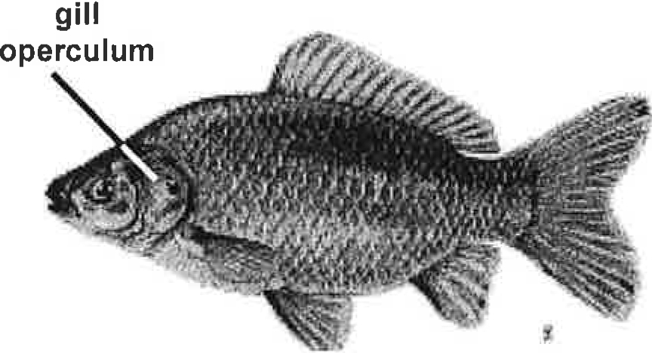
Homeostasis is the ability of a body to maintain equilibrium within its internal environment when dealing with external changes. The main function of homeostasis is to keep all the processes of the body stable, even if there are variations in the weather or the outside environment. Regulation of internal temperature is one of the most important aspects of homeostasis. Humans, as warm-blooded (or endothermic) animals, have many strategies and systems to regulate our internal body temperature. Fish and reptiles, as cold-blooded (or ectothermic) organisms, lack these internal systems to regulate their body temperature, and rely on external sources, like the sun or a heating lamp, to ensure their bodies can still function (digesting food, breathing, excreting waste, etc.)

Any change in the internal body temperature of Goldfish, Carassius auratus, can be easily observed by counting the number of times the goldfish breathes per minute. We can observe this by counting how many times the gill cover (or operculum) opens and closes. The operculum opens and closes as water (containing oxygen) passes over the gills. When the metabolic rate (temperature) increases, the animal uses more oxygen and the operculum can be seen to open and close more frequently.

Pre-lab questions:
1. Using one of the following sentence frames, paraphrase in your own words the definition of homeostasis.
____________ is characterized by ____________.
____________ is defined as ________________.
_________________________________________________________________________________________________________________________________________________________________________________________________________________________________________________________
2. Compare and contrast the similarities and difference(s) between endotherms and ectotherms in how they maintain homeostasis using one of the following sentence frames.
Both ___ and ___ need to/ have to _____. However they differ because _____.
While ___ and ___ respond differently to ____, they are similar because ______.
The most noticeable/notable difference between ___ and ___ is that ____, whereas ____.
_______________________________________________________________________________________________________________________________________________________________________________________________________________________________________________________________________________________________________________________________________________________________________________________________________________________________
Observing Homeostasis in Goldfish

INTRODUCTION
Homeostasis is the ability of a body to maintain equilibrium within its internal environment when dealing with external changes. The main function of homeostasis is to keep all the processes of the body stable, even if there are variations in the weather or the outside environment. Regulation of internal temperature is one of the most important aspects of homeostasis. Humans, as warm-blooded (or endothermic) animals, have many strategies and systems to regulate our internal body temperature. Fish and reptiles, as cold-blooded (or ectothermic) organisms, lack these internal systems to regulate their body temperature, and rely on external sources, like the sun or a heating lamp, to ensure their bodies can still function (digesting food, breathing, excreting waste, etc.)

Any change in the internal body temperature of Goldfish, Carassius auratus, can be easily observed by counting the number of times the goldfish breathes per minute. We can observe this by counting how many times the gill cover (or operculum) opens and closes. The operculum opens and closes as water (containing oxygen) passes over the gills. When the metabolic rate (temperature) increases, the animal uses more oxygen and the operculum can be seen to open and close more frequently.

Pre-lab questions:
1. Using one of the following sentence frames, paraphrase in your own words the definition of homeostasis.
____________ is characterized by ____________.
____________ is defined as ________________.
_________________________________________________________________________________________________________________________________________________________________________________________________________________________________________________________
2. Compare and contrast the similarities and difference(s) between endotherms and ectotherms in how they maintain homeostasis using one of the following sentence frames.
Both ___ and ___ need to/ have to _____. However they differ because _____.
While ___ and ___ respond differently to ____, they are similar because ______.
The most noticeable/notable difference between ___ and ___ is that ____, whereas ____.
_________________________________________________________________________________________________________________________________________________________________________________________________________________________________________________________________________________________________________________________________________________________________________________________________________________________________________

