GATTACA Journal Questions
- After watching the entire movie, what was your reaction? _____________________________________________________________________________________________________________________________________________________________________
- Do you agree or disagree with the idea that genetically altered humans are better or “more fit” than naturally created humans? Why or why not? ____________________________________________________________________________________________________________________________________________________________________________________________________________________________
- What is your idea of the “ideal” or “perfect” human being? ____________________________________________________________________________________________________________________________________________________________________________________________________________________________
- Recently, Dr. Stephen Marquardt, a plastic surgeon in California, developed the Marquardt Beauty Mask using the Golden Ratio and mathematical shapes like pentagons and decagons. He uses this to define what beauty is for all genders, races, cultures and eras.
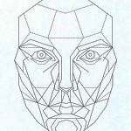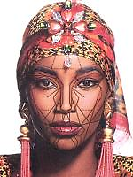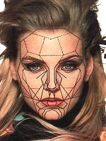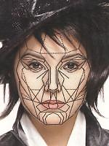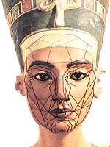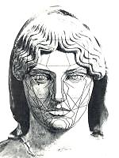
Mask Black Caucasian Asian 1350 B.C. Egypt 500B.C. Greece
Do you think beauty can be shown mathematically or is beauty in the eye of the beholder? Why or why not? _______________________________________
______________________________________________________________________________________________________________________
GATTACA Journal Questions
- After watching the entire movie, what was your reaction? _____________________________________________________________________________________________________________________________________________________________________
- Do you agree or disagree with the idea that genetically altered humans are better or “more fit” than naturally created humans? Why or why not? ____________________________________________________________________________________________________________________________________________________________________________________________________________________________
- What is your idea of the “ideal” or “perfect” human being? ____________________________________________________________________________________________________________________________________________________________________________________________________________________________
- Recently, Dr. Stephen Marquardt, a plastic surgeon in California, developed the Marquardt Beauty Mask using the Golden Ratio and mathematical shapes like pentagons and decagons. He uses this to define what beauty is for all genders, races, cultures and eras.
Mask Black Caucasian Asian 1350 B.C. Egypt 500B.C. Greece
Do you think beauty can be shown mathematically or is beauty in the eye of the beholder? Why or why not? _______________________________________
______________________________________________________________________________________________________________________

