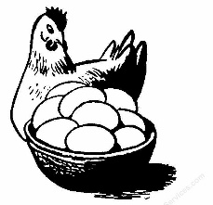
Egg Osmosis Inquiry Lab

Essential Question: How do different solutions affect egg cells?
Habits of Mind: Curiosity and Proof, Evidence, & Argumentation
Introduction:
In all cells, survival depends on the ability to maintain homeostasis by regulating the movement of molecules across the cell membrane. In osmosis, water molecules diffuse (move) across a semi-permeable membrane toward a solution with high concentration of solutes (low concentration of water). For example, if human red blood cells (RBCs) are placed in water instead of blood plasma, water will enter the RBC until they swell, burst and die (known as “cytolysis”). If RBCs are placed in a solution with a high concentration of solutes compared to the RBC, water will diffuse out of the cell through the cell membrane into the solution. The RBC will shrink or “plasmolyze."
Biologists often use three terms to describe the relationship between the cell and its environment: hypertonic, hypotonic and isotonic. Cells in hypertonic solutions have a HIGHER concentration of solutes OUTSIDE the cell than inside causing water to move out of the cell. Cells in hypotonic solutions have LOWER concentrations of solutes outside the cell than inside, causing water to move into the cell. Cells in isotonic solutions have equal concentrations of solutes (dissolved substances in a solution) and water inside and outside of the cell. Therefore, water diffuses back and forth, and the cell stays the same size.
In this lab, we will be studying eggs with dissolved shells as a model for a living cell membrane. We will learn about the effects of hypertonic and hypotonic solutions with these eggs.

Answer the following questions with information from above:
- What are hypertonic solutions?
_______________________________________________________________________________________________________________________________________________________________________________________
- What are hypotonic solutions?
_______________________________________________________________________________________________________________________________________________________________________________________
- What are isotonic solutions? _______________________________________________________________________________________________________________________________________________________________________________________
Egg Osmosis Inquiry Lab

Essential Question: How do different solutions affect egg cells?
Habits of Mind: Curiosity and Proof, Evidence, & Argumentation
Introduction:
In all cells, survival depends on the ability to maintain homeostasis by regulating the movement of molecules across the cell membrane. In osmosis, water molecules diffuse (move) across a semi-permeable membrane toward a solution with high concentration of solutes (low concentration of water). For example, if human red blood cells (RBCs) are placed in water instead of blood plasma, water will enter the RBC until they swell, burst and die (known as “cytolysis”). If RBCs are placed in a solution with a high concentration of solutes compared to the RBC, water will diffuse out of the cell through the cell membrane into the solution. The RBC will shrink or “plasmolyze."
Biologists often use three terms to describe the relationship between the cell and its environment: hypertonic, hypotonic and isotonic. Cells in hypertonic solutions have a HIGHER concentration of solutes OUTSIDE the cell than inside causing water to move out of the cell. Cells in hypotonic solutions have LOWER concentrations of solutes outside the cell than inside, causing water to move into the cell. Cells in isotonic solutions have equal concentrations of solutes (dissolved substances in a solution) and water inside and outside of the cell. Therefore, water diffuses back and forth, and the cell stays the same size.
In this lab, we will be studying eggs with dissolved shells as a model for a living cell membrane. We will learn about the effects of hypertonic and hypotonic solutions with these eggs.

Answer the following questions with information from above:
- What are hypertonic solutions?
_______________________________________________________________________________________________________________________________________________________________________________________
- What are hypotonic solutions?
_______________________________________________________________________________________________________________________________________________________________________________________
- What are isotonic solutions? _______________________________________________________________________________________________________________________________________________________________________________________
Materials:
- Triple Beam Balance
- 3 cups
- 3 eggs (with dissolved shells)
- 3 different solutions
  - Solutions available to you will be:
    - Water
    - Salt water
    - Corn syrup
    - Vinegar
  - You may bring in another solution of your choice if you would like to see what happens to an egg when placed in said solution. For example, you could use an energy drink, soda, sugar water, etc.
Procedures:
Day One: Wednesday/Thursday
- Decide what three solutions you would like to use. You must determine which solutions will be hypertonic, hypotonic, and isotonic. Record the three solutions you would like to use on your data sheet.
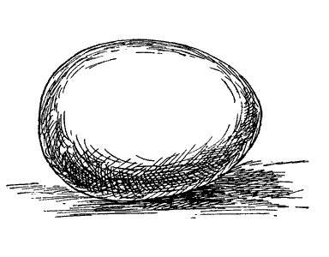
- CAREFULLY wash the vinegar and remaining shell off the three eggs.
- Weigh each egg and record your results on your data sheet.
- Place three eggs into three different cups labeled with your:
  - NAME(S)
  - PERIOD NUMBER
  - SOLUTION (water, corn syrup, salt water, etc.)
- Submerge (completely cover) each egg with the correct solution and set aside for 24-48 hours.
- TAKE A PHOTO: In addition to weighing each egg, take a picture of each egg for “before and after” shots that will eventually go in your lab report.
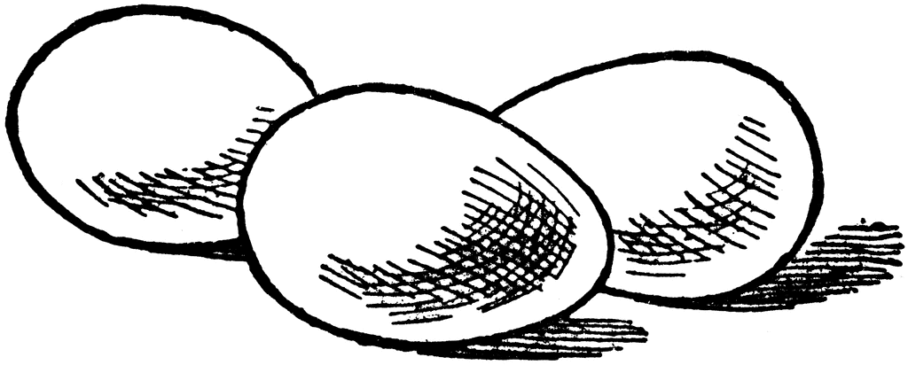
Day Two: Friday
- Carefully remove the eggs, rinse carefully, and pat dry.
- Notice the appearance and firmness of each egg.
- TAKE A PHOTO: Take a photo of your egg in the solution (or out of the solution) that will eventually be posted in your final lab report.
- Weigh the eggs and record your data and observations.
- Completely clean all cups and scale, then discard the eggs in the proper trashcan.

FINAL Essential Assignment Product:
- Smore Flyer “lab report” including before and after photos of your eggs.
Materials:
- Triple Beam Balance
- 3 cups
- 3 eggs (with dissolved shells)
- 3 different solutions
  - Solutions available to you will be:
    - Water
    - Salt water
    - Corn syrup
    - Vinegar
  - You may bring in another solution of your choice if you would like to see what happens to an egg when placed in said solution. For example, you could use an energy drink, soda, sugar water, etc.
Procedures:
Day One: Wednesday/Thursday
- Decide what three solutions you would like to use. You must determine which solutions will be hypertonic, hypotonic, and isotonic. Record the three solutions you would like to use on your data sheet.
- CAREFULLY wash the vinegar and remaining shell off the three eggs.
- Weigh each egg and record your results on your data sheet.
- Place three eggs into three different cups labeled with your:
  - NAME(S)
  - PERIOD NUMBER
  - SOLUTION (water, corn syrup, salt water, etc.)
- Submerge (completely cover) each egg with the correct solution and set aside for 24-48 hours.
- TAKE A PHOTO: In addition to weighing each egg, take a picture of each egg for “before and after” shots that will eventually go in your lab report.
Day Two: Friday
- Carefully remove the eggs, rinse carefully, and pat dry.
- Notice the appearance and firmness of each egg.
- TAKE A PHOTO: Take a photo of your egg in the solution (or out of the solution) that will eventually be posted in your final lab report.
- Weigh the eggs and record your data and observations.
- Completely clean all cups and scale, then discard the eggs in the proper trashcan.

FINAL Essential Assignment Product:
- Smore Flyer “lab report” including before and after photos of your eggs.

