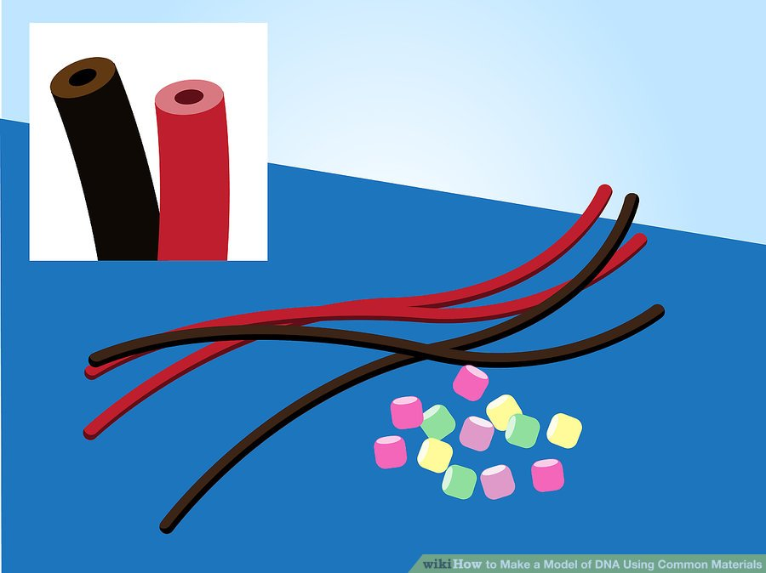
1
Select your candy. To make the sugar and phosphate sides, use strands of black and red licorice that have a hollow center. For the nitrogenous bases, use four different colored gummy bear candies.
- Whatever candy you use, make sure that it is soft enough to allow a toothpick to puncture it.
- If you have them on hand, colored marshmallows are a great substitute for gummy bears.
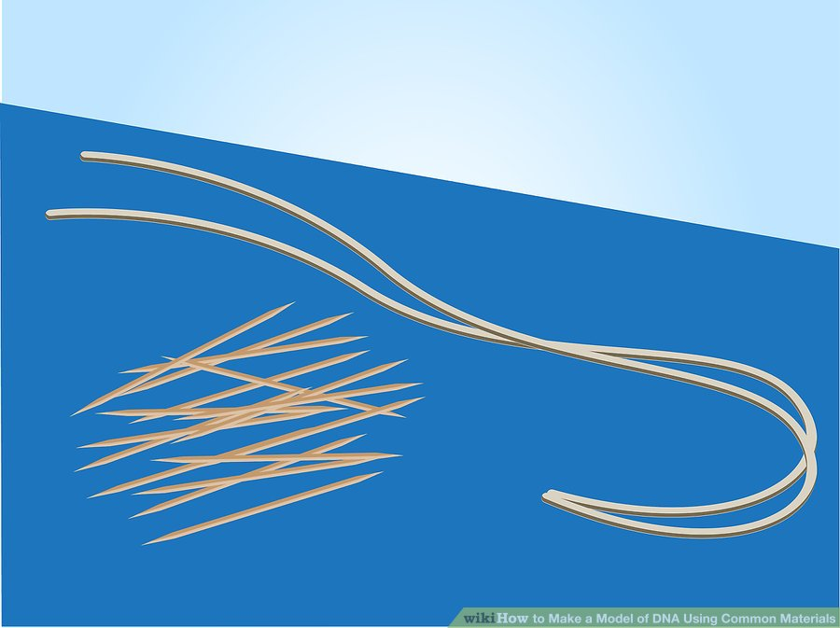
2
Prepare your other supplies. Gather string and toothpicks to be used in creating the model. The string should be cut to be about a foot long, although you can make it longer or shorter based on your preferred size of DNA model.
- Use two pieces of string that are the same length to make the double helix.
- Make sure you have at least a dozen toothpicks, although you may need a few more or less depending on how large you make your model
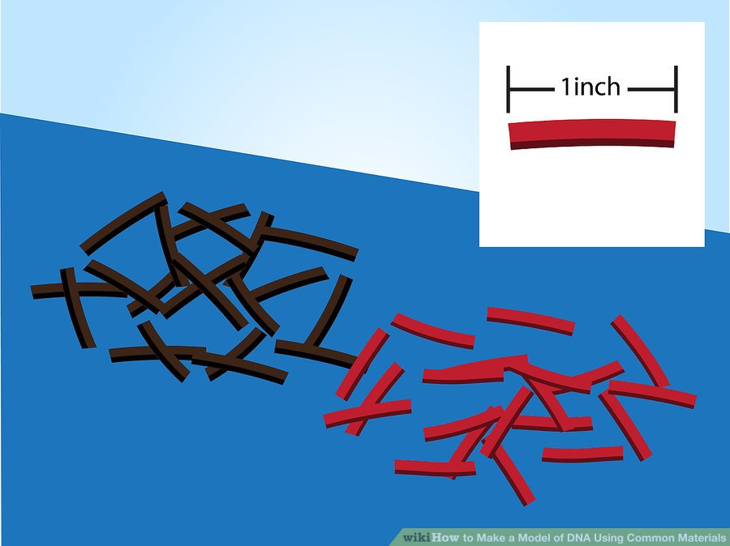
3
Cut the licorice. These will be strung on your string in alternating colors, and should be cut to be one inch long.
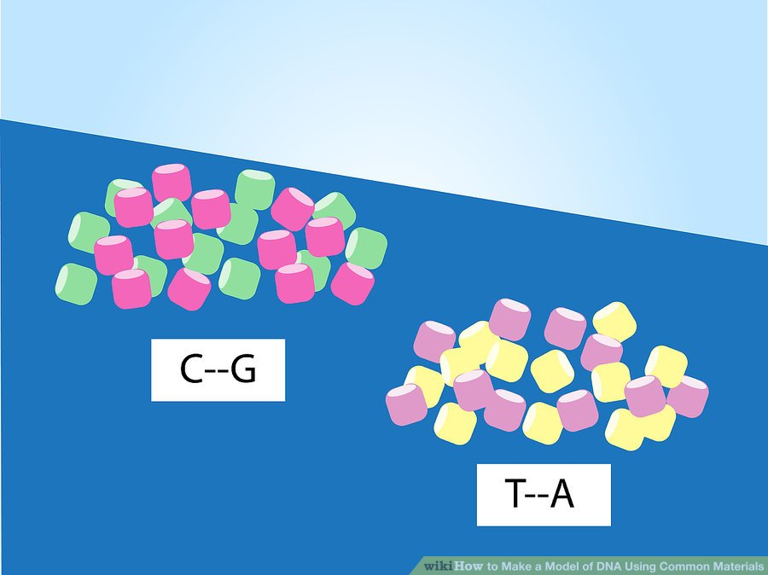
4
Pair off your gummy bears. In a DNA strand, pairs of cytosine and guanine (C and G) are paired together, while pairs of thymine and adenine (T and A) are paired together. Choose four different colored gummy bears to represent these nitrogenous bases.
- It doesn’t matter if a pair goes C--G or G--C, as long as those are always the two in a pair.
- You cannot mix colors between pairs. For example, you cannot combine T--G or A--C.
- The colors you choose are completely arbitrary and are entirely based on personal preference.
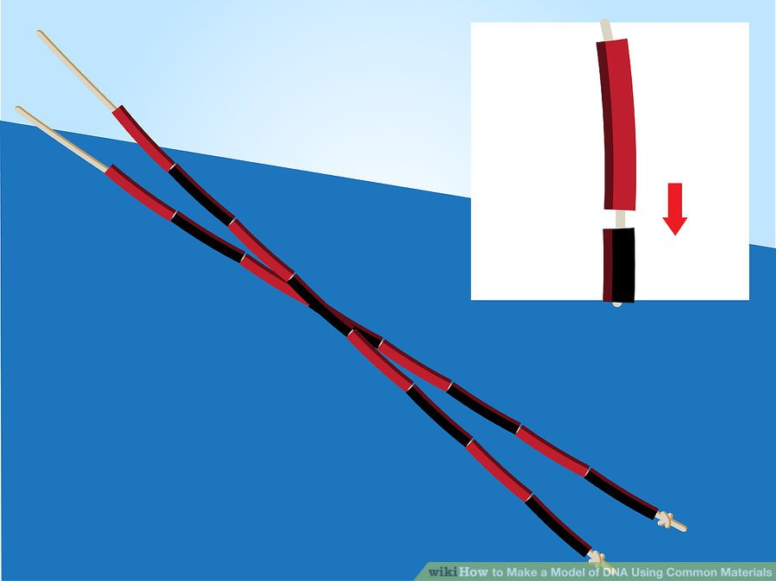
5
String your licorice. Take the two pieces of string and tie a knot in the bottom of each to prevent the licorice from slipping off. Then, thread the string through the hollow centers of the licorice in alternating colors.
- The two colors of licorice symbolize the sugar and phosphate that make up the double helix strands.
- Choose one color to be the sugar group; your gummy bear nitrogenous bases will be attaching to this color of licorice.
- Make sure that your two strands have licorice in the same order, so that they line up when placed next to each other.
- Tie another knot to the other end of the string once you have finished adding all your licorice pieces.
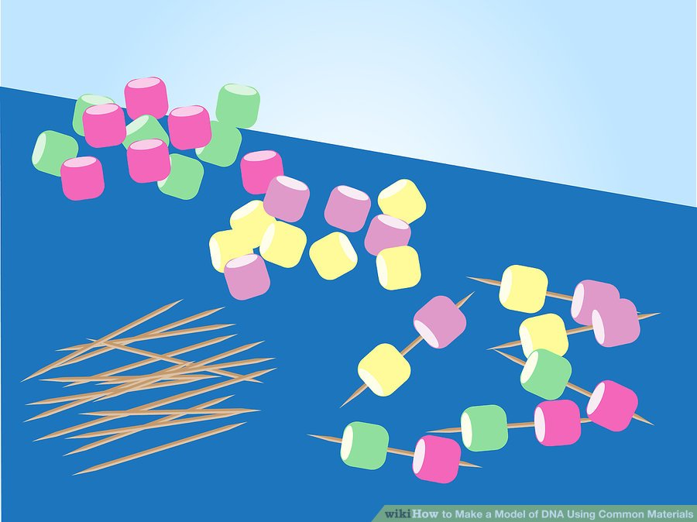
6
Attach your gummy bears with toothpicks. Once you have paired off all your gummy bears in the C--G and T--A groups, use a toothpick and stick one bear from each pair at the ends of the toothpicks.
- Push the gummy bears far enough on each toothpick that at least ¼ of an inch of the sharp end is still sticking out.
- You can have more of some pairs than others; the number of pairs in real life DNA determines differences and changes in the genes they form.
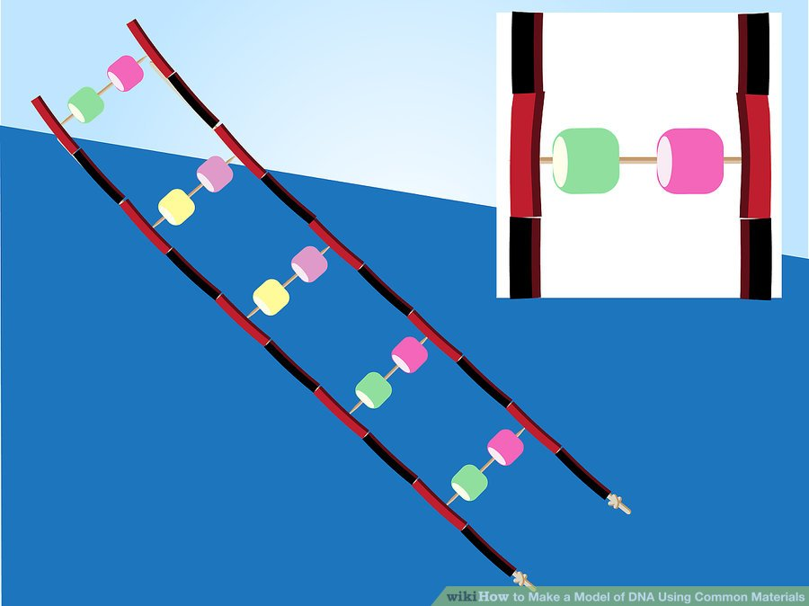
7
Attach your gummy bears to the licorice. Lay out your two licorice strands flat on a smooth surface, and then attach the gummy bear toothpicks to the licorice by inserting the sharp ends into the licorice.
- You should be attaching the toothpicks only to the “sugar” molecules that you decided on. These are all the pieces of licorice in the same color (for example, all the red pieces).
- Use all your gummy bear toothpicks, don’t worry about saving any.
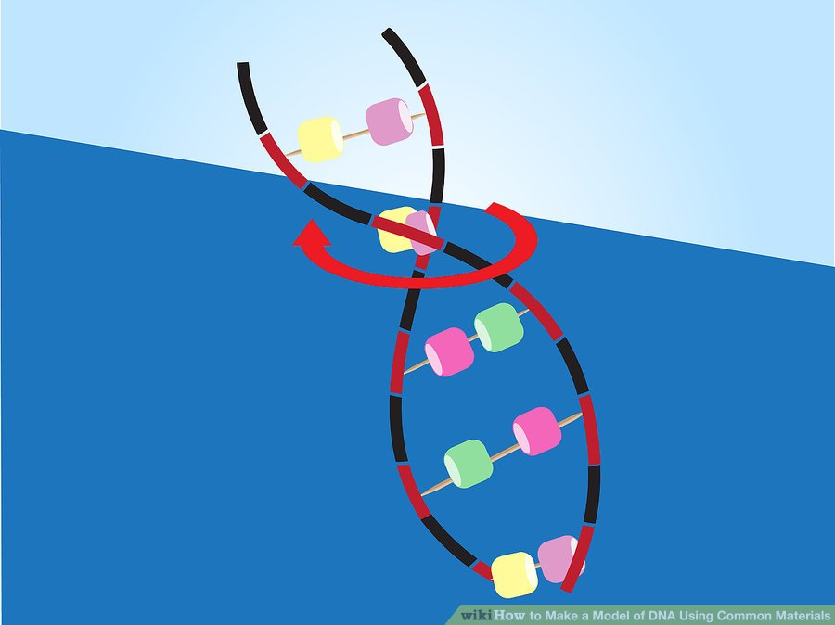
8
Twist your double helix. Once you have attached all your gummy bear toothpicks to the licorice, twist the strands in a counter-clockwise direction to give the spiral appearance of a true double helix. Enjoy your completed DNA model!

