CREATE YOUR OWN

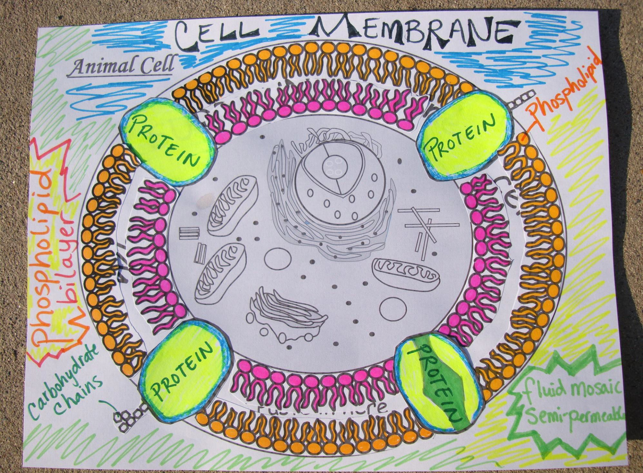

CELL MEMBRANE

Animal Cell

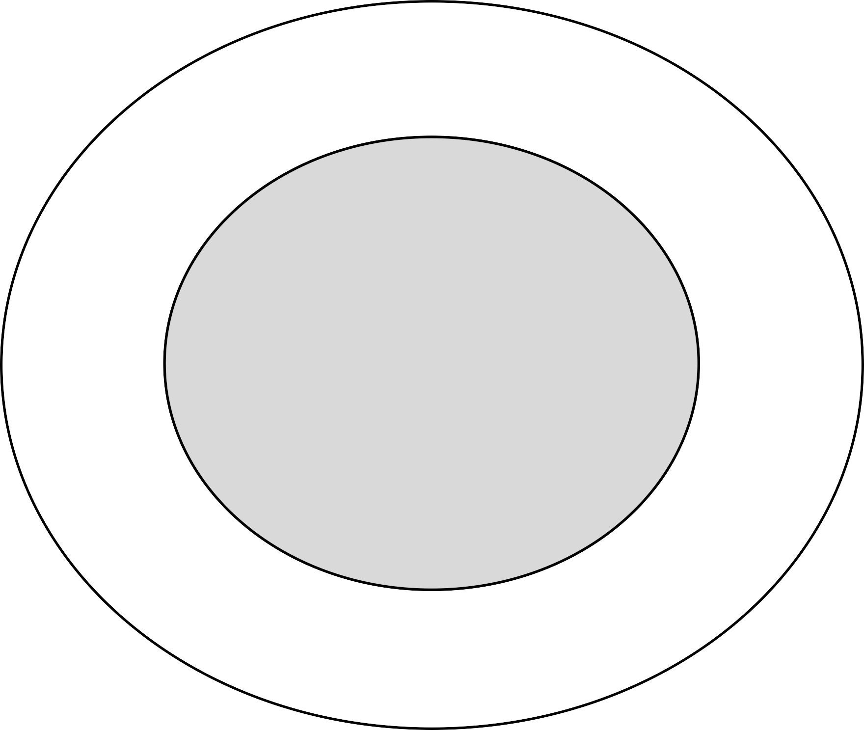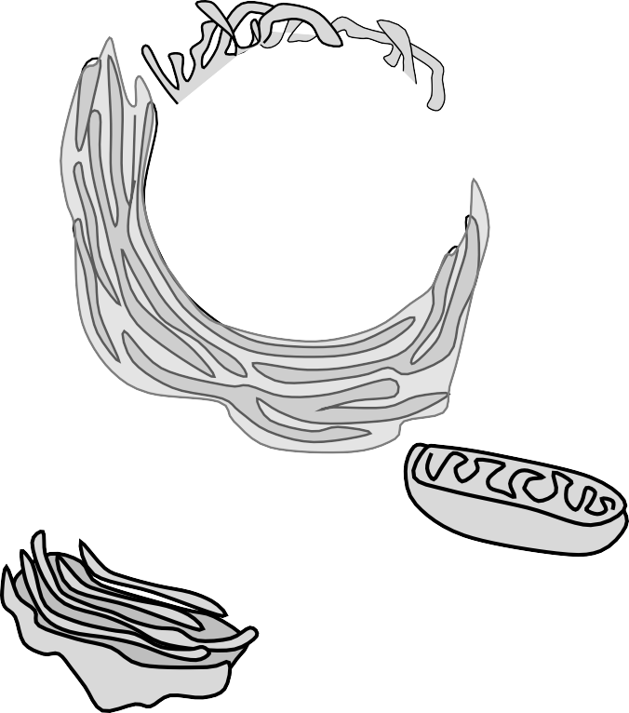

Paste in here



**Directions to Create Cell Membrane**

**Step 1**. *Color* the figures on **this page**

**Step 2**. *Cut out* **the figures** by cutting along the dotted lines

**Step 3**. *Organize the* **figures** into 4 categories:

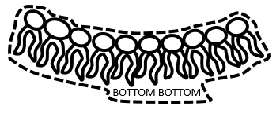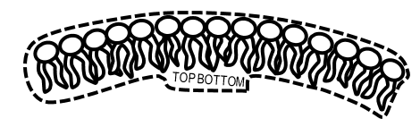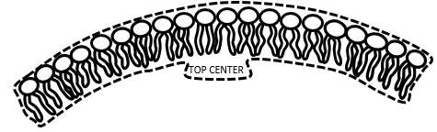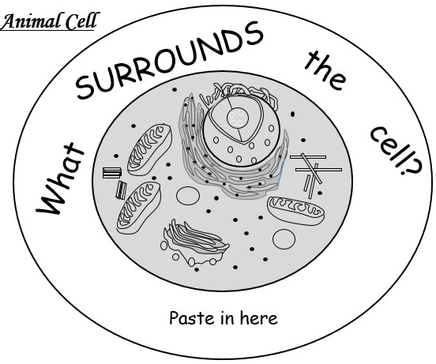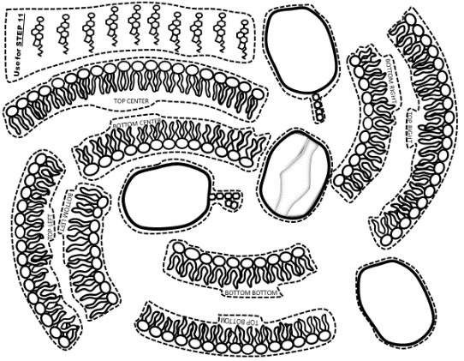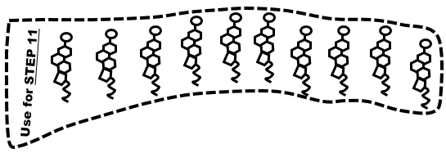

1.) the **phospholipids** that start with the word



“**BOTTOM**”

2.) the **phospholipids** that start with the word

“**TOP**”

**Step 4**. *Take the phospholipids that start with the word* ***TOP*** *and place them in the outer portion of the circle* ***BASED*** *on the second word*

For example:

This goes in the outer portion of the circle in the **CENTER**

3.) the **proteins** that have no words

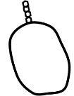

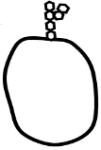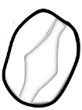

4.) the **cholesterols** that you will be using for step 11

© 2014 Katie Garcia

**Continuing Step 4**. *Take the phospholipids that start with the word* ***TOP*** *and place them in the outer portion of the circle* ***BASED*** *on the second word*

**Step 5**. *Check your work*

*Does it look like the picture below so far?*

**Step 6**. *Take the phospholipids that start with the word* ***BOTTOM*** *and place them in the outer portion of the circle* ***BASED*** *on the second word*

**Step 7**. *Check your work*

*Does it look like the picture below so far?*

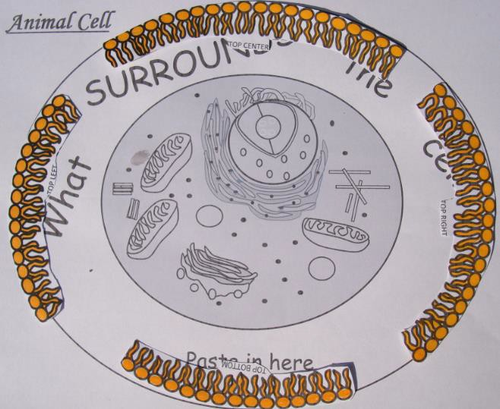



**TOP CENTER**

**TOP BOTTOM**

**TOP RIGHT**

**TOP LEFT**

© 2014 Katie Garcia

**BOTTOM CENTER**

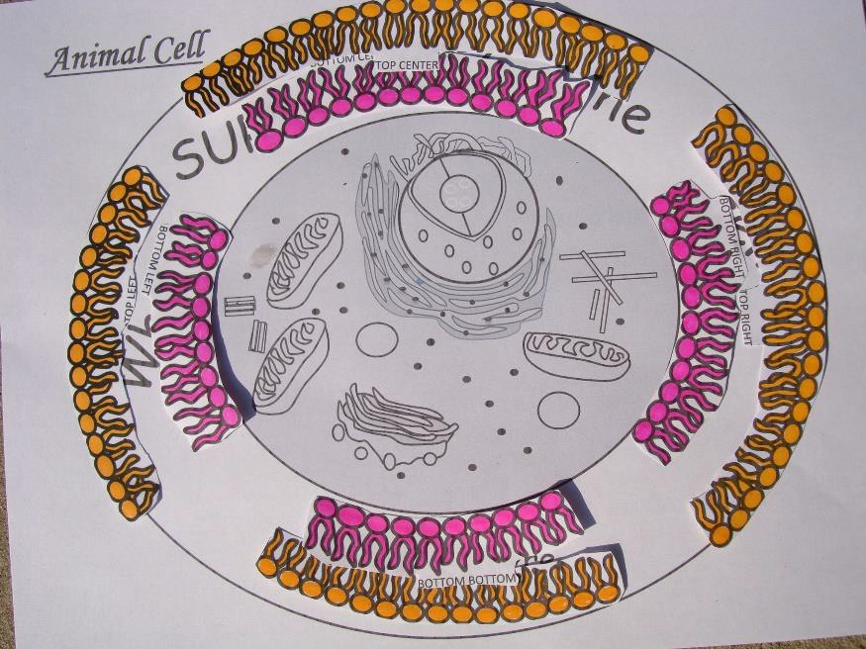**BOTTOM BOTTOM**



**BOTTOM LEFT**

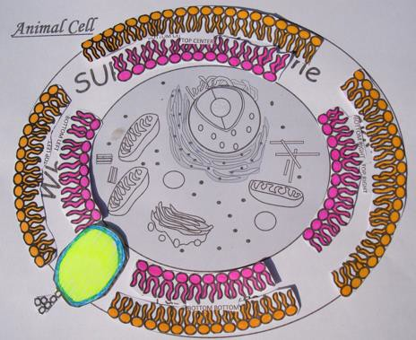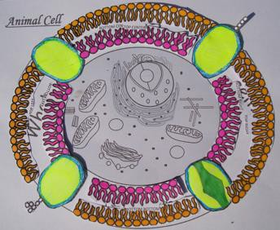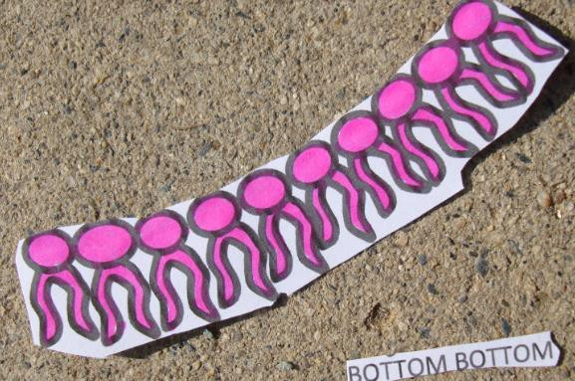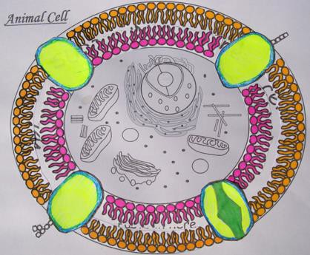

**Step 9**. If everything looks goods, **cut off the words** from your phospholipids & put them back in their position

© 2014 Katie Garcia

**Step 10**. Now **GLUE** everything down you are almost done!

**Step 11. Add *Cholesterol* Cut around each cholesterol and place it in between some of the phospholipids.**

**GLUE them!**

Now your DONE!! =)

**Step 8**. Add in your proteins!

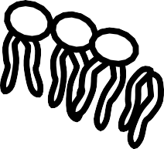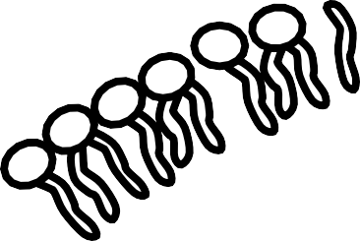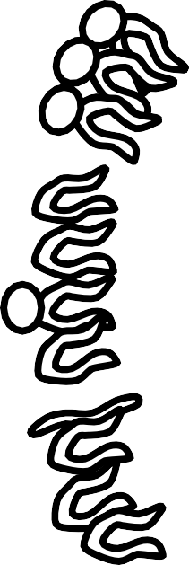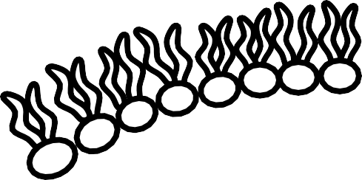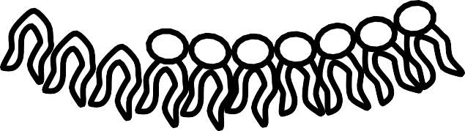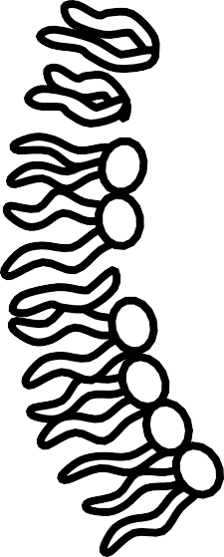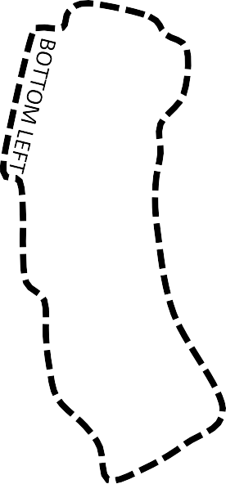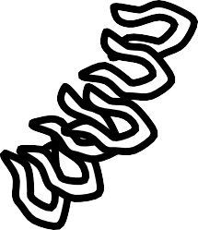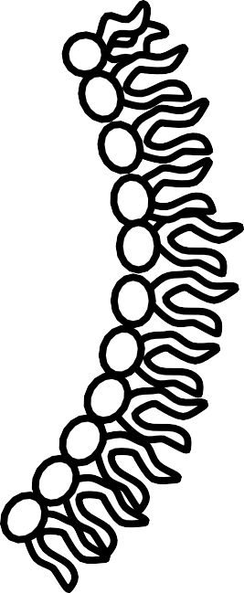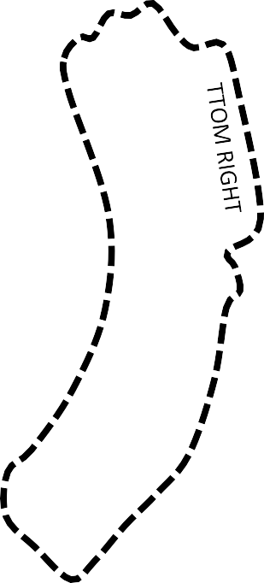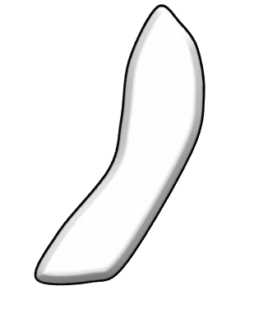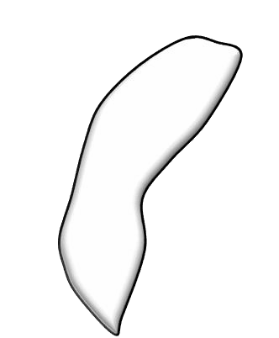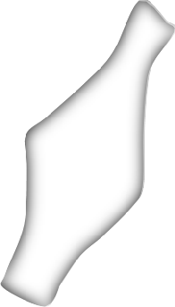

TOP RIGHT

TOP LEFT

**TOP TOP**

BOTTOM CENTER



TOP RIGHT

TOP LEFT

**TOP TOP**

BOTTOM CENTER



# Animal Cell

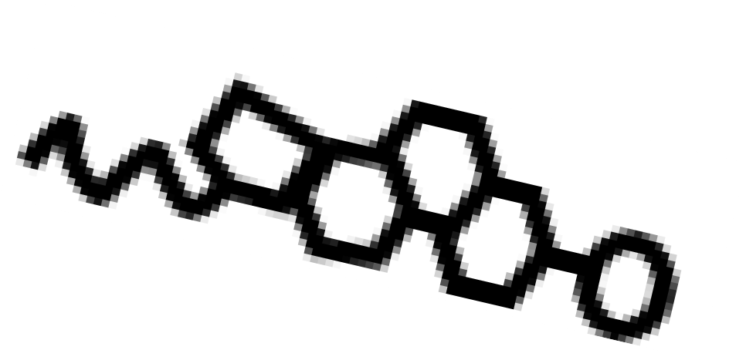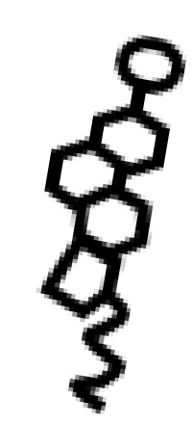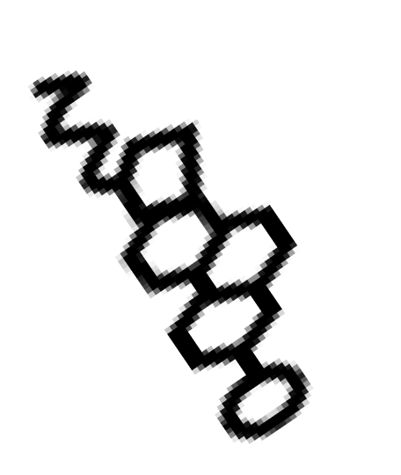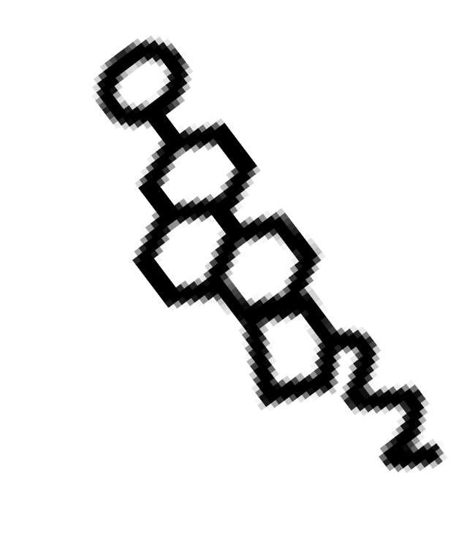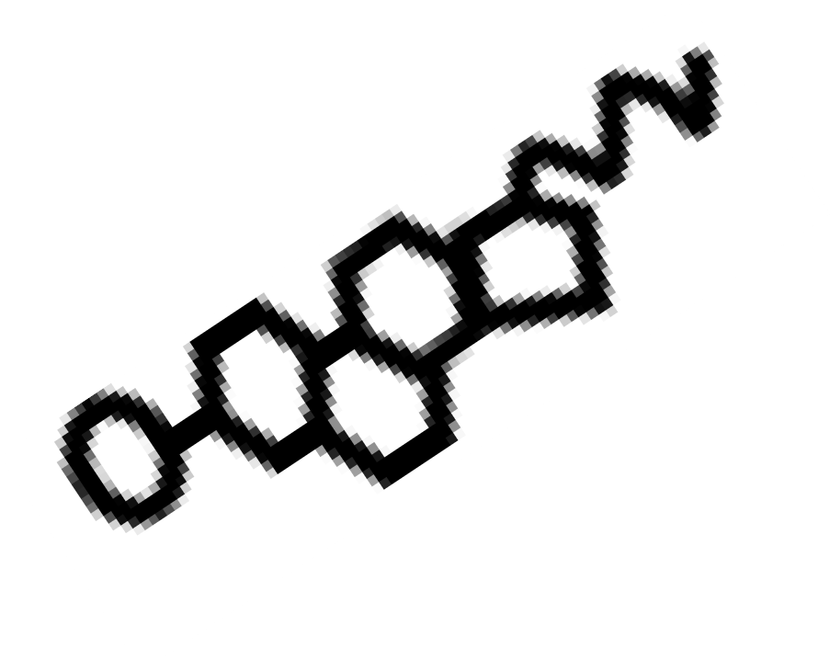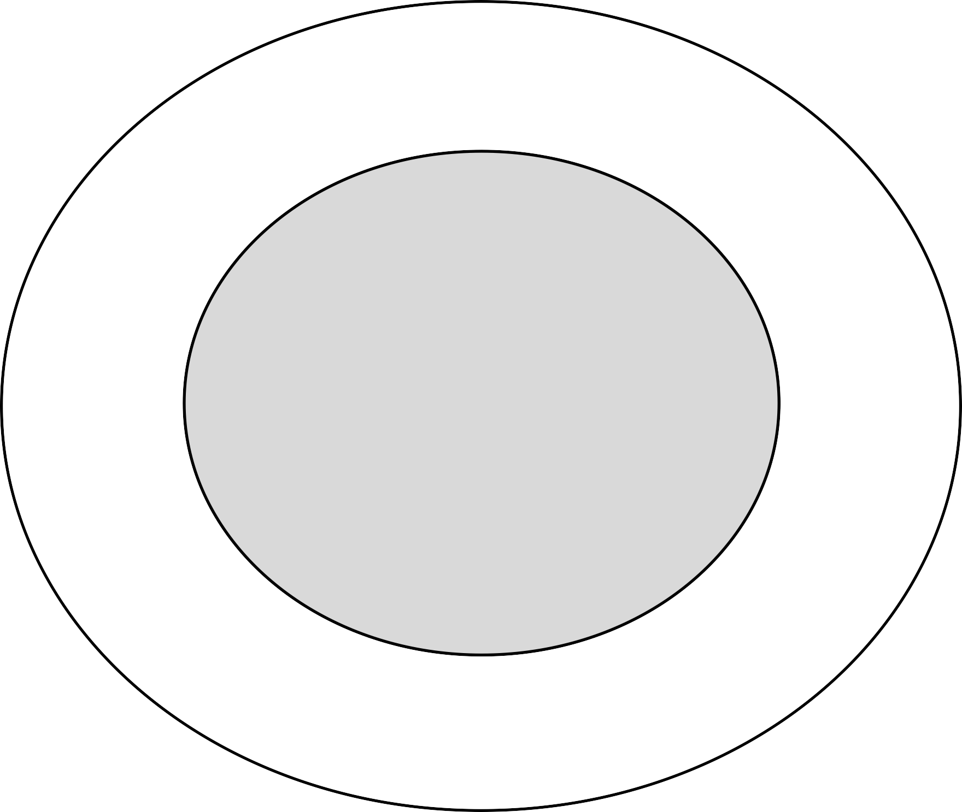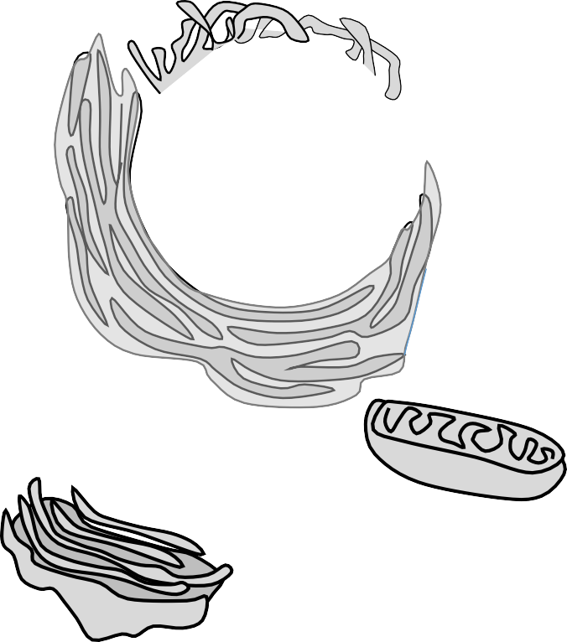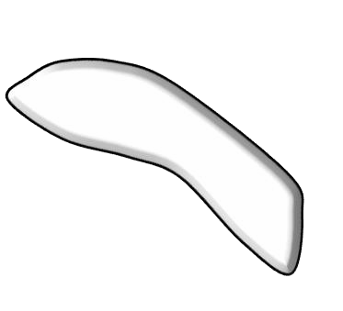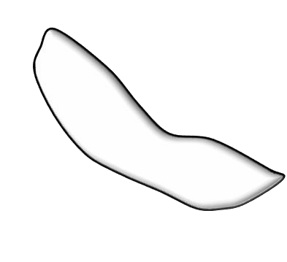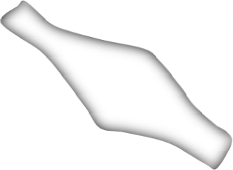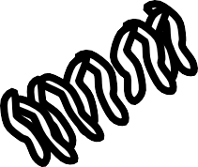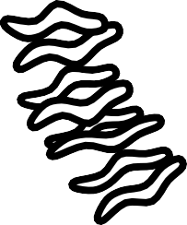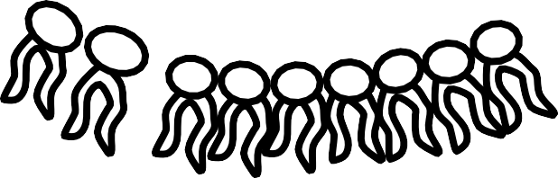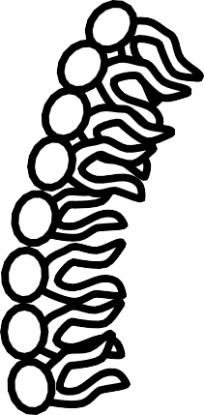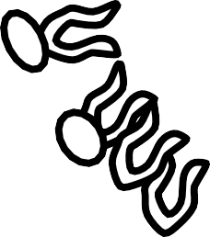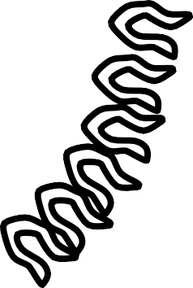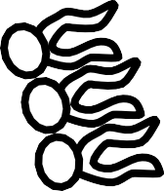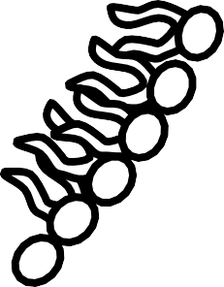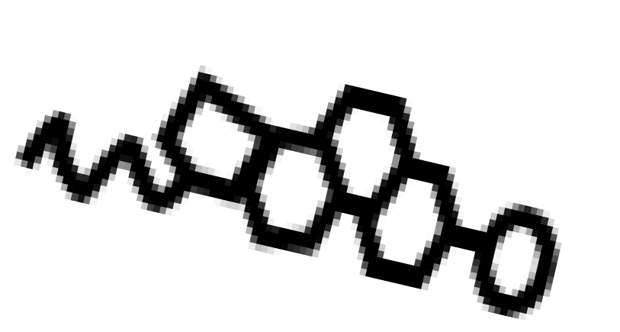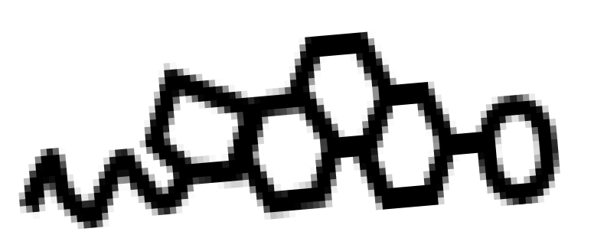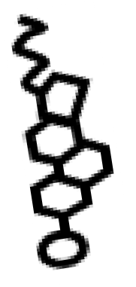

**- ANSWER KEY**

© 2014 Katie Garcia