Cellular Respiration Notes
Cellular Respiration: The breakdown, or digestion, of food to get energy from the food.
- Used by all cells to carry out life processes; Ex. Moving, breathing, reproducing cells
- This process releases the energy stored in chemical bonds in glucose (C₆H₁₂O₆)
Cellular respiration reaction:
C₆H₁₂O₆ + 6O₂ ---------------- 6CO₂ + 6H₂0 + 38 ATP
(It’s the opposite of photosynthesis!)
Photosynthesis:
6CO₂ + 6H₂0 + light energy ------------- C₆H₁₂O₆ + 6O₂
1. Glycolysis (splits glucose)
In Cytoplasm

2 Pyruvates

In mitochondrion
Without Oxygen (Anaerobic)
Fermentation
- Muscles create Lactic Acid
- Yeast/Bacteria create Ethanol alcohol
With Oxygen (Aerobic)
2. Krebs Cycle
3. Electron Transport System
In Cytoplasm

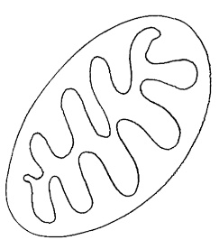
Glucose (C₆H₁₂O₆₎
34 ATP
Without Oxygen
Mitochondrion
2 ATP
2 ATP
With Oxygen
Fermentation: Ethanol or lactic acid
Glycolysis:
Glucose splits to become 2 Pyruvates
Cell membrane

