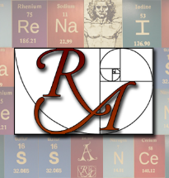 | Topic: Cell Membrane Structure  Objective:  I can describe the structure of the cell membrane. | Name:
 |  | Class/Period:
 |  | Date:
Essential Question:
What is the structure of the cell membrane?
Questions: | Cell membranes  - Robert Hook  - Saw cork cells through a microscope  - 1665 paper coined the term “cells  - Cell Theory, late 1800s  - All organisms are composed of cells  - The cell is the basic unit of structure and function in organisms  - All cells are produced by other cells  - Membrane Structure  - Lipid bilayer  - Fatty Acid Tail- Nonpolar tails  - Hydrophobic  - Photsphate group head- Polar head  - Hydrophilic  - These are called phospholipids  - Cholesterol  - Gives membrane strength  - Proteins  - Creates pores or channels to allow ions and molecules to pass through  - Different cells allow different ions/molecules through  - Some proteins act as “flags” so cells can recognize others.  - Fluid Mosaic Model  - Current model for understanding the membrane structure and function  - States that:  - Phospholipids can move freely around the bilayer  - Proteins can move around also  - This movement is like a fluid (or a bubble!)

