The Carbon Cycle Game
(Adapted by Jennifer Ceven from “The Incredible Journey,” Project Wet)

Please credit the author, Jennifer Ceven, Grade 6 Science Teacher, when using this lesson

Summary:
By rolling a die, students will simulate a molecule of carbon’s movement throughout various locations within the carbon cycle.

Objective:
- Students will describe the movement of carbon within the carbon cycle.
- Students will evaluate the relative timing of movement through various locations in the carbon cycle.

Materials:
- 7 Dice
- 7 Station Signs
- 7 Station Movement Directions
- Data record sheets for each student

Background:
The movement of carbon through various aspects of the natural environment is the focus of much scientific research. Global warming and climate change can be attributed to the increased amount of heat-trapping gases, such as carbon dioxide.
Students must develop an understanding of how carbon moves through the environment in order to appreciate the complexity of developing solutions to address problems associated with climate change. In addition, since anthropogenic influences impact how much carbon is reintroduced to the active carbon cycle, students should recognize that human actions negatively affect the environment.

Warm-Up:
- Review what carbon is (an element, the stuff of life)
- Discuss where carbon can be found on Earth.
- Discuss the role of carbon in each of the places identified.
- Review the processes that move carbon around in the carbon cycle
  - Physical processes
    - Water currents
    - Settling to the ocean floor or to the ground
  - Chemical and Biological processes
    - Respiration – Exchange of gases through breathing
    - Photosynthesis - The synthesis of complex organic materials, esp. carbohydrates, from carbon dioxide, water, and inorganic salts, using sunlight as the source of energy and with the aid of chlorophyll and associated pigments.
    - Combustion – The act or process of burning

    - Dissolving gaseous carbon dioxide into water, where it takes the form of carbonic acid
    - Coming out of solution of carbonic acid to become carbon dioxide in the air (same process that occurs when you open a soda )
    - Death and Decomposition - breakdown or decay of organic matter

The Activity:
- Tell students that they are going to be carbon atoms moving through the carbon cycle.
- Categorize the places carbon can be found into these stations: Atmosphere, Plants, Animals, Soil, Ocean, Deep Ocean, and Fossil Fuels. Point out the areas of the room that are labeled with each station and contain the directions for movement from that station.
- Assign students to each station randomly and evenly. Have students identify the different places carbon could go from that given station. Discuss the processes that allow for the transfer of carbon between stations. Students should make a line and roll the die individually to follow the directions for movement from (or retention at) each station. Remind them that they are representing atoms of carbon moving through the carbon cycle and that they should record their movements on the data sheet.
- Students will realize the routine movements (or non-movements) in the carbon cycle.
- Once the carbon atoms (students) have had a chance to roll the die ten times, have each student create a bar graph using the data they collected. The bar graph should represent the number of times the carbon atom (student) was at each station.
- Using graph paper, create a large bar graph recording the number of carbon atoms (students) at each station.

Wrap-Up and Action Plan:
- Ask a few students to tell the story of how their carbon atom moved through the cycle.
- Discuss the results – using the bar graph have the students explain where the most/least amount of carbon was in the cycle?

Assessment:
- Rate students’ understanding on their responses from class or group discussions.
- Assign a follow-up activity:
- Role-play the motion of carbon throughout the carbon cycle.
- Write a story about your carbon atom as it moved through the carbon cycle.

The Carbon Cycle
DATA RECORD SHEET
Record the places you have traveled as a carbon molecule.

Station Stop What Happens Destination

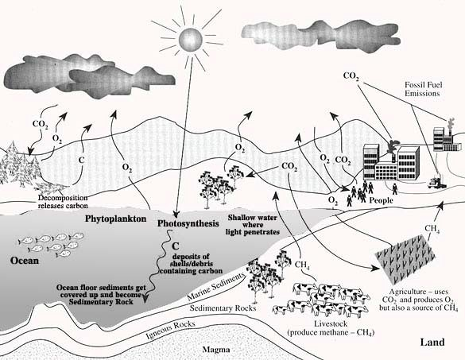
The Carbon Cycle

The Carbon Cycle
REFERENCE PAGE

Carbon Cycle Vocabulary

Reservoir: temporary holding place for carbon
Fossil fuels: coal, oil (petroleum), gas
Atmosphere: CO₂ reservoir
Ocean carbon: largest reservoir of carbon (dissolved CO₂, carbonate, bicarbonate)
Organic molecule: molecule that contain carbon
Combustion: process of burning
Photosynthesis: process by which photoautotrophs trap solar energy and use it to make sugar and O₂
Respiration: process where food molecules are broken down to produce energy and CO₂

Image Source: http://www.bigelow.org/foodweb/carbon_cycle.jpg

The Carbon Cycle
THE ATMOSPHERE

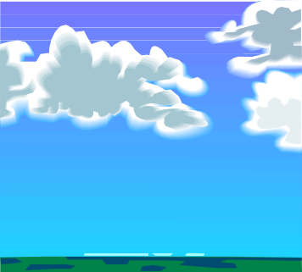

You are currently a molecule of carbon dioxide in the atmosphere.

If you roll… | Then you …
1 | Stay in the atmosphere. Much of the carbon dioxide in the atmosphere moves through the atmosphere.
2 | 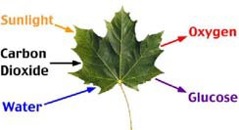  Go to plant. You are used by a plant in photosynthesis.
3 | Stay in the atmosphere. Much of the carbon dioxide in the atmosphere moves through the atmosphere.
4 | Stay in the atmosphere. Much of the carbon dioxide in the atmosphere circulates through the atmosphere.
5 | Go to surface ocean.
6 | Go to plant. You are used by a plant in photosynthesis.

The Carbon Cycle
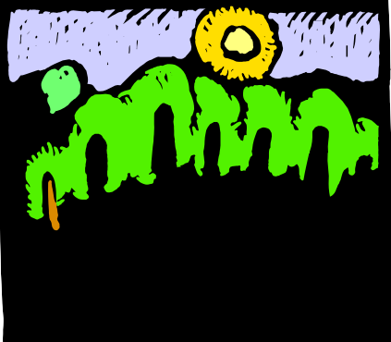PLANTS

You are currently a carbon molecule in the structure of the plant.

If you roll… | Then you …
1 | Go to soil. The tree shed its leaves.
2 | Stay in plant. You are a carbon molecule in the tree’s trunk.
3 | 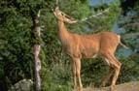  Go to animal. The leaves and berries that the plant produced contain your carbon molecule and were eaten.
4 | Stay in plant. You are a carbon molecule in the tree’s roots.
5 | Stay in plant. You are a carbon molecule in the tree’s branches.
6 | Stay in plant. You are a carbon molecule in the tree’s trunk.

The Carbon Cycle
ANIMALS

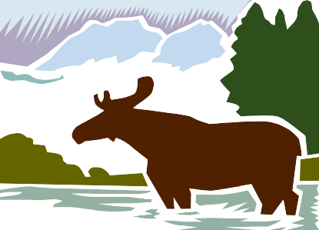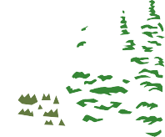

You are currently a molecule of carbon in an animal.

If you roll… | Then you …
1 | Stay in animal. The carbon molecule is stored as fat in the animal.
2 | Go to soil. The animal that consumed you died and your carbon molecule is returned to the soil.
3 | Go to atmosphere. The animal that consumed you respired (breathed) you out as carbon dioxide.
4 | Stay in animal. You are eaten by a predator.
5 | Go to atmosphere. The animal that consumed you respired (breathed) you out as carbon dioxide.
6 | Go to atmosphere. The animal that consumed you respired (breathed) you out as carbon dioxide.

The Carbon Cycle
SOIL

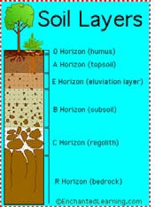
You are currently a molecule of carbon dioxide in the soil.

If you roll… | Then you …
1 | Stay in the soil. Much of the carbon in the soil is stored there.
2 | Go to plant. You are used by a plant in photosynthesis.
3 | 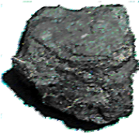  Go to fossil fuels. Your carbon molecule has been in the soil so long it turns into fossil fuels.
4 | Go to the atmosphere.
5 | Stay in the soil.
6 | 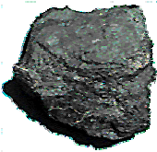  Go to fossil fuels. Your carbon molecule has been in the soil so long that it turns into fossil fuels.

The Carbon Cycle
SURFACE OCEAN

You are currently a molecule of carbon dioxide in the surface ocean.

If you roll… | Then you …
1 | Go to deep ocean.
2 | Stay in the surface ocean.
3 | Go to deep ocean. Your carbon atom was part of an ocean organism that has died and has sunk to the bottom of the ocean.
4 | Stay in the surface ocean.
5 | Go to the atmosphere.
6 | Go to the atmosphere.

The Carbon Cycle
DEEP OCEAN

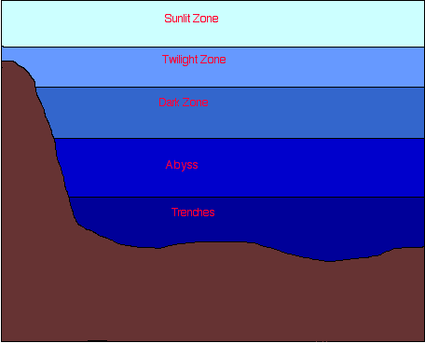
You are currently a molecule of carbon in the deep ocean.

If you roll… | Then you …
1 | Stay in the deep ocean.
2 | Stay in the deep ocean.
3 | Go to surface ocean.
4 | Go to surface ocean.
5 | Go to surface ocean.
6 | Go to animal. An organism in the water has taken you up as food in the deep ocean.

The Carbon Cycle
FOSSIL FUELS

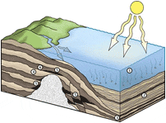
Fossil fuels are a rich source of energy that has been created from carbon that has been stored for many millions of years.

If you roll… | Then you …
1 | Stay in the fossil fuels.
2 | Stay in the fossil fuels.
3 | Stay in the fossil fuels.
4 | Stay in the fossil fuels.
5 | Go to the atmosphere. Humans have pumped the fuel that you are part of out of the ground and have used it to power their cars.
6 | Go to the atmosphere.

PROCEDURE
AP ENVIRONMENTAL SCIENCE
The Carbon Cycle Grune

- Groups should have 3 students . Each student chooses a playing piece. This playing piece represents a carbon atom. Each group needs 2 coins and a playing board. Each person requires a question sheet and a copy of the playing board. The group needs some colored pencils.

- Place your playing pieces on space #1. Flip the coins as instructed on the following pages . Flip your coins at the start of the turn following instructions as you go. Do not follow the sequence of the numbers, follow the chance moves that the coins present. Two or more players can occupy the same place. When your carbon atom is returned to the atmosphere, you have completed one cycle. Continue playing until told to stop.

- On your individual game board, use the colored pencils to keep track of your cycles with each color representing a single cycle. Label the cycles 1st, 2nd, etc. Everyone who travels through the cycle and understands the process is a winner ......BUT, for "fun"
  - Who visited the most organisms
  - Who completed the most cycles
  - who completed the longest cycle? the shortest?
  - Who spends the most time in the atmosphere?
- Have fun .... then answer the questions in your lab book. Be sure to tape this sheet in as well.

DISCUSSION QUESTIONS

- For the sake of time and space, some important pathways have been left out of the game. Note these pathways and describe how carbon atoms might enter into and cycle through these pathways. In particular, note the aquatic and fossil fuel pathways.

- In the course of the carbon cycle, are carbon atoms themselves ever created? Ever destroyed? Ever changed into other kinds of atoms? Ever changed into other compounds? Explain.

- What changes do occur in the state of carbon atoms in the course of the cycle? Describe the organic and inorganic states of carbon and the changes that occur between these states.

- Why are some carbon atoms from Carbon Dioxide not incorporated into sugar molecules in darkness? Start by answering: What is the potential energy of carbon dioxide? Of sugar? What is necessary for them to go to a higher phase'?

- Much of the food ingested into each organism is metabolized in cell respiration. Why is this so? What does the organism need and get out of this process and how does it get it?

- What happens to carbon atoms as a result of respiration?

- (SUMMARY) Why is a natural ecosystem not polluted by wastes from the various organisms? In chart form, discuss waste, from what organism and used by.

f •

CARBON CYCLE GAME BOARD

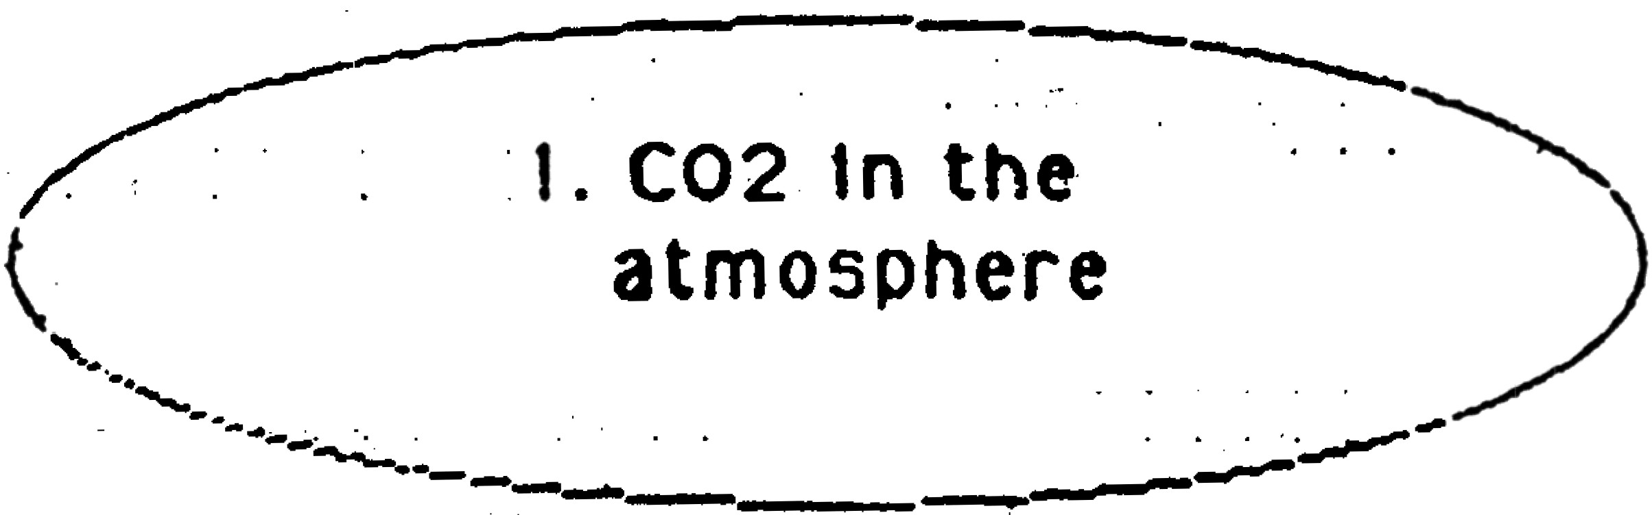

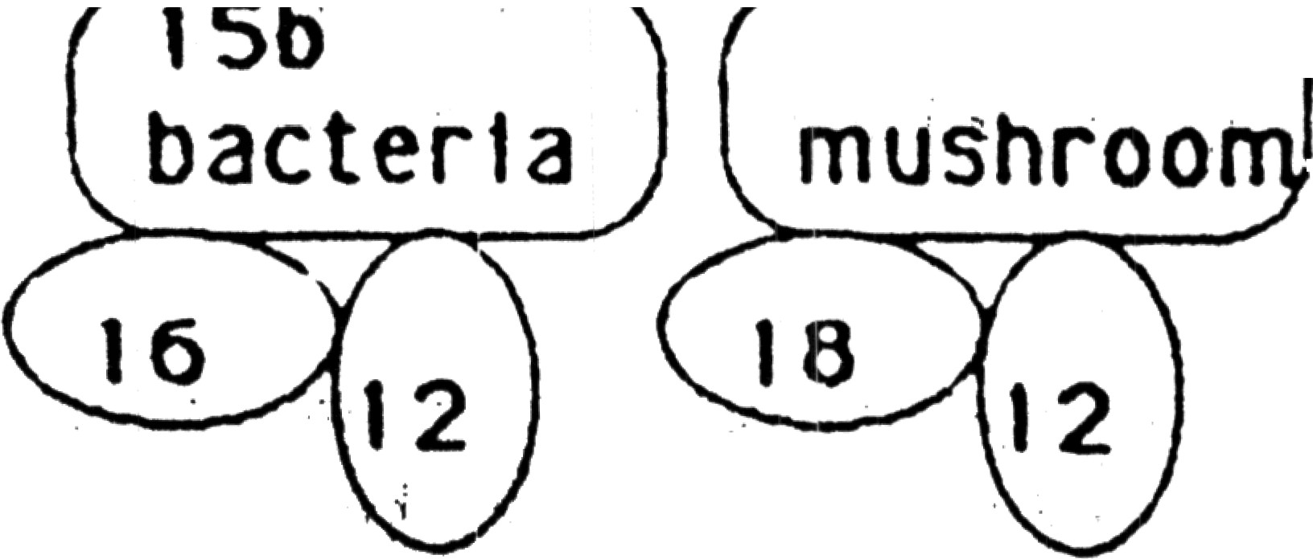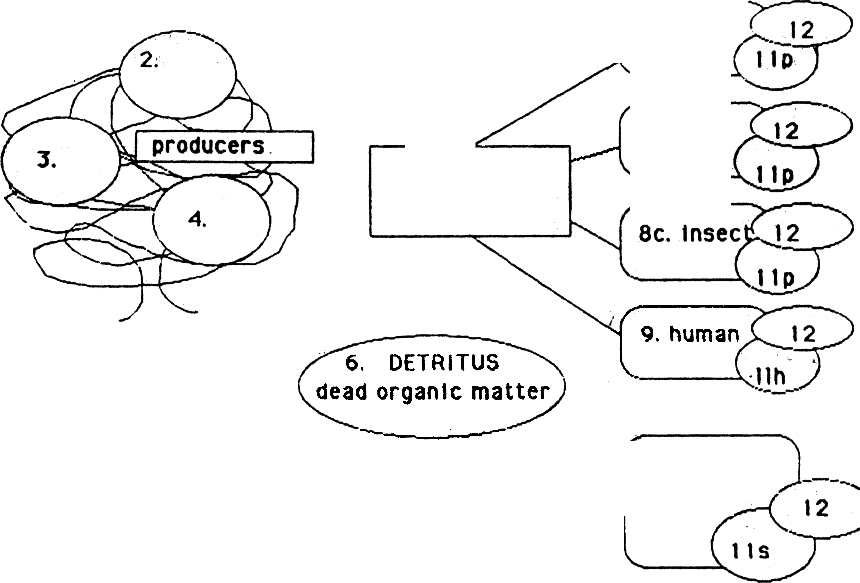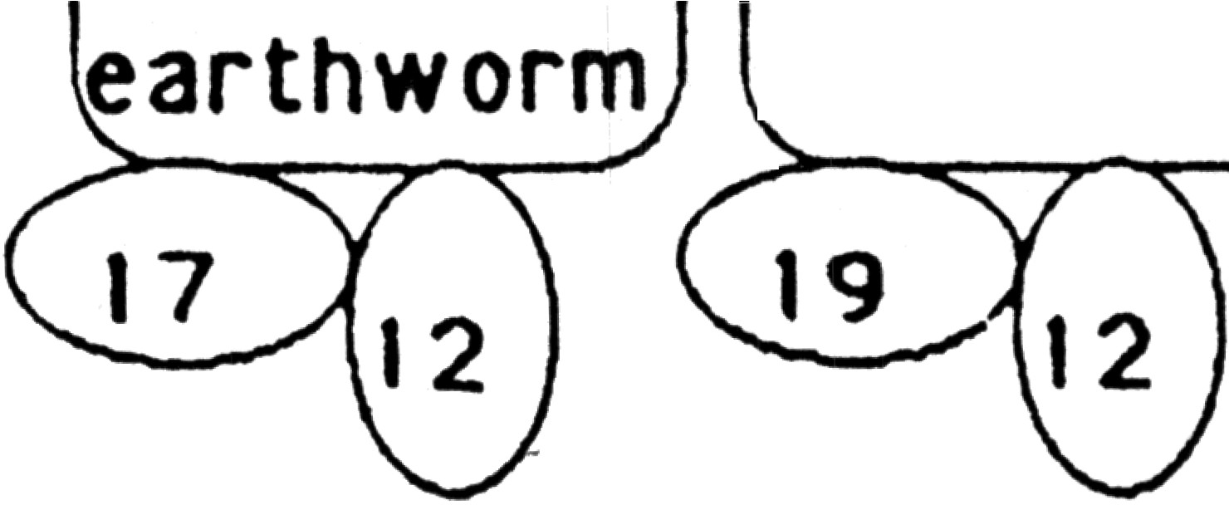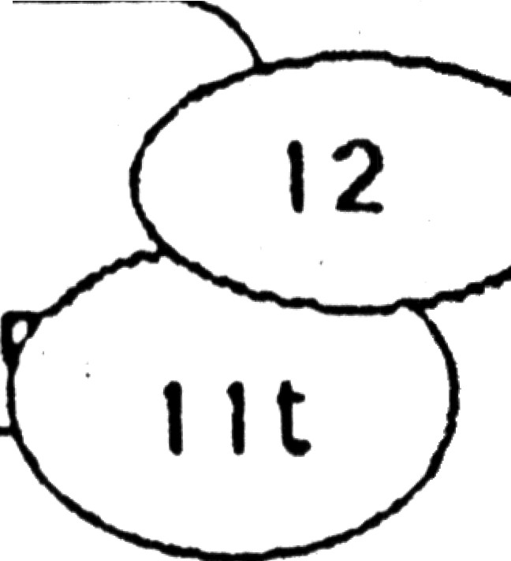5. pri mary
consumer.
herbi vore

7. '"
F I R E )

..,.,, .....:.----- ----.........

. Sa. small ·
.. mammal

Sb. bird

·Secondary

7(To-: d-e tr-1tus reeders and d-eco-
m-p-o-ser--s)

consumer

---- 1 sr s1
1nsec t gru

  - tn1r<1
. order
consume

THE CARBON CYCLE GAME
NOTE: H=heads T = Tails Flip 2 coins unless you are told otherwise
START AT NUMBER 1
1. YOUR CARBON ATOM IS NOW A MOLECULE OF CO2 IN THE ATMOSPHERE.
Flip two coins
TT Not absorbed; your carbon atom remains in the atmosphere for another turn.
TH or HR your carbon atom is absorbed into a leaf of a plant. Go to number 2

2 . THE MOLECULE OF CO2 WITH YOUR CARBON ATOM IS NOW IN A LEAF OF A PLANT.
Flip two coins
TT NO SUNLIGHT! NO photosynthesis. the CO2 molecule with yourl carbon atom returns to the atmosphere. Go back to #1.
TH or HR SUNLIGHT! Photosynthesis. Tour carbon atom is I incorporated into a sugar molecule by photosynthesis. Go to number 3.
- YOUR CARBON ATOM IS NOW IN A MOLECULE OF SUGAR IN A PLANT
Flip two coins
TT the sugar molecule with your carbon atom is oxidized in cell respiration to provide energy for plant growth. your carbon atom is released in a molecule of CO2. Go back to number 1.
TB or HR the sugar molecule with your carbon atom is incorporated into a molecule making up the tissue of a plant. Go to space Number 4.
- YOUR CARBON ATOM IS NOW IN A MOLECULE OF SUGAR IN A PLANT.
Flip two coins
TT The plant is eaten by an animal. go to Number 5 and take another turn to determine what kind of animal.
TB or HR plant part dies. its organic matter is detritus . Go to
Number 6.

- THE PLANT TISSUE WITH YOUR CARBON ATOM
CONSUMER.
Flip one coin twice .
T & T mammal herbivore -- go to BA
T & B bird -- go to BB B & T insect -- go to SC
IS EATEN BY A PRIMARY

H & H human, perhaps yourself -- go to 9

- YOUR CARBON ATOM IS NOW IN A MOLECULE OF DEAD ORGANIC MATTER OR DETRITUS.
Flip two coins
TT or TH consumed by a detritus feeder or decomposer. Go to 10 and take another turn to determine which one.
HR FIRE! go to 7.

- THE MOLECULE WITH YOUR CARBON ATOM IS NOW BEING OXIDIZED (BURNED) IN A FIRE. OXYGEN IS COMBING WITH YOUR CARBON ATOM AND IT IS BEING RELEASED IN A MOLECULE OF CARBON DIOXIDE. GO IMMEDIATELY BACK TO NUMBER 1 WITHOUT TAKING A TURN.

8A, 8B AND SC THE PLANT TISSUE WITH YOUR CARBON ATOM IS NOW BEING INGESTED BY A PRIMARY CONSUMER AS PART OF ITS FCX>D.
Flip two coins
TT the molecule with your carbon atom is metabolized into a molecule making a tissue of the consumer's body. go to llP
TH CELL RESPIRATION! Go to 12.
HH the molecule with your carbon atom is not digested. it passes through the intestinal tract as fecal waste. -- go to 6.

9 . THE PLANT TISSUE WITH YOUR CARBON ATOM IS NOW BEING INGESTED BY A HUMAN -- PERHAPS YOURSELF, AS A PART OF FCX)D.
Flip two coins
TT the molecule with your carbon atom is metabolized into a molecule making up a tissue in your body. Go to llH
TH CELL RESPIRATION! Go to 12
HH the molecule with your carbon atom is not digested, It passes through the intestinal tract and out as fecal waste. Go to number 6.
THE MOLECULE CONTAINING YOUR CARBON ATOM IS NOW BEING INGESTED BY A PRIMARY DETRITUS FEEDER OR DECOMPOSER.
Flip one coin twice.
TT earthworm go to 15E
TH decomposer -- fungus (mushroom) Go to 15F HT decomposer -- bacteria Do to 15B
HH insect -- go to 15I
llH. YOUR CARBON ATOM IS NOW IN A MOLECULE MAKING UP A TISSUE OF YOUR OR ANOTHER HUMAN'S BODY.
Flip one coin
T the molecule is broken down and metabolized in cell respiration, go to 12
H when the human dies of injury and/or disease and if the body is cremated, the carbon atom will go to number 7.
YOUR CARBON ATOM IS NOW IN A MOLECULE MAKING UP A TISSUE OF A PRIMARY CONSUMER OR HERBIVORE.
Flip two coins
TT the molecule is broken down and metabolized in cell respiration
-- go to 12.
TH the primary consumer is eaten by a secondary consumer.
Go to 13
HH the primary consumer dies of injuries and/or disease. go to 6.
11S YOUR CARBON ATOM IS NOW IN A MOLECULE MAKING UP A TISSUE OF A SECONDARY CONSUMER OR A CARNIVORE.
Flip two coins
TT the molecule is broken down and metabolized in cell respiration
-- go to 12.
TH the secondary consumer is eaten by a third order consumer.
Go to 14
11H the secondary consumer dies of injuries and/or disease.
Go to 6.

llT YOUR CARBON ATOM IS NOW IN A MOLECULE MAKING UP A TISSUE OF A THIRD ORDER CONSUMER OR A CARNIVORE.
Flip two coins
TT the molecule is broken down and metabolized in cell respiration
-- go to 12.
TH the third order consumer is eaten by another third order consumer. Go to 14
HH the third order consumer dies of injuries and/or disease.
Go to 6.

12. THE MOLECULE CONTAINING THE CARBON ATOM IS NOW BEING BROKEN DOWN IN CELL RESPIRATION TO PROVIDE ENERGY FOR THE CONSUMER'S MOVEMENTS AND FUNCTIONS. IN THIS PROCESS, YOUR CARBON ATOM IS COMBINED WITH OXYGEN ATOMS AND IS RELEASED BACK INTO THE AIR AS CARBON DIOXIDE. Go immediately back to number 1 without taking another turn.

13 . THE MOLECULE WITH YOUR CARBON ATOM IS NOW BEING INGESTED BY A SECONDARY CONSUMER.
Flip two coins
TT the molecule is metabolized into a molecule making up a tissues of the consumer's body. Go to llS
TH CELL RESPIRATION! . Go to 12.
HH the molecule with your carbon atom is not digested. it passes through the intestinal tract and out as fecal matter. Go to 6

14 . THE MOLECULE WITH YOUR CARBON ATOM IS NOW BEING INGESTED BY A COW A CONSUMER.
Flip two coins
TT the molecule is metabolized into a molecule making up a tissues of the consumer's body. Go to llT
TH CELL RESPIRATION! . Go to 12.
HH the molecule with your carbon atom is not digested. it passes through the intestinal tract and out as fecal matter. Go to 6.

l5B THE MOLECULE BACTERIA.
WITH YOUR CARBON ATOM IS NOW BEING ABSORBED BY A

Flip

T
H
one coin
it gets incorporated into a molecule of the it gets broken down and metabolized in cell go to 12.
bacteria - go to 16 respiration --

15E THE MOLECULE WITH EARTHWORM.
YOUR CARBON ATOM IS NOW BEING INGESTED BY AN

Flip

TT
TH

HH
two coins
it gets incorporated into a molecule of the worm's body. Go to
17.
it gets broken down and metabolized in cell respiration. Go to
12.
it is not digested; it passes through the intestinal tract and
out as fecal matter. Go to number 6

15F THE MOLECULE WITH YOUR CARBON ATOM IS NOW BEING ABSORBED BY A FUNGUS (MUSHROOM).
Flip one coin
T it gets incorporated into a molecule of the fungus. -- go to 18.
H it gets broken down and metabolized in cell respiration -- go to 12.

15I THE MOLECULE WITH YOUR CARBON ATOM IS NOW BEING INGESTED BY AN
INSECT GRUB.
Flip two coins
TT it gets incorporated into a molecule of the insects body.
Go to 19.

TH CELL RESPIRATION! .
HH it is not digested. out as fecal waste.
Go to 12.
it passes through the intestinal tract and Go back to 6

16 YOUR BODY.
CARBON MOLECULE IS NOW A MOLECULE MAKING UP THE BACTERIA'S

Flip
TT

TH HH
two coins
the molecule is broken down and metabolized in cell respiration
-- go back to 12.
the bacteria is eaten by an earthworm go to lSE the bacteria dies, Go to 6.

17 YOUR CARBON MOLECULE BODY.
IS NOW A MOLECULE MAKING UP THE EARTHWORM'S

Flip
TT

TH HH
two coins
the molecule is broken down and metabolized in cell respiration
-- go back to 12.
the worm is eaten by an bird -- go to 15E
the worm dies of injury or disease -- go to 6.

- YOUR CARBON MOLECULE IS NOW A MOLECULE MAKING UP A MUSHROOM.
Flip two _coins
TT the molecule is broken down and metabolized in cell respiration
-- go back to 12.
TH the mushroom is eaten by an insect -- go to 15I
HH the mushroom matures and d ies -- Go to 6

- YOUR INSECT.
Flip
TT

TH
HH
CARBON MOLECULE IS NOW A MOLECULE MAKING UP THE BODY OF AN

two coins
the molecule is broken down and metabolized in cell respiration
-- go back to 12.
the insect is eaten by a small mammal. -- go to 8A the insect dies of injury or disease -- go to 6.

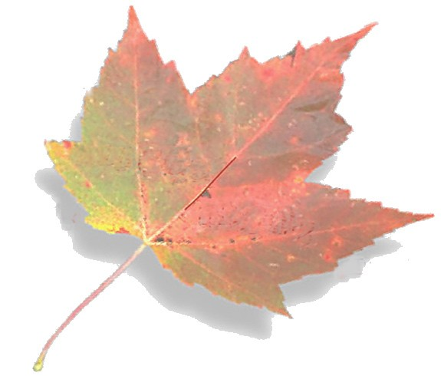
Carbon, Climate, and Laser Technology
The Carbon Cycle Pursuit Game
Teacher’s Guide
- www.atd.ucar.edu/apol/biocomplexity
- www.eo.ucar.edu

Subject Focus: Earth Science Biology Chemistry
Materials & Preparations Time:
Preparation: 30 minutes to make one game, although the process can be greatly expedited by involving students

Introduction: 10 minutes

Playing time: 30 minutes

Materials:
  - game board
  - game instructions (can be affixed to back side of game board)
  - 7 dice, one color-coded
to correspond to a specific
carbon reservoir
  - 7 color-coded sets of ten question cards correspond- ing to a specific carbon reservoir
  - 1 game piece token/marker per team

Teacher Materials:
See Assembly Instructions that follow
National Science Content Standards Addressed:
Standards C, D, and F

Learning Objectives:
    - Learn the biological carbon cycle as each team moves as carbon through the atmosphere, oceans, biosphere, and lithosphere
    - Correctly identify and use the terms carbon source, sink, and reservoir
    - Learn about human’s role today in impacting the carbon cycle
    - Understand that the carbon cycle is a dynamic system that plays a
significant role in Earth’s atmospheric composition
    - Understand that changes in Earth’s atmospheric composition impact climate and life on Earth

Objective of Game:
Small groups of 2-3 students work together to correctly answer questions about the carbon cycle and advance through all seven carbon reservoirs on the game board before their opposing team.

Procedure:
- Assemble game pieces as instructed on the Assembly page at least one day prior to play. For a class of 30 students, five games should be constructed. It takes approximately 30 minutes to assemble one game setup.

Game Day Directions: Have competing teams read and disucss the Carbon Cycle Pursuit Directions page together before beginning play. Ask the class as a whole
if there are any questions pertaining to how to play the game. After all questions are answered, begin play.

Extensions and Assessment:
Ask teams to develop new sets of questions for the game. Assign them a particular reservoir or have them determine a set number of questions for each. Make sure that students list their sources for their questions’ content. Some excellent sources can be found in the appendix to Carbon, Climate and Laser Technology.

The Carbon Cycle Pursuit game is intended as a review or to expand student knowl- edge following class content on the carbon cycle and/or climate change. Teachers can create their own question cards on the blank question card template provided to em- phasize specific learning objectives. Students’ ease in correctly answering the question cards will be indicative of their understanding of the carbon cycle and its connection to Earth’s climate.

Carbon Cycle Pursuit · Game Directions
LEARNING OBJECTIVE: To increase students’ knowledge of the
carbon cycle and humans’ impact on it.

GAME OBJECTIVE: To be the first team to cycle through all carbon reservoirs on the game board. To win, one must correctly answering a carbon card question while in each reservoir, then roll the appropriate dice to ad- vance to another location within the carbon cycle.

MATERIALS:
- Game board - 7 sets of question cards - Minute glass for keeping time
- 7 carbon cycle dice - Token for each team (optional)

HOW TO PLAY THE GAME:
  - Have students form competing teams, each with two or three players.
2. Distribute items listed under “Materials” to each pair of competing teams.
- Set out the game board, place each color-coded die near its matching carbon reservoir, and place the seven stacks of carbon question cards along side the game board, image-side up.
- Present the game’s objective and rules to the class as a whole, or have competing teams review
them independently.

RULES OF THE GAME:
1. The team with a member possessing a birthdate closest to the day’s date goes first. (It does not matter if the birth date has recently past or is upcoming.) The team going first is referred to as Team A; the team going second, Team B.
2. Each team puts their marker in the Fossil Fuel resevoir to begin. Each carbon reservoir is
image- and color-coded (e.g. “orange” with a traffic image for the Fossil Fuel reservoir; “green”
with a plant image for the Vegetation reservoir).
- Team B pulls the first question card from the Fossil Fuel stack and reads the carbon question to Team A, whose players have one minute to discuss and decide on their answer. (The answer is specified on the card.)
- If Team A players do not answer the question correctly, their turn is over and the question card goes to the bottom of the stack. However, if they do answer correctly, they receive the question card and a roll of the Fossil Fuel resevoir die to attempt to advance.
- If Team A rolls the die and it lands showing another reservoir, Team A may advance their token to it, and their turn ends. If they roll the die and it lands on the reservoir they are currently in, they must remain there, and their turn ends. They will have an opportunity to advance after answering another carbon card question correctly on their next turn.
- Team B now repeats the same process.
- After a team’s players correctly answer a carbon card question in the same reservoir three times but fail to advance to a new reservoir, or if all questions in the resevoir have been exhausted, they may move their token to another carbon resevoior shown on their die.
- To win, a team must be first to successfully cycle through all seven reservoirs on the game board and receive a carbon question card from each by correctly answering its question.

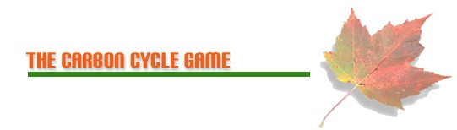

Carbon Cycle Pursuit
Game Assembly Teacher Instructions

Materials needed for Game Assemblance:

- Copy of Carbon Cycle Pursuit Directions
- Copy of game board, preferrably in color
- A color copy of each reservoir die (7 total)
- 7 Manila folders or 7 pages of firm paper stock (20 lb. weight)
- Two-sided Question Cards printed and laminated (8.5”x11”pages)
- Container to hold game contents
- Envelope or rubber band for question cards
- Two game piece tokens, one for each team, preferrably representing a component of the carbon cycle
- Use of a laminator machine, printer, and copier
- Clear tape or stapler

Advanced Preparation:

For a class of 30 students, with three students per team, you will need to prepare five Carbon Cycle Pursuit games. To make the process easier, solicit student assistance. Instructions for making one game follow:

Step 1: Print the following on a color printer: game board, 2-sided question cards (7 double-sided pages), and the 7 color-coded reservoir dice (materials follow on attached pages)
Step 2: On the backside of the game board page, copy the game directions.
Step 3: Laminate the game board and directions page as well as the question card pages.
Step 4: Cut out the question cards and organize them by reservoir. Each of the 7 reservoirs
will have a set of 10 game card questions that are color-coded to match the reservoir and the reservoir die.
Step 5: Cut out the 7 die along each die’s outline and staple or glue each to one side of a manila folder or heavier paper stock. Cut out each die with its new backing, and fold into a cube along dotted lines. Secure fold with tape to maintain each die’s cube shape.
(See illustrations that follow.)
Step 6: Add two markers/game pieces of your choosing -- one for each team -- to complete the advanced preparation of the Carbon Cycle Pursuit game. You may wish to choose markers that reflect some component of the carbon cycle (e.g. a leaf, pumas rock) or have each team do so for homework prior to playing the game.

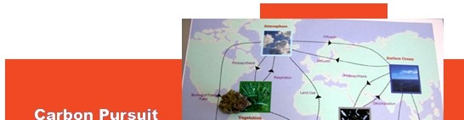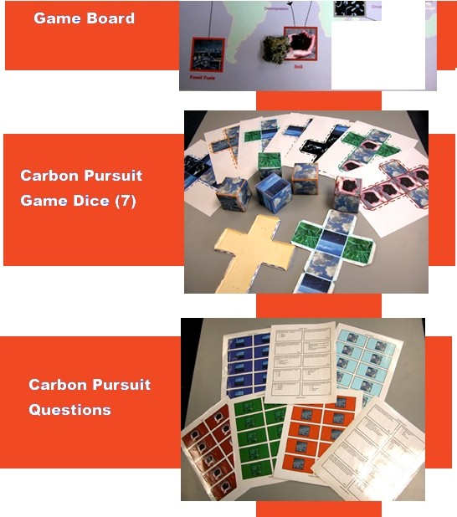

-- i
•-

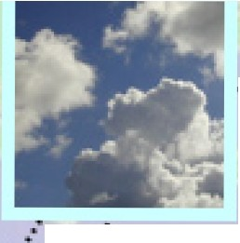
11.tmospbca-e Carbon Cycle Pu rsuit

..·• •• •• • ,• •• •••• • 111 11t
........·

,•ti•••
Di tfusion
••tt 11•11• • • lo ti f!llll tl llt, •••• .Ir...
,,..... ll ll l f t!t .. ,• • ' 1 1 1 1

·j·····

..
.. ..'
....
"...."
.....
.

,.••1 •••• ., .
'• . .
' i.t ...

...... ......._J
....
·....Surface Ocean
·+.

Pho1os.yn1hc;is. '
•.
..
.
....
r
...
DiIfusion "f"··• ......
• • I! •

II f IJi I t> 1 f I I I I f f f I 19 <t I II It rt •
...

. = ..
.
r \ .\. , ! .· ....... .

Rapira1ion
.
...

Pho1osyn1hc..i,; •••,•'·•••

.."It,
•
.
. ''·t\ ·- .::... /!.,!..!, .... .
.k··

..
.,..
.·•

Burning of Fossi,.
,\0t. ..,,.,.
''r·. ''\·- -;- ._-..,:-.
v • .,

l...m1d

'
L"s..= ••

J,.
.
.•.
...
.•.

..
,.··
..••••• D..".OOmJ!OS111on

...
... ·.

.

Fuds. :
. . . \ \ i_'

i\ ·. .·.·
. ,. · /
;.... . . ..
..
..
...

Vegetation
I •• P 11"4 i a t .......
... ..
.,-,.,4",,

... ..

.. _;
:
..
..
11""",........
- •Cim11.ltion

D.'.l'0rnpo,;i1ion ·-:.
...
...
...
, . ,, Cirrulm ion

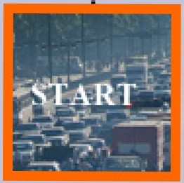. . I ct •• fl '•
-

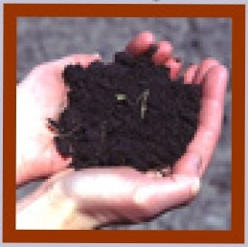
Marine Biota ···

D..."'OrnJ10:'-i1ion

•.....

...
...
.
.
,..
.

Fossil Fuels

Soil
Carbon cv.cle Pu rsuit

.- .-., L'
./ia ·--· .:,':!··
i;7-- -

Deep Ocean

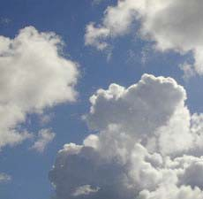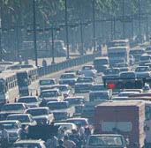Carbon Cycle Pursuit:
Fossil Fuel Die (Orange) 1

3 2

7 4

7 4

3 2

6 5

6 5

1

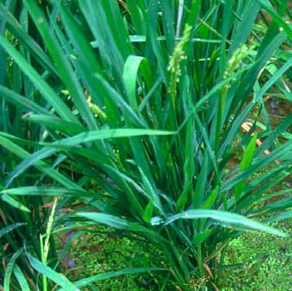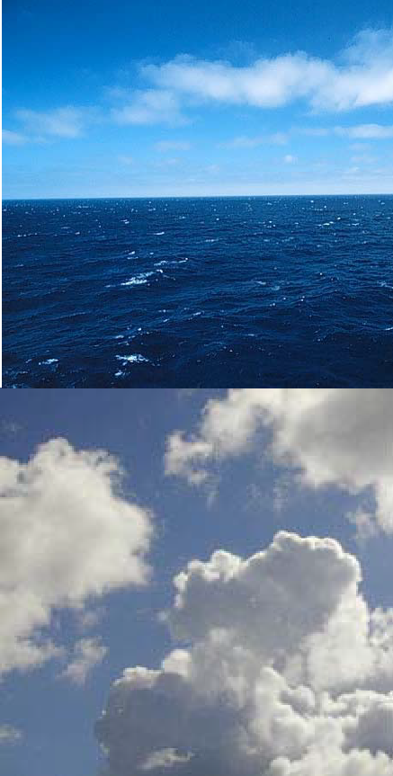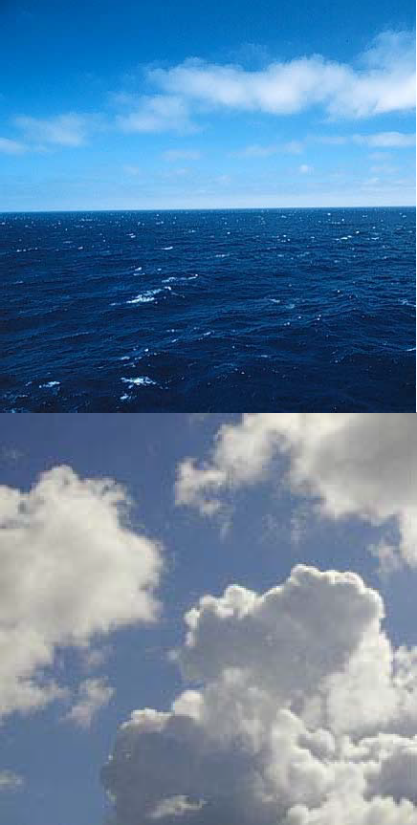Carbon Cycle Pursuit 1
Atmosphere Die (Sky Blue)

3 2

7 4

7 4

3 2

6 5

6 5

1

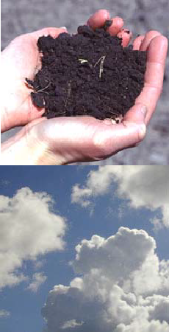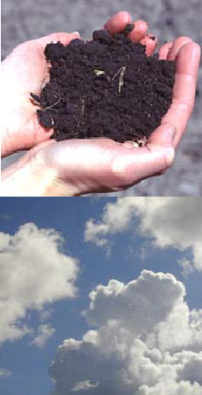Carbon Cycle Pursuit Vegetation Die (Green)
1

3 2

7 4

7 4

3 2

6 5

6 5

1

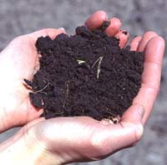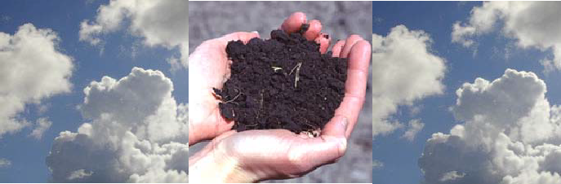1
Carbon Cycle Pursuit Soil Die (Brown)

3 2

7 4

7 4

3 2

6 5

6 5

1

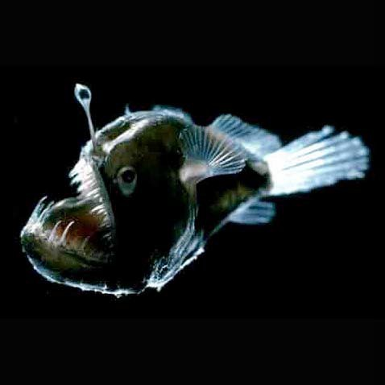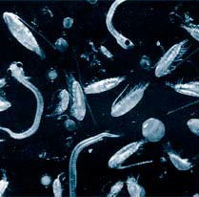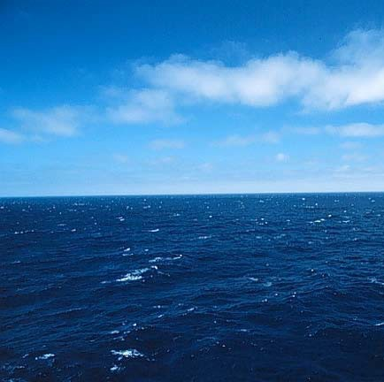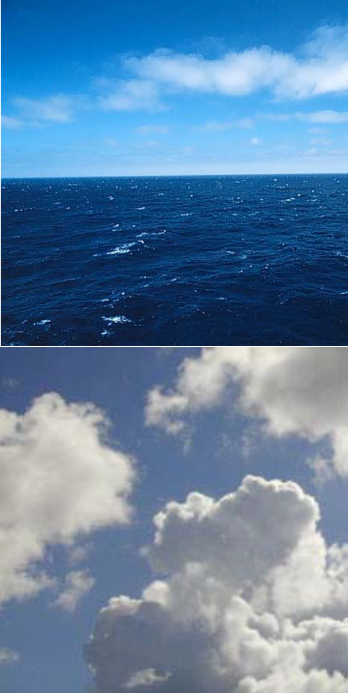Carbon Cycle Pursuit 1
Surface Ocean Die (Ocean Blue
3 2

7 4

7 4

3 2

6 5

6 5

1

Carbon Cycle Pursuit 1
Marine Biota Die (Pink)

3 2

7 4

7 4

3 2

6 5

6 5

1

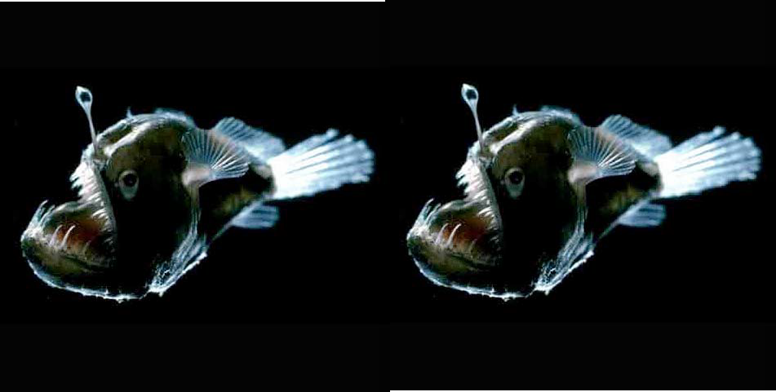1
Carbon Cycle Pursuit Deep Ocean Die (Gray)

3 2

7 4

7 4

3 2

6 5

6 5

1

FOSSIL FUELS
Approximately how many Megatons of Carbon do humans produce by burning fossils fuels each year? (1 Megaton = one million tons)
- 5
- 50
c. 500
d. 5,000

d
How does the US get the majority of its energy?
- Petroleum
- Natural Gas
- Coal
- Oil

a
What percent of our countries electricity comes from the burning of coal?
a. 10%
b. 20%
c. 40%
d. 60%

d
How many pounds of carbon is each person in the US responsible for producing per year?
a. 46
b. 460
c. 4600
d. 46000

c
How many pounds of carbon is each person in Japan responsible for producing per year?
a. 180
b. 1800
c. 18000
d. 180000

b
How many trees would each American have to plant to make up for how much CO2 we release into the atmosphere each year?
- 8
- 80
c. 800
d. 8,000

c
Which state uses the most oil to produce electricity?
- California
- New York
- Colorado
- Florida

d
Coal power plants produce approximately ____ of CO2 emissions from electric utilities in the US.
a. 35%
b. 50%
c. 75%
d. 90%

d
True or False: Ccar engines exist that do not produce CO2 as a byproduct.

True
True or False: Increased CO2 levels in the atmosphere will be detrimental to ones health.

True

FOSSIL FUELS

FOSSIL FUELS
1.

FOSSIL FUELS

ATMOSPHERE
2.
What percent of the atmosphere is carbon dioxide? a. 0.04%
b. 0.4%
c. 4%
d. 40%

a
What percent of the atmosphere was carbon dioxide before the start of the industrial revolution?
a. 0.0028%
b. 0.028%
c. 0.28%
d. 2.8%

b
True or False: CO2 is a very reactive molecule in the atmosphere.

False
How much of an increase of CO2 in the atmosphere have we seen since the industrial revolution?
- 5% increase
- 15% increase
- 30% increase
- 50% increase

c
The radiative forcing due to CO2 is at present slightly larger than ______ of the total greenhouse gas forcing.

a. 50%
b. 26%
c. 12%
d. 4%

a.
Geochemical measurements made on ancient ocean sediments suggest that atmospheric CO2 levels over the past __________ years were never as high as they are today.
a. 100,000
b. 500,000
c. 5,000,000
d. 20,000,000
d
The average annual increase of CO2 since 1958 has been ____ ppm (parts per million per year).
a. 0.5
b. 1.0
c. 1.5
d. 2.0

c
The increase of CO2 in the atmosphere for years 2002 and 2003 were __ ppm and __ ppm,(parts per million) respectively.

a. 0.5, 0.6
b. 1.0, 1.1
c. 1.7, 1.8
d. 2.4, 2.3
d
CO2 atmospheric concentrations increased by ____ ppm (parts per million) in 2004.
a. 1.5
b. 2.0
c. 2.5
d. 3.0

a
True or False: Release of a carbon dioxide molecule affects the atmosphere for a very long time.

True

ATMOSPHERE

ATMOSPHERE
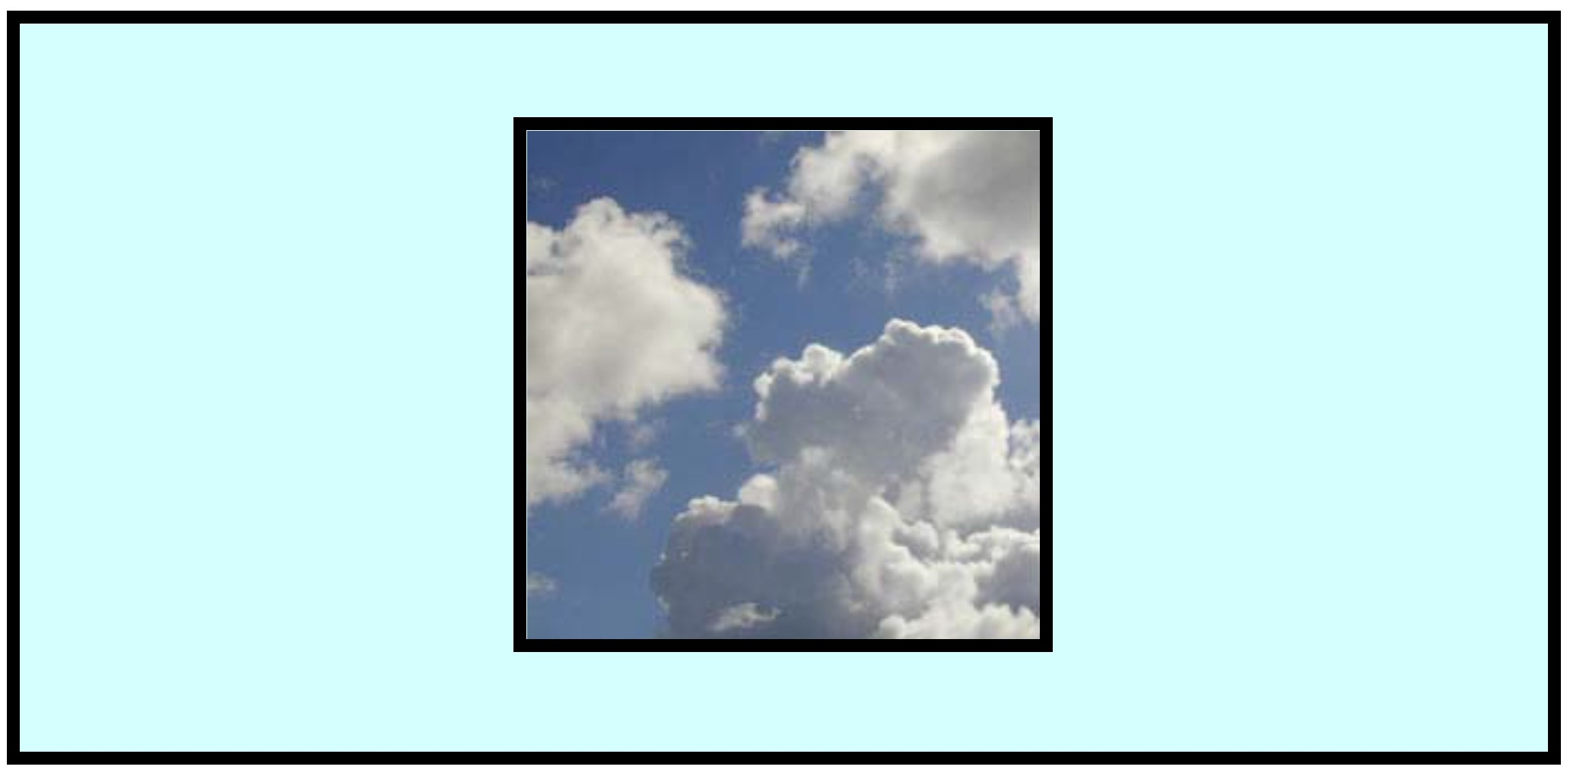
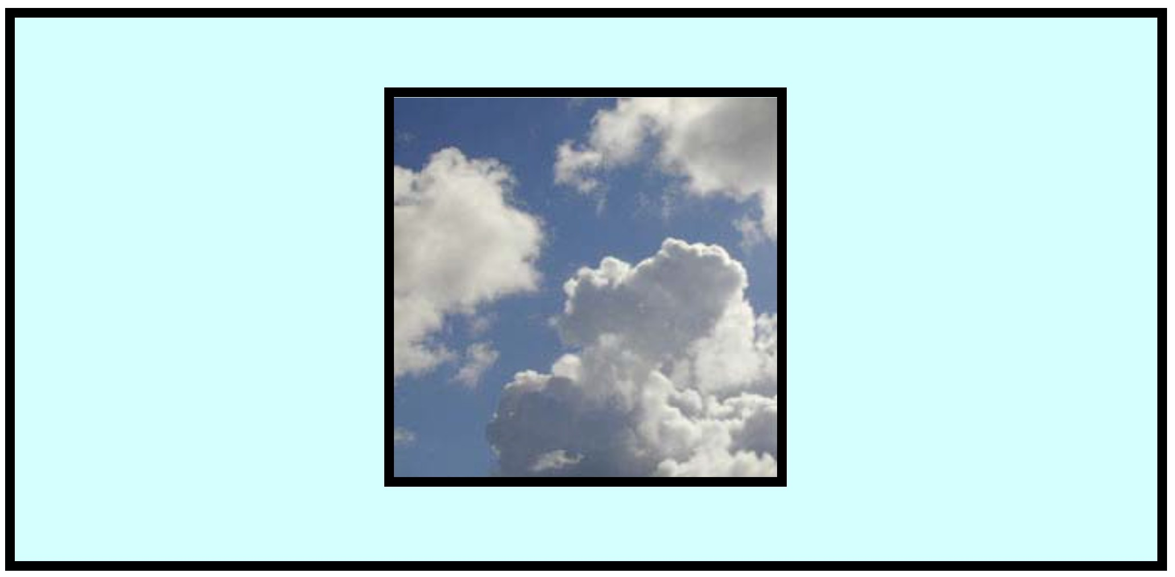
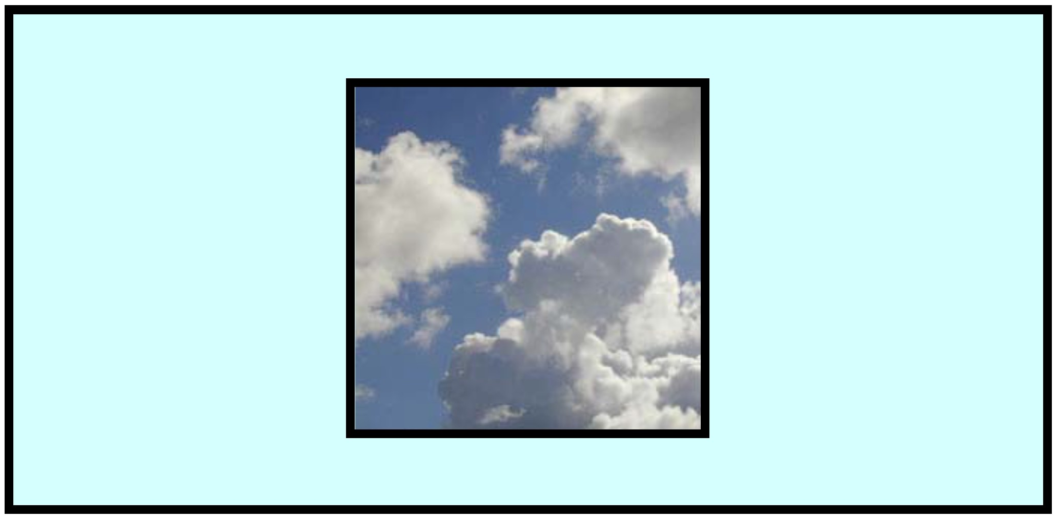
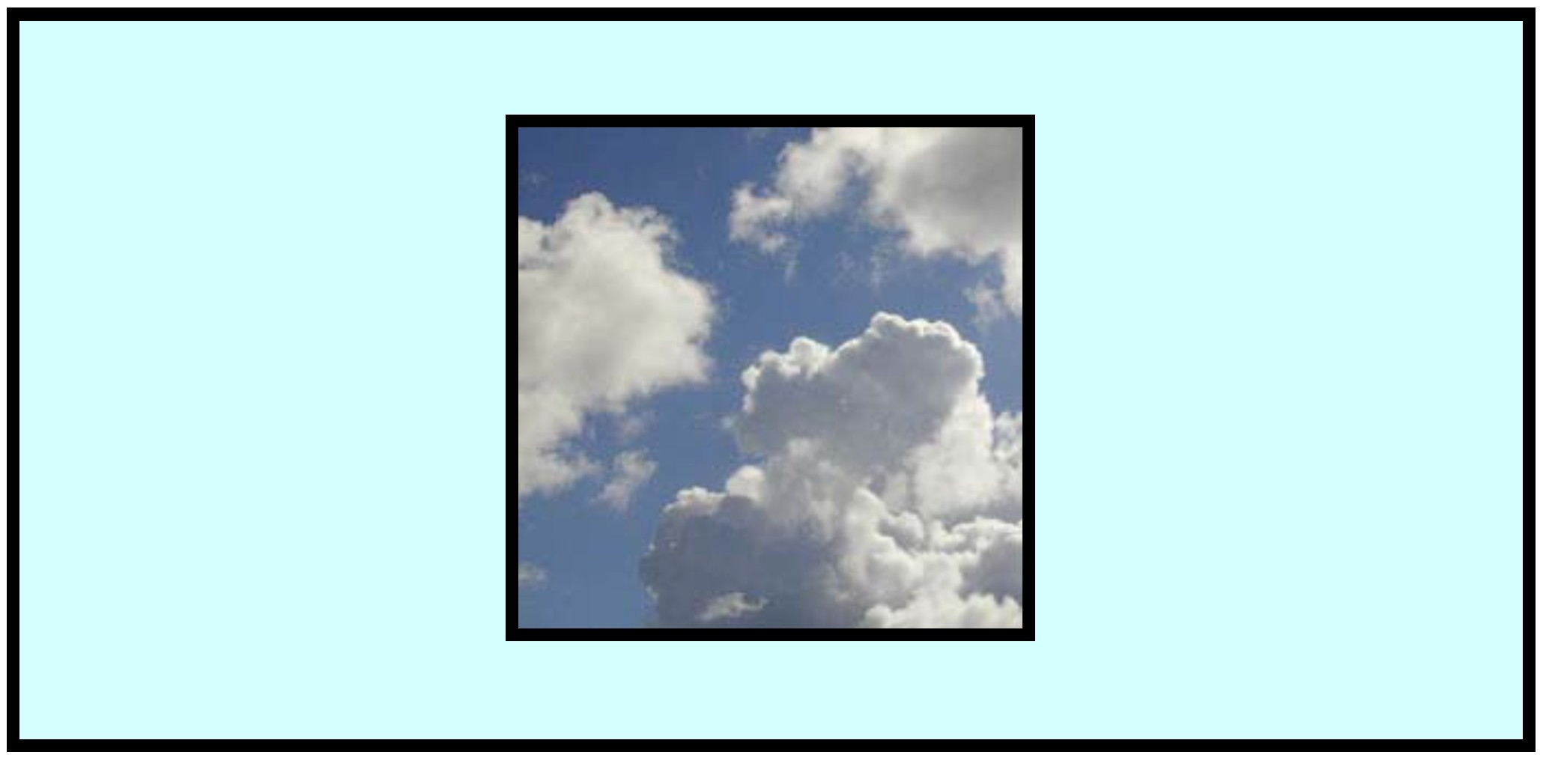
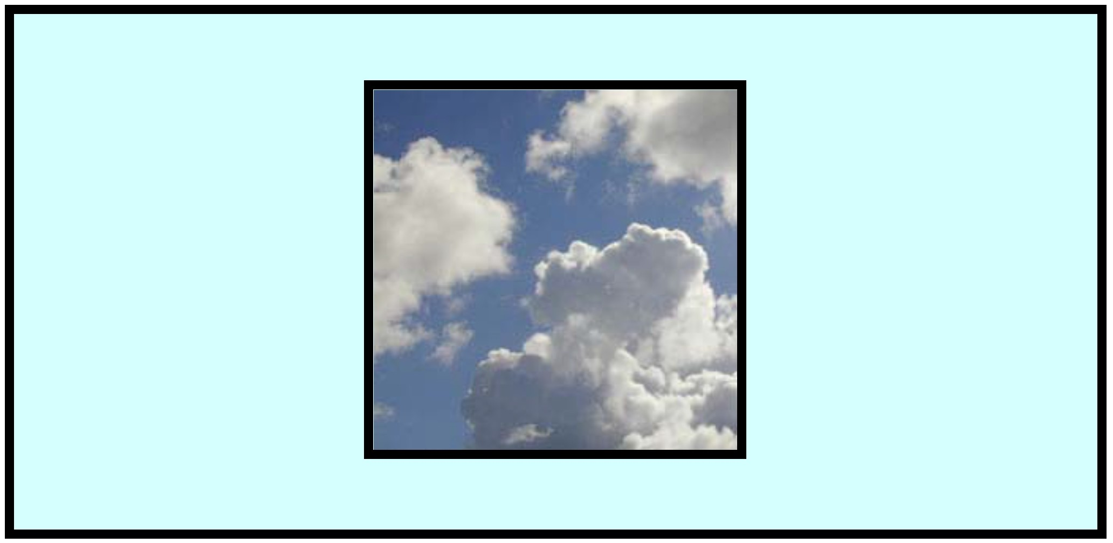
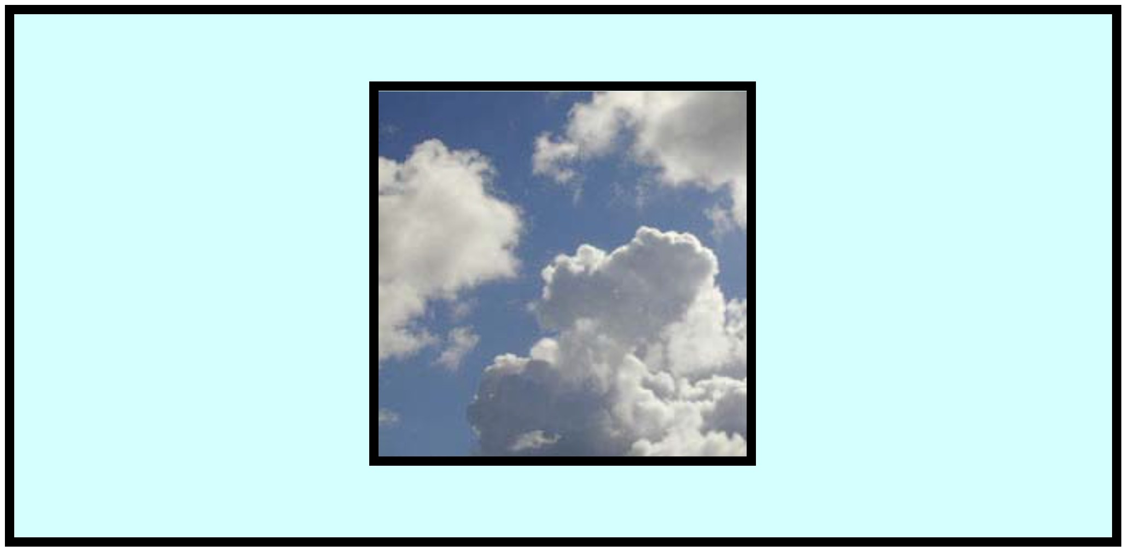
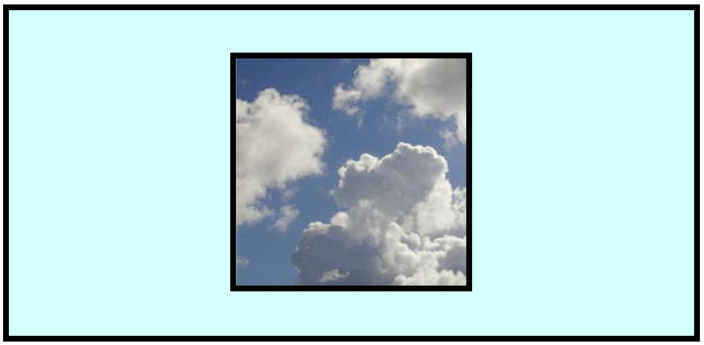
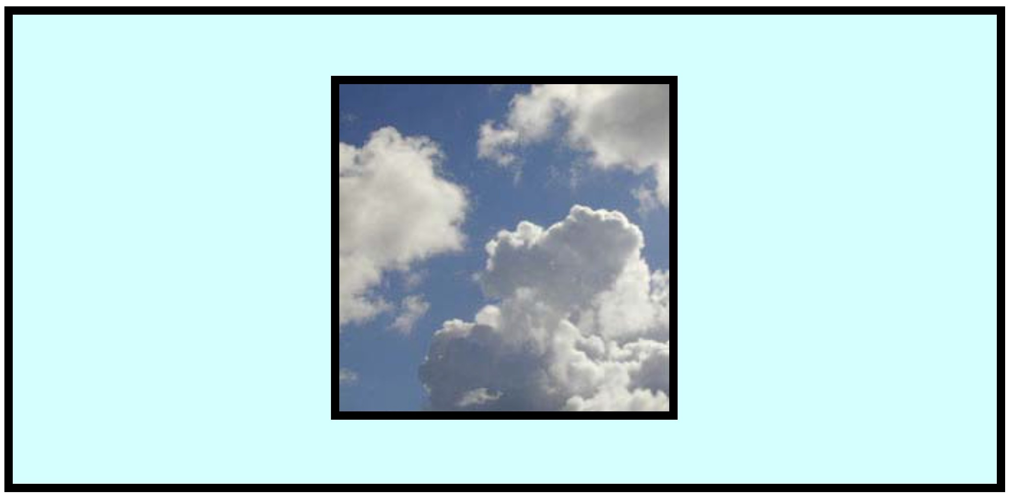
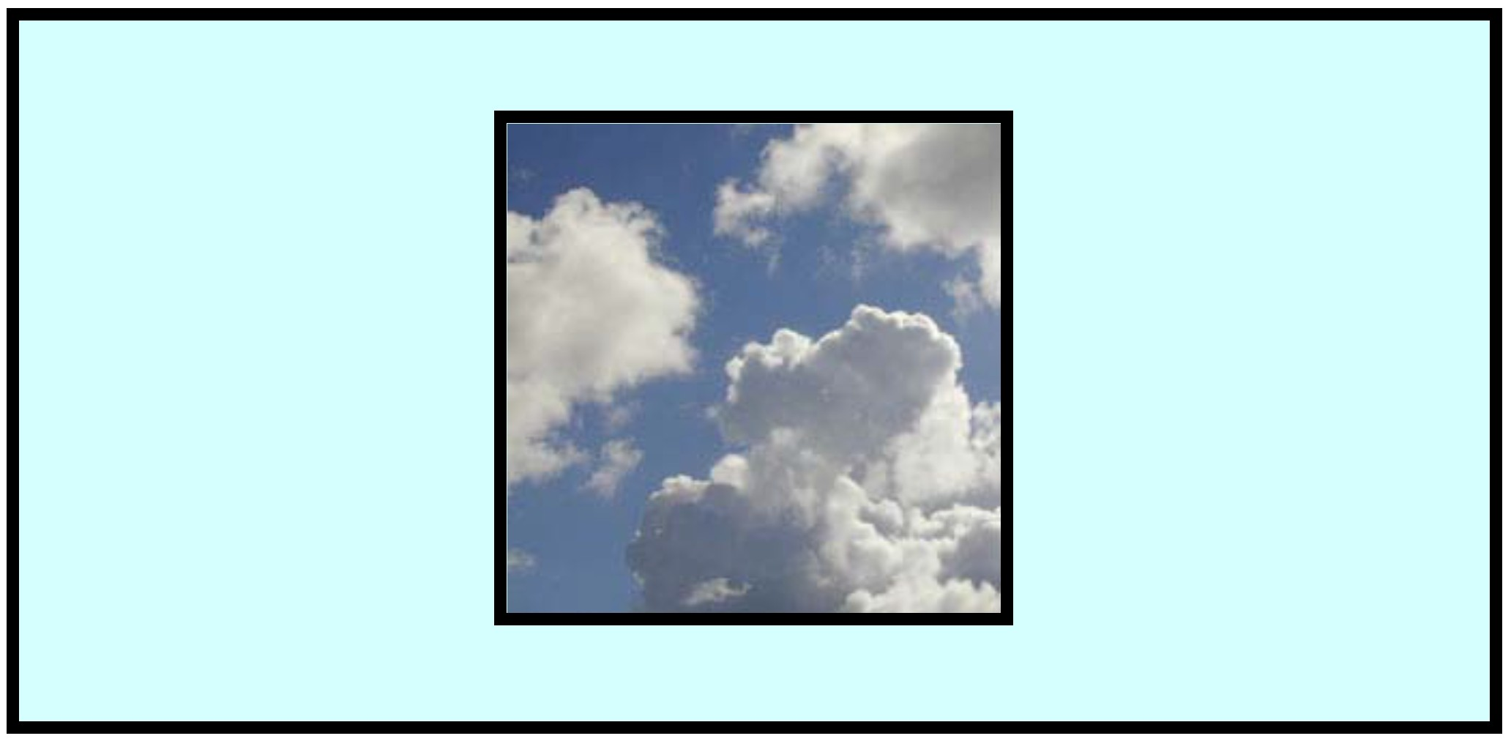
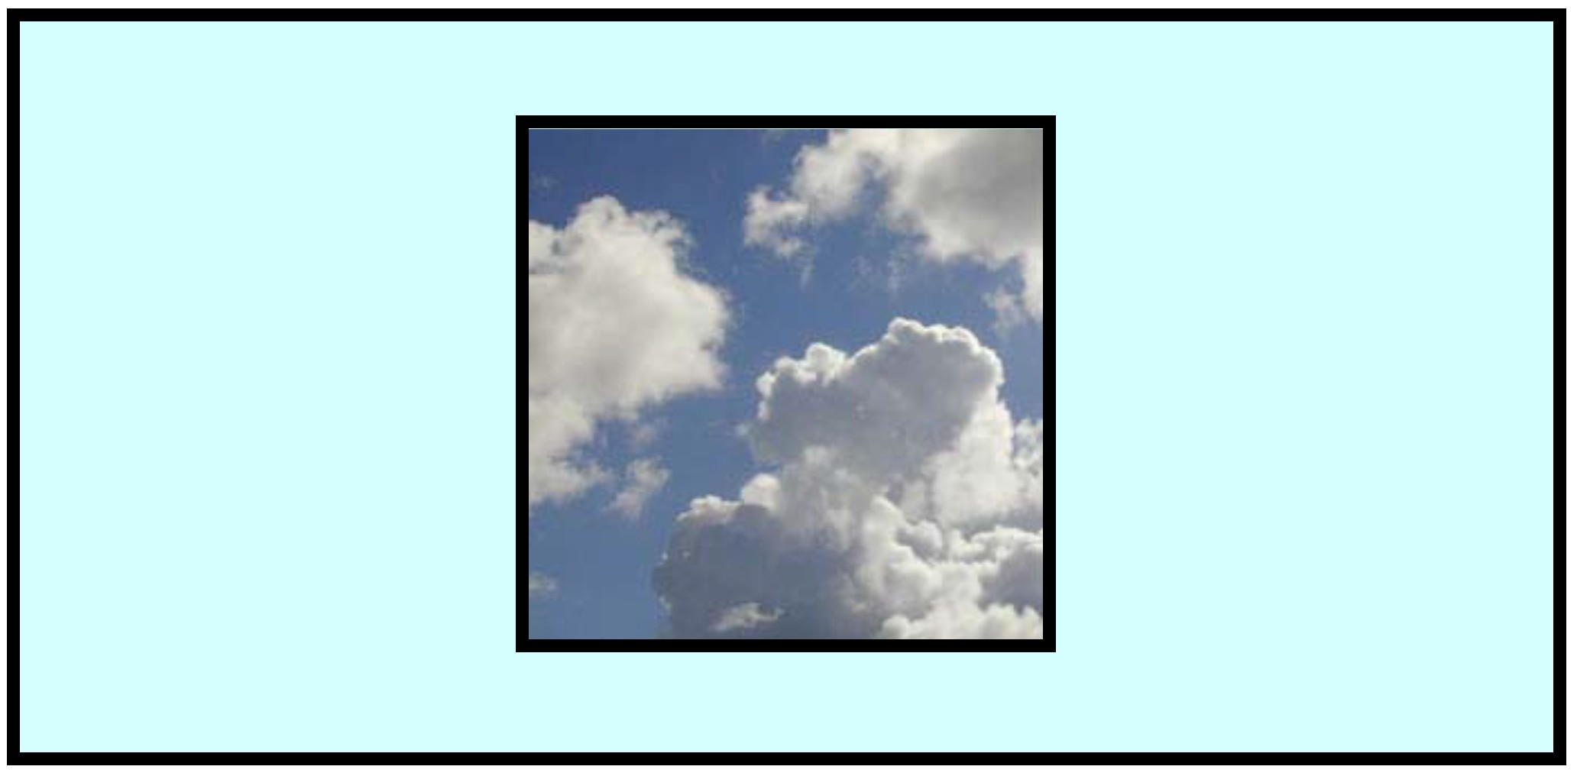

ATMOSPHERE

VEGETATION
1.
Which of the following releases CO2 into the atmosphere?
- burning wood
- harvesting wood
- clearing of forest
- all of the above

d
True or False: Forests that grow after being cut down by logging companies serve as large carbon sinks. (Meaning they take up a lot of CO2)

True
Forest cover about __ of the land surface of the earth. a. 1/2
b. 1/3
c. 1/4
d. 1/6

b
True or False: Plants both absorb CO2 from the atmosphere and release it, and therefore serve as both a source and a sink in the carbon cycle.

True
True or False: Worldwide, forested land is being cleared at a rate of about one football field per second.

True
The process by which the plants give off CO2 is called
- regeneration
- regurgitation
- respiration
- relaxation

c
A carbon sink is
- something that stores carbon
- something that gives off carbon
- something that destroys carbon
- can be any of the above

a
A carbon source is
- something that stores carbon
- something that gives off carbon
- something that destroys carbon
- can be any of the above

b
Plants and forests serve as
- carbon sinks
- carbon sources
- both
- neither

c
True or False: If atmospheric CO2 levels continue to increase, plants will take in more CO2 and grow faster.

True

VEGETATION

VEGETATION
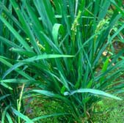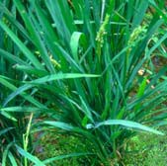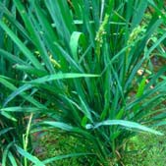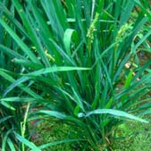

VEGETATION

SOIL
Which of the following take up CO2 from the atmosphere?
- soil
- ocean
- plants
- all of the above

d
True or False: When plants die and deteriorate into the soil, they release CO2.

True
The soil serves as a
- carbon sink
- carbon source
- both
d. neither

b
Detritus is
- small organisms living in the soil
- dead plants and animals deteriorating in the soil
- the scientific name for worms
- another name for soil

b
Soils store about ___ of the earth’s total CO2.
a. 3%
b. 13%
c. 30%
d. 63%

a
True or False: Soils emit more CO2 into the atmosphere than humans.

True
The erosion and weathering of rocks
- release CO2
- store CO2
- both
- neither

a
True or False: Carbon compounds in the soil react to form humus.

True
Currently the US farmlands are responsible for storing
___ metric tons of carbon.
- 2 million
- 20 million
- 100 million
- 200 million

b
If the US were to increase the carbon storage in its farmland tenfold over the next 40 years, this total uptake would account for ____ of the US yearly output in carbon.
a. 12%
b. 24%
c. 48%
d. 96%
a

SOIL

SOIL

SOIL

SURFACE WATER
True or False: The ocean absorbs more CO2 than land.

False
True or False: The surface ocean stores more carbon than soils.

False
The surface ocean absorbs approximately ___ GtC per year. (GtC = Gigatons of Carbon)
- 20
- 50
- 90
d. 140

c
True or False: The ocean helps regulate the amount of CO2 in the atmosphere.

True
True or False: As carbon dioxide enters the surface water, much of it reacts and only a small fraction of it remains in CO2 form.

True
Much of DIC (Dissolved Inorganic Carbon) in the surface water is
- transported to the poles by ocean currents
- sinks to the deep ocean
- absorbed by fish
- none of the above

a
True or False: More carbon can dissolve in cold water than in warm water.

True
The ______ is the process by which large biologically formed particles sink into the deep ocean.
- oceanic pump
- dissolution
- oceanic decay
- biological pump

d
The mechanism by which skeletal structures of sea life transfer carbon to the deep ocean by sinking is called
- the skeletal pump
- the carbonate pump
- the carcass pump
- the calcium pump

b
True or False: The surface ocean only absorbs CO2 from the atmosphere.

False

SURFACE WATER

SURFACE WATER
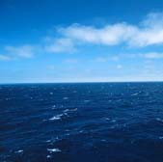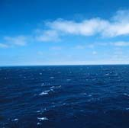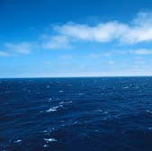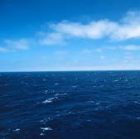

SURFACE WATER

MARINE BIOTA
True or False: Phytoplankton are a class of micro- organisms that take in CO2 in the ocean.

True
Phytoplankton is eaten by
- zooplantkton
- fish
- whales
- all of the above

d
Microorganisms will die if
- pH becomes too high or low
- carbon to nitrogen ratios are changed
- temperature significantly changes
- all of the above

d
Marine Biota utilize ___ GtC annually. (Gigatons of carbon)
- 5
- 20
- 50
- 80

c
True or False: Shells in the ocean contain CO2.

False
True or False: Ocean life can survive without carbon.

False
True or False: When carbon levels get too high, they prevent sea animals fromo undergoing the chemical processes that form their shells (calcium carbonate).

True
Which animals will be hurt by increased CO2 levels?
- algae
- mollusk
- coral
- all of the above

d
True or False: The marine biota reservoir is the only reservoir where its yearly fluxes are much larger than the size of the reservoir itself.

True
The most dynamic reservoir in the carbon cycle is
- plants
- soils
- ocean
- marine biota

d

MARINE BIOTA

MARINE BIOTA

MARINE BIOTA

DEEP OCEAN
a.
Carbon dioxide that enters the Deep Ocean is removed from the carbon cycle for ____ of years.
- tens
- hundreds
- thousands
- millions

b
True or False: Once the CO2 enters the deep ocean, we don’t have to worry about it for at least 100 years.

True
True or False: Once the CO2 enters the deep ocean, it will never circulate up again and cause CO2 levels to rise in the atmosphere.

False
At the poles
- Cold dense water sinks to the ocean floor and fills the ocean basins
- Much of the CO2 freezes and is trapped in the polar ice
- The CO2 is released into the atmosphere
- none of the above

a
The mechanism by which the ocean circulates CO2 from the surface water to the deep oceans near the poles is called the
- oceanic circulation
- dissolution
- oceanic transpiration
- solubility pump

d
True or False: When cold water from the deep ocean heats up, it releases CO2. while rising to the surface.

True
The deep ocean accounts for more than ___ of the earth’s carbon.
a. 5%
b. 16%
c. 50%
d. 65%

d
The deep ocean gets carbon from
- the surface ocean
- marine biota
- both
- neither

c
Where are we likely to see a carbon buildup first?
- at the poles
- at the equator
- everywhere
- its random

a
Is the deep ocean a place where we can store extra carbon indefinitely?
- yes
- no
- we don’t know
- it depends

b

DEEP OCEAN

DEEP OCEAN
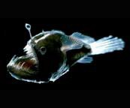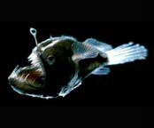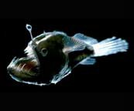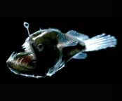

DEEP OCEAN

TEACHER QUESTIONS

TEACHER QUESTIONS

TEACHER QUESTIONS

TEACHER QUESTIONS

