Biomolecules Foldable Instructions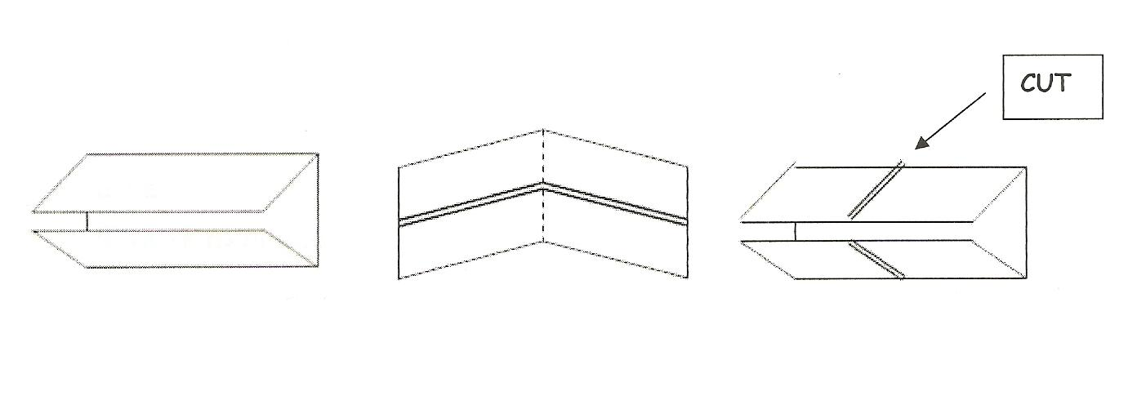
A
B
C
D

Once your foldable is cut and labeled, glue it onto PAGE 12 in your INB.
Front of Tabs:
Carbohydrates (Tab A) | Lipids (Tab B)
1. Label tab Carbohydrates  2. Draw the structure of a carbohydrate | 1. Label tab Lipids  2. Draw the structure of a Lipid
Proteins (Tab C) | Nucleic Acids (Tab D)
1. Label tab Protein  2. Draw the structure of a protein | 1. Label tab Nucleic Acid  2. Draw the structure of a nucleic acid

Inside of Tabs, use your notes to label the following:
Carbohydrates (Tab A) | Lipids (Tab B)
1. Monomer=  2. At least 2 Functions=  3. 2-4 Examples= | 1. Monomer=  2. At least 2 Functions=  3. 2-4 Examples=
Proteins (Tab C) | Nucleic Acids (Tab D)
1. Monomer=  2. 2 Functions=  3. 2-4 Examples= | 1. Monomer=  2. 2 Functions=  3. 2-4 Examples=

