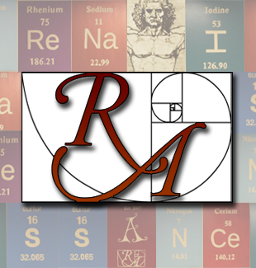
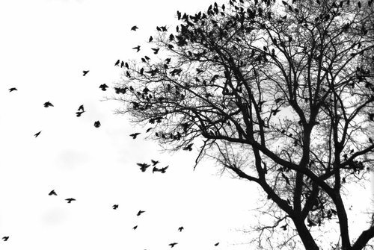
BIOLOGY

{2017- 2018 Class Syllabus}

Welcome to
{2016-2017 Class Syllabus}

www.sciencewithburdick.weebly.com

Biology is the study of life, and this class will focus on the fundamental principles including biochemistry, genetics, and cell biology relating to human biology. This required laboratory-based science class will lay a strong foundation for further science classes students may take in high school. Students will use the scientific method to investigate topics like cellular energetics, cell division, genetics, and evolution.
Ms. Burdick  Room 57  caroline.burdick@district6.org  (541) 494-6280 (office)

Materials needed daily:
- Writing utensil(s)
- 3- Subject spiral notebook
- Glue and/or stapler
- Scissors
- Colored pencils/ Markers
- A positive attitude

Grading:
Grades are earned based on:
- Labs & Homework
- Projects
- Tests & Essential Assignments
- Participation & Class Behavior
- Interactive Notebooks
- Final Exams

Grading scale will follow Renaissance's rubric found on the following page.

Late Work:
Students who have an excused absence from class must turn in missing assignments within one week for full credit.

Students with unexcused absences, or choose to turn their work in late, will earn no higher than a 2.5 (C) on their late assignment. Tests or quizzes are the exception.

Interactive Notebooks (INBs):
Students are expected use a spiral notebook EVERY DAY in class. This is their largest Essential Assignment and in order to earn credit for this class, students must keep them organized and updated on a daily basis. This notebook becomes their textbook for the course, and offers an excellent study aide for tests, projects and final exams. Students will submit their INBs at the end of the semester for a grade.

Topics we will explore include:
- Methods of science
- Photosynthesis & Cellular Respiration
- Macromolecules
- Cell division
- DNA & RNA structure & function
- Genetics and eugenics
- Disease
- Evolution

Attendance:
To succeed in this class, it is necessary for students to attend and participate in class everyday. Engagement during class is an expectation. If you miss class for any reason, it is your responsibility to retrieve any missing work.

Students may retrieve missing assignments from Ms. Burdick's website or from the filing milk crate.

Cell Phones:
In order to help my students focus, they are required to turn off and place their phones in their backpack during class. If students are caught using their phone during class- without permission- they will forfeit it until the end of class. A second violation will result in a referral and students may retrieve their phone from the office at the end of the day.
Essential Assignments:
Essential assignments are aligned with state graduation standards or essential skills and are often weighted more than typical assignments.

To earn credit for this course, students must turn in every essential assignment by the end of the semester.

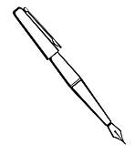

This syllabus is subject to change at any time with Ms. Burdick's discretion.

RENAISSANCE GRADING RUBRIC:
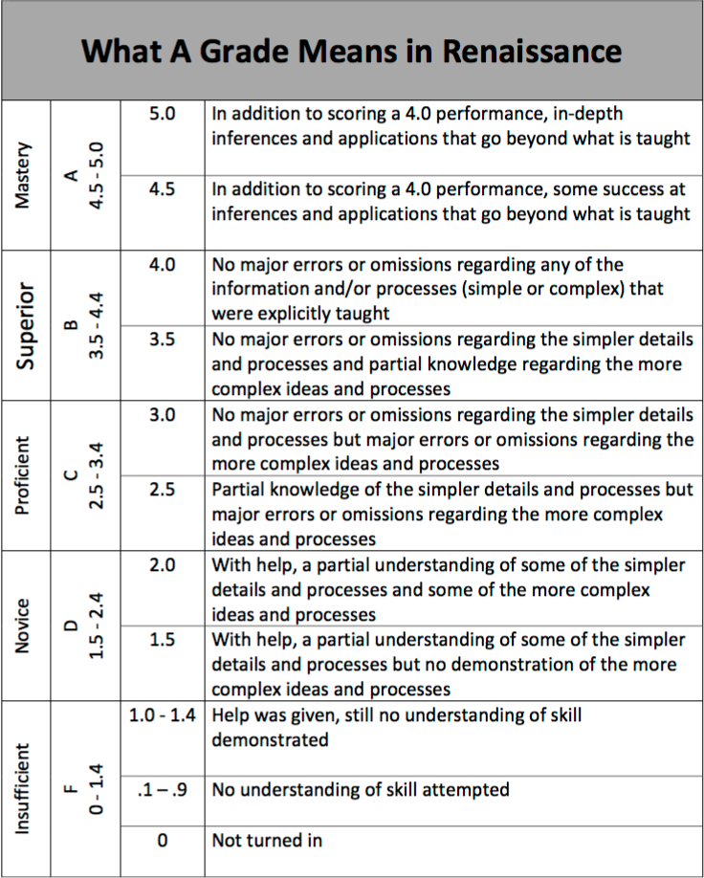

Biology Safety and Class Expectations Agreement

Safety Expectations:
- Carefully follow all written and verbal instructions given by Ms. Burdick for each activity.
- Use lab supplies as they are intended.
- Keep all lab supplies in the classroom, unless otherwise instructed.
- Immediately report ALL injuries, broken glass, or spilled chemicals to Ms. Burdick, no matter how minor.
- Maintain mature and respectful behavior during labs, field trips and activities.
- Clean up after yourself and others.

Class Expectations:
- Cell Phones: Students will place cell phones in small bins near their seat to prevent distractions during class. Please do not use cell phones in class unless given permission. Parents, should you need to contact your student, please call the office. Otherwise, please be aware of how distracting texting and phone calls can be when they occur during class.
- Checking Grades: Synergy is an excellent way to stay current on student's grades and missing assignments. I recommend students and parents check Synergy once a week.
- Food and Drink: Since Biology is a lab- based science course, water is the only acceptable drink in class. Small snacks are acceptable, provided they do not become a distraction.
- Restroom & Water Breaks: Students are responsible for material covered in class and are encouraged to use the facilities before or after class. Students must sign out before leaving the classroom.
- Respect and Integrity: During the course of our class, we may discuss controversial issues that may elicit emotional responses from students. I highly encourage students to engage in classroom discussion from a place a care, assume positive intentions of other students and teachers alike, and refrain from racist, sexist, homophobic or otherwise hurtful remarks.

(Cut and return the bottom portion to Ms. Burdick)

"We have read and understood the course syllabus and expectations for safe and respectful classroom behavior."

PARENT/GUARDIAN INFORMATION AND SIGNATURE

Student Name (Please print): ________________________________________________________________
Parent/ Guardian Name (Please Print): ________________________________________________________
Best Phone Number(s) to call: _____________________________ Best time(s) to call: ________________
Best Email Address to Contact: ______________________________________________________________
(Email communication is the most effective way to discuss any concerns, ideas or issues with Ms. Burdick.)
"I (circle one) allow / do not allow my student to view PG-13 movies during class."
Parent/ Guardian Signature: ___________________________________________ Date: ___________

STUDENT SIGNATURE

"I understand that it is my responsibility to:
- Attend class and put forth my best work every day.
- Conduct myself as a responsible, mature student.
- Respect all people in the classroom, including myself."

Student Signature : _________________________________________________ Date: ___________

