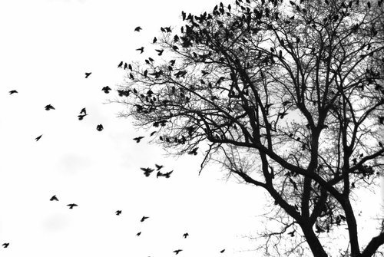
BIOLOGY

Welcome to
{2016-2017 Class Syllabus}

{2016- 2017 Class Syllabus}
Ms. Burdick  Room 57  caroline.burdick@district6.org  (541) 494-6280
Biology is the study of life, and this class will focus on the fundamental principles including biochemistry, genetics, and cell biology relating to human biology. This required laboratory-based science class will lay a strong foundation for further science classes students may take in high school. Students will use the scientific method to investigate topics like properties of water, genetics, cell biology, disease, and ecology.
Topics we will explore include:
- DNA & RNA
- Genetics and heredity
- Cell biology
- Biochemistry
- Cellular energetics
- Disease
- Human Systems
- Ecology & Evolution

Attendance:

To succeed in this class, it is essential for students to attend and participate in class everyday. Engagement during class is an expectation. If you miss class for any reason, it is your responsibility to retrieve any missing work.

Tardiness is unacceptable and may result in detention or other appropriate consequences.

Cell Phones:

In order to help my students focus, they are required to place their phones in bins near their seat during class. If students are caught using their phone during class- without permission- they will forfeit it until the end of class. A second violation will result in a referral and forfeiting their phone until the end of the day.
Secrets for Success in Biology:
- Be curious.
- Ask questions.
- Ask for help.
- Take accountability and responsibility for your own learning.
Materials needed daily:
- Writing utensil
- Interactive notebook (spiral notebook)
- 3 Ring Binder
- A positive attitude

Grading:

Grades are earned based on class, lab, homework, projects, quizzes, tests and participation/ behavior.
- Labs & Homework
- Projects
- Tests & Essential Assignments
- Participation/ In-Class Activities

Grading scale will follow Renaissance's rubric found on the following page.

Late Work:

Students who have an excused absence from class may retrieve any missing work from the filing folder with previous assignments. For full credit, missing work must be turned in within one week with an attached Past Due Slip.

Students with unexcused absences, or choose to turn their work in late, will earn no higher than a 2.5 (C) on their late assignment. A Past Due Slip must be attached.

Be Responsible  Be Respectful
Be Kind

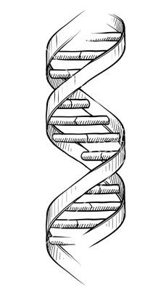
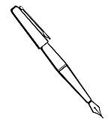

MS. BURDICK CAN MODIFY ALL OF THE ABOVE AT ANY TIME.

RENAISSANCE GRADING RUBRIC:
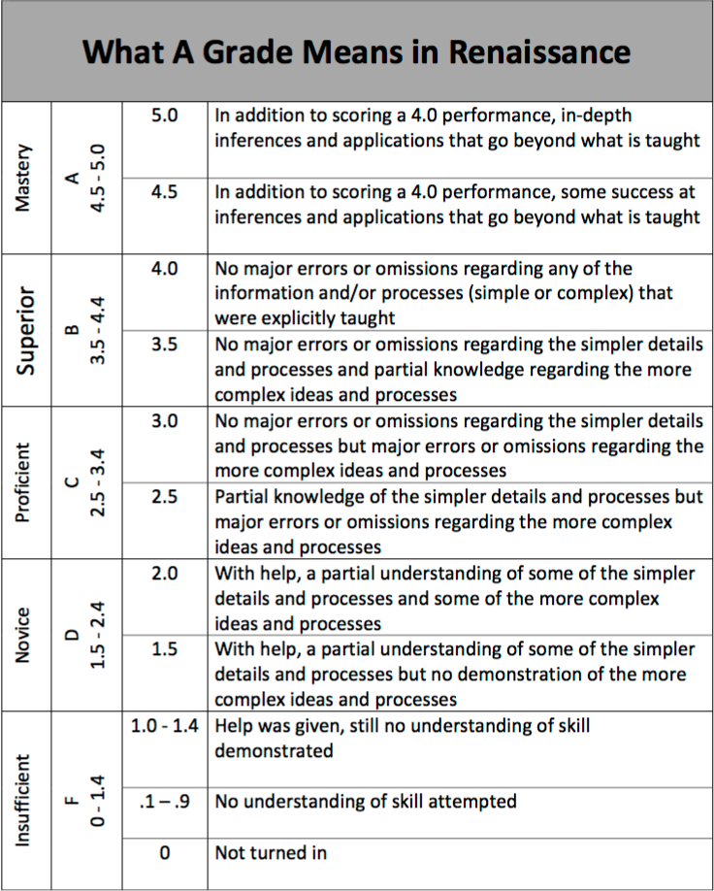

Biology Safety and Class Expectations Agreement

"We have read and understood the course syllabus and expectations for safe classroom behavior."

PARENT/GUARDIAN INFORMATION AND SIGNATURE

Student Name (Please print): _________________________________________________________
Parent/ Guardian Name (Please Print): _________________________________________________
Best Phone Number(s) to call: ________________________ Best time(s) to call: ________________
Best Email Address to Contact: _______________________________________________________
(Email communication is the most effective way to discuss any concerns, ideas or issues.)
Parent/ Guardian Signature: _______________________________________ Date: ___________

STUDENT SIGNATURE

"I understand that it is my responsibility to:
- Attend class and put forth my best work every day.
- Conduct myself as a responsible, mature student.
- Respect all people in the classroom, including myself.

Student Signature : ____________________________________________ Date: ___________

Safety Expectations:
- Carefully follow all written and verbal instructions given by Ms. Burdick for each activity.
- Use lab supplies as they are intended.
- Wear safety goggles and protective clothing when instructed to do so by Ms. Burdick.
- Keep all lab supplies in the classroom, unless otherwise instructed.
- Immediately report ALL injuries, broken glass, or spilled chemicals to Ms. Burdick, now matter how minor.
- Maintain mature and respectful behavior during labs and activities.
- Clean up after yourself and others.

Class Expectations:
- Cell Phones: Students will place cell phones in small bins near their seat to prevent distractions during class. Please do not use cell phones in class unless given permission. Parents, should you need to contact your student, please call the office. Otherwise, please be aware of how distracting texting and phone calls can be when they occur during class.
- Checking Grades: Synergy is an excellent way to stay current on student's grades and missing assignments. I recommend students and parents check Synergy once a week.
- Food and Drink: Since biology is a lab- based science course, water is the only acceptable drink in class. Small snacks are acceptable, provided they do not become a distraction.
- Restroom & Water Breaks: Students are responsible for material covered in class and are encouraged to use the facilities before or after class. Students must sign out before leaving the classroom.
- Respect and Integrity: During the course of our class, we may discuss controversial issues that may elicit emotional responses from students. I highly encourage students to engage in classroom discussion from a place a care, assume positive intentions of other students and teachers alike, and refrain from racist, sexist, or homophobic remarks.

