Project Due Date: Specialized Cell Chosen:
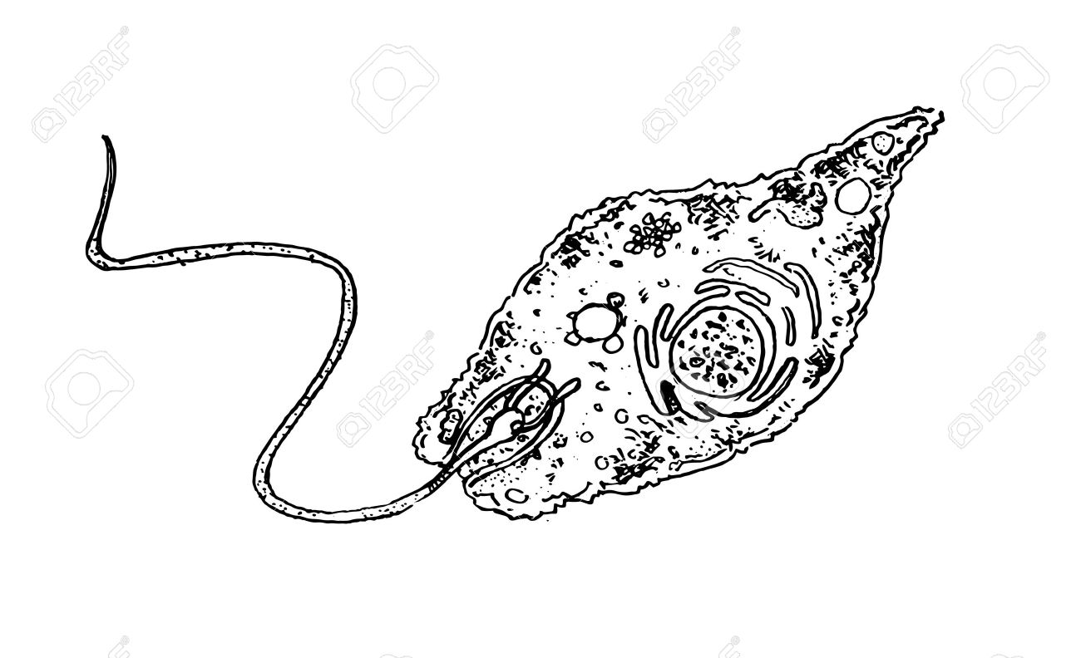
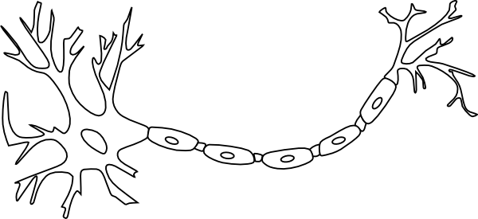
Structure and Function of a Specialized Cell
Project

Project Objective:
Create a unique product that demonstrates the structure and function of specialized cells.

A. Oral Presentation:
Each group member will be responsible for presenting the product and research information to a small group of classmates. These small groups will contain students who focused on different types of cells. Presentations (no matter what you’re presenting) must be 5-7 minutes long.

Research Requirements (include the following information):
- Describe the special features of the cell you chose. How does your cell differ from the generalized plant or animal cell?
- What specialized organelles (or lack of organelles) are found in this cell?
- What is the function of this cell?
- How does its function fit in with the function of other cells to work in tissue or an organ (i.e. Muscle cells create muscles like your biceps)?
- How does this cell's function help keep the organism alive?
- What are some issues that could affect the function of this cell, and what are the effects? (for example, if nerve cells are cut, it prevents signals from reaching areas of the body and could lead to paralysis.)
- Include 2-3 fun/interesting facts about your cell.
B. Work Log:
Your group will keep a work log detailing your goals and what work you complete on a daily basis. You must provide written evidence in your log that each person contributed equally to all phases of the project. Your log will be checked at the end of each work session.

C. Create a cell model / Compose a song / Create a YouTube video / Write a paper and create a Google Slides presentation.

CHOOSE ONLY ONE OF THESE PRODUCT OPTIONS.

D. Bibliography
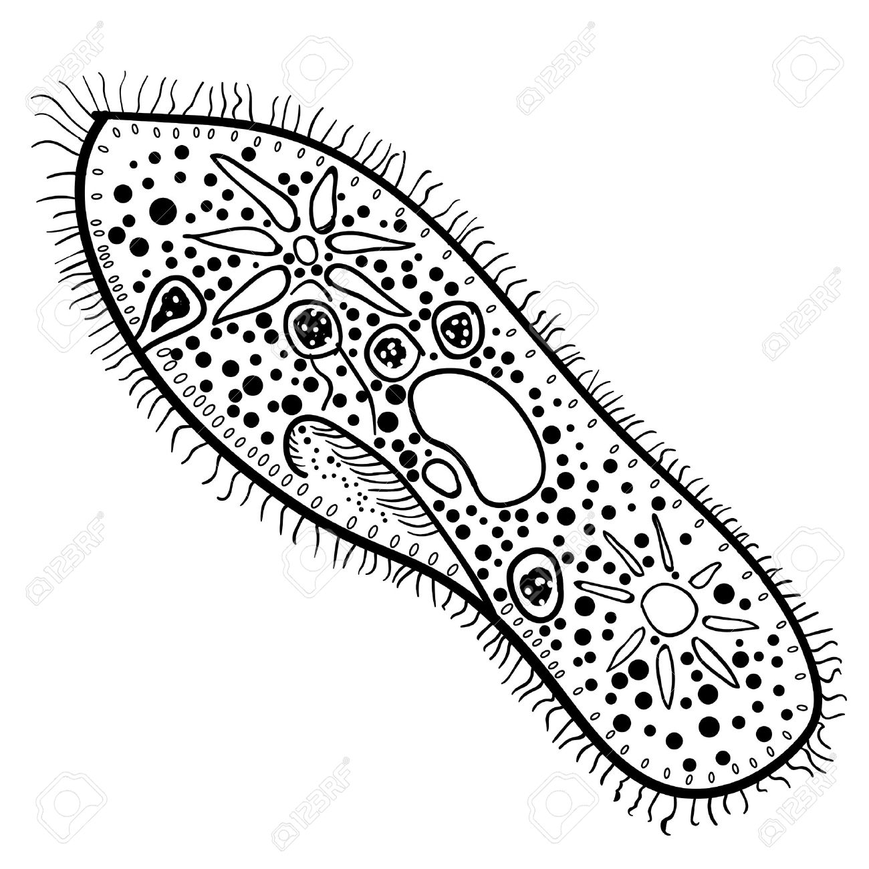
You must include a bibliography with all resources used to gather information. They should be written in MLA format.
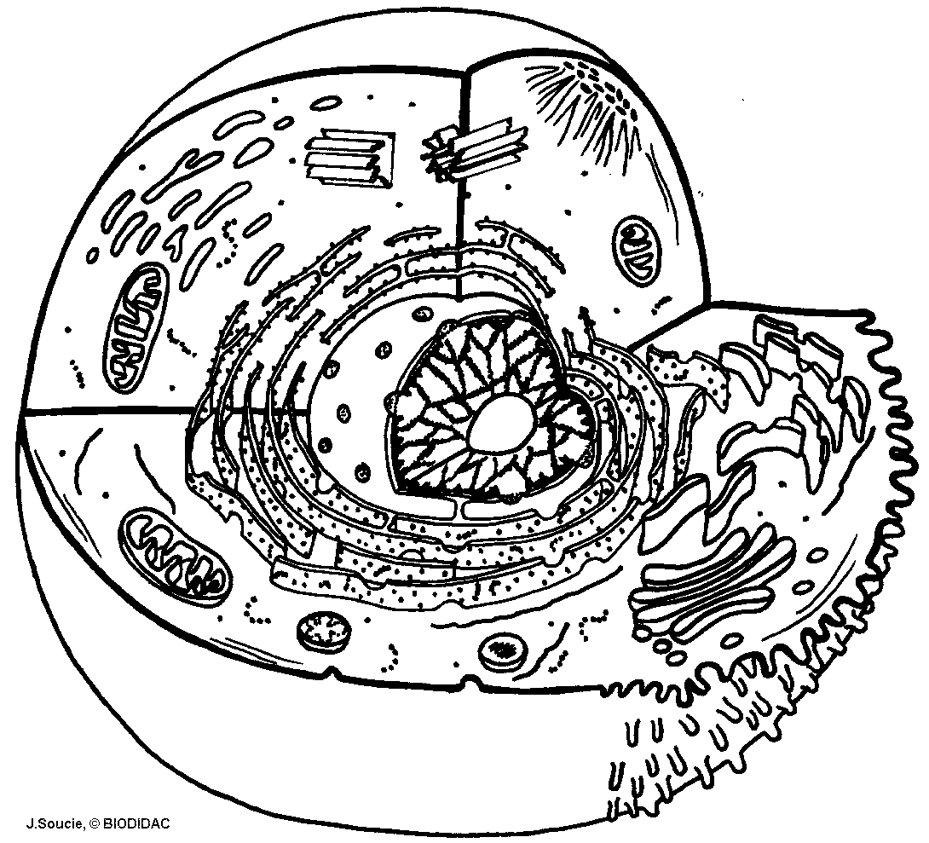

- Model Requirements:
- Model must include all parts (organelles/structures) covered in class AND any parts unique to that type of cell. For example, some special parts of nerve cells might include dendrites, the axon and myelin sheath.
- The parts must be accurate for shape, size and location inside the cell.
- The parts should reflect the relative size inside the real cell. For example, the nucleus should be very large compared to the ribosomes.
- All parts should be three-dimensional.
- All parts should be labeled clearly and with correct spelling. If your model is difficult to label, draw a diagram of your model with the parts identified or use a key.
- The model must be large enough to easily distinguish all the parts from the back of the classroom, but NO larger than one half of a standard poster board.
- The model is study and neat.
- Each person in the group must contribute materials toward the project and take part in the building process.
- TIP: Don't spend any money on your materials!! Recycle anything you can find at home or school.
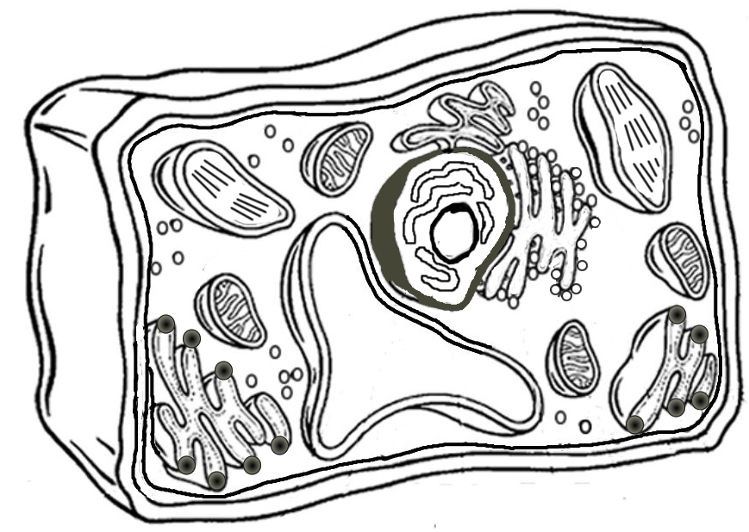
- Song Requirements:
- Song must include important information that you researched.
- Song must include all organelles, including specialized parts.
- It must be at least 3 minutes long and recorded.
- Lyrics must be printed for all students.
- Handout of lyrics must include a visual (picture or drawing) of the specialized cell.
- Must be accurate information and include fun facts.
- Each person in group must contribute lyrics or beats to the song.
- Any information not covered in your song must be presented to the class.

- YouTube Video Requirements:
- Video must be at least 5-7 minutes long.
- Must include all organelles and any specialized parts of the cell.
- Must include visuals/ pictures/drawings of cell structure.
- Video should include all presentation information, research and fun facts.
- Each person must be featured in the video in some fashion.
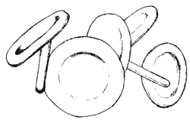
- Your video would serve as your presentation, so think of a creative way to present the information!

- 1-Page Paper and Google Slides Presentation
- Paper must include all important research information.
- Paper and Google Slides must include all organelles, including specialized parts.
- Google Slides presentation should be at least 5-7 minutes long.
- Paper should have at least one visual showing the structure of the cell.
- Google Slides should have multiple visuals to show the class what the cell looks like.
- Each person in the group will be responsible for their own 1-page paper (it won’t be a group paper). The group members must, however, contribute to the slideshow in some fashion.
SPECIALIZED CELL PROJECT RUBRIC

CATEGORY | 5- MASTER | 4- SUPERIOR | 3-PROFICIENT | 2-NOVICE | 1-INSUFFICIENT
Content | All organelles (or explanation about lack of organelles) included in project | Most organelles (or sufficient explanation for lack of organelles) included | Some organelles included (explanation for lack of cells included) | A few organelles are included (no explanation for lack of organelles) | No organelles included or explanation for lack of organelles.
Creativity | Design of project seems well thought out. Elements are neatly arranged and very easy to interpret. Students went above and beyond to create a completely unique product. | Design of project seems relatively well thought out. Elements are neat and easy to interpret. Students demonstrated a high level of creativity. | Design of project seems thought out and elements are relatively neat though some elements are visually difficult to interpret. | More effort needed and project does not seem well thought out. Required elements are sloppy and difficult to interpret. | Very little effort put forth into creating a unique product.
Accuracy | Group went above and beyond to include additional accurate information. Every piece of information is included in project. Every requirement is fulfilled (i.e. lyrics printed and included for class) | Every piece of information is included in project. Every requirement is fulfilled (i.e. lyrics printed and included for class, labels on model, ) | Includes 1-2 pieces of incorrect information in project. Missing one or two requirements of product. | Includes many pieces of incorrect information. Missing multiple requirements of product. | Only 1 or two pieces of correct information. Missing most requirements of product. Product seems unfinished.
Work Logs | All work logs complete, goal-oriented, detailed, and demonstrated that each group member participated in each section of the project. | Most work logs complete, detailed, and demonstrated that most group members participated in each section of the project. | Some work logs are complete, with some details, and information about how group members participated in the process. | Some work logs complete, but lacking in detail. | No work logs complete.
Bibliography | 5 cited sources included on a bibliography | 4 cited sources included on a bibliography | 3 cited sources included on a bibliography | 2 cited sources included on a bibliography | 0-1 cited sources included on a bibliography or no bibliography included
Peer Feedback | To be determined

