Why Big, Intense Wildfires Are the New Normal

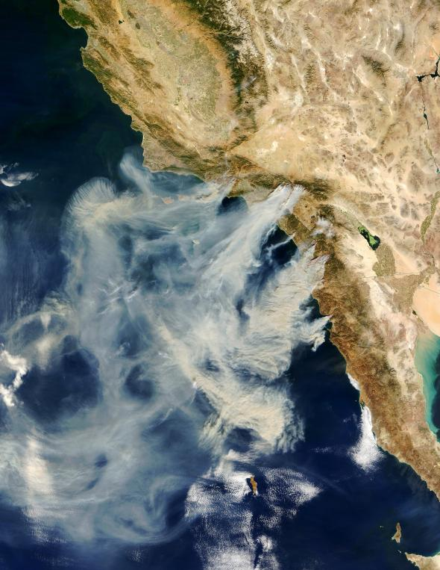
Climate change, untamed vegetation, and development have created a new wildfire landscape.

VIEW IMAGES
A satellite image of the 2003 Cedar Fire in San Diego County, known as the largest single fire in modern California history.

PHOTOGRAPH COURTESY JACQUES DESCLOITRES, MODIS RAPID RESPONSE TEAM, NASA GSFC
By Melody Kramer, National Geographic
PUBLISHED AUGUST 30, 2013
The large wildfire burning in and around Yosemite National Park has already consumed more than 184,000 acres, and shows no signs of slowing down. The blaze, which has been dubbed “Rim Fire,” is now the largest fire in the Sierra Nevada mountain range and one of the largest in California’s history. (Related: “With Rim Fire Near, a Look at Yosemite’s History With Fire.”)
The Rim Fire is one of more than 30 blazes currently churning across the West. And a combination of higher temperatures, untamed underbrush, less rain, and more developments in the region means that the number and intensity of wildfires is likely to increase in the coming years, says Don Wuebbles, a professor of Atmospheric Sciences at the University of Illinois.
“This probably is the new normal,” he says.
“If we look at how the climate has changed over the past 50 years—with warmer temperatures increasing beyond what we used to see in the early part of the 20th century, and changes in precipitation—fires will continue to happen and get worse and worse,” says Wuebbles, who co-authored a draft federal report linking climate change to an increase in severe weather trends.
The numbers certainly back him up: Wildfires are roaring through twice as many acres per year on average in the U.S. than they were 40 years ago, U.S. Forest Service Chief Tom Tidwell told the Senate in June.
That number could very well double again in the next 30 years, says Wuebbles.
“I would say that this [fire season] is the new normal but it may not be the new normal for long,” he says. “Thirty years from now, we may look upon this as being a much better period than what we may be facing then.”
Fueling Fires: Climate Change
All wildfires need three things to burn: ignition, fuel, and the right climate, says Erica Smithwick, the director of Landscape Ecology at Penn State University and an expert on fire patterns.
“But if you play with any of these things, you’re going to manipulate the fire,” she says.
Take climate, for instance. Climate models indicate that in some portions of the West, future temperatures could rise by as much as 7ºC (12.6ºF), says Smithwick.
(Related: “Why Is the West Ablaze?”)
“If precipitation also increases significantly, it may help mediate the changes caused by temperature,” Smithwick says. “But most likely, an intense warming will contribute to more forest fires because there will be more combustion potential.”
States in the West have already seen temperatures jump. Over the past three decades, Arizona—which saw huge wildfires earlier this season—has seen its ten-year average temperature increase by 2.3ºF, compared to 1.6ºF for the entire U.S. And California—currently home to ten blazes—is experiencing the driest calendar year so far on record, says Christopher C. Burt, the author of Extreme Weather: A Guide and Record Book and the weather historian for Weather Underground.
“I’m sure that’s one of the causes of the fires this year,” he says. “And the reason the Yosemite fire is so large is because it’s so dry there.”
The changes in temperature—combined with a longer growing season—lead to what Wuebbles calls a “perfect storm of wildfires.”
“You might get to the point where in some parts of the West, there are no more forests,” says Wuebbles. “When you see more long periods without precipitation and you combine that with warmer temperatures and earlier snow melts, you see a trend in a lot of acreage burning.”
Watch how photographers capture unique images of fast-moving forest fires.
Fueling Fires: Changes in Vegetation
Increasing temperatures and drought conditions then create more fuel for the fires. In Arizona, two decades of record-level droughts have increased area vegetation to record numbers.
And in many parts of the West, a history of fire suppression—that is, fighting fires in areas where they were once allowed to burn—has also increased the amount of dry vegetation. This vegetation then builds up and allows more dangerous and uncontrolled fires to spread, putting both humans and nature at risk.
“In some of these systems, you would have fires burning in the understory—or the floor of standing forests—and they wouldn’t kill the trees,” says Smithwick. “But if the understory starts to grow, then the fire could be carried up into the canopy and even trees like sequoias could be at risk.” (Related: “How Sequoias Survive Wildfires.”)
In many areas susceptible to wildfires, including Yosemite, the National Park Service conducts “prescribed burns,” both to clear unsafe vegetation and restore the local ecology. But the changes fall far short of what once occurred naturally. And changes in climate mean that the vegetation that is cleared may come back in a completely different form.
“The forests will adjust,” says Stephen J. Pyne, a fire historian and the author of several books on fire management. “But if the climate changes, you’re not going to get the same stuff back.”
As a result, Pyne says the entire system will change.
“It’s very likely that we’re into an era where the fires of the past will not be the fires of the future,” he says. “But it’s equally likely that the fires of today will not be the fires of the future.”
Fueling Fires: More Development and More People
As fuels increase and temperatures rise, the number of people moving to areas that border wildlands—a location called a WUI, short for wildland-urban interface—also continues to increase. The number of housing units within half a mile of a national forest, for instance, grew from 484,000 in 1940 to 1.8 million in 2000.
“There’s a powerful economic incentive for local governments to encourage local land developments in a WUI,” says Lloyd Burton, a professor at the University of Denver who studies environmental and disaster management law and policy. “But then a wildfire starts, and it outstrips the local government’s firefighting capabilities.”
“So when there’s a wildfire, the local government calls in the federal government—and basically half of the U.S. Forest Service’s budget goes into firefighting,” he says.
Some 70,000 communities in the U.S. are at high to moderate risk from “uncharacteristically large wildfires,” estimates the U.S. Forest Service. When a fire does break out, their elite firefighting units—known as hotshots—then go in and battle the blazes. (Related: “Who Are the Hotshots?”)
Often, says Smithwick, these hotshots are battling fires to protect homes or structures in areas that once would have been allowed to burn.
“You have people in the way of these fires,” she says. “And some of these fires shouldn’t be put out in the first place—they reduce the fuels and cleanse the system.”
But as residential developments continue to expand into the WUIs, the firefighters are supposed to protect them, says Burton, who recently wrote about the costs of living in the forest in the Denver Post.
“It puts more and more of these firefighters at risk,” he says. “It’s a situation that’s become increasingly untenable.”
The Future
And the situation will not improve—as long as communities don’t mitigate the risks, says Burton.
“There are some counties in Arizona and New Mexico and Colorado that compel residents to take mitigation measures—like building structures that are made of fire-resistant materials—and others that have done nothing at all,” he says.
Meanwhile, out in California—which did pass a statewide fire-mitigation law after a deadly 1991 wildfire—waits with baited breath for the rest of fire season.
“I predict that this September and October will be horrific,” says Burt, the weather historian, who recently wrote about the worst wildfires in U.S. history. “We’ve received only 65 percent of normal precipitation in the burn areas. When the offshore wind flow develops in September and October, our summer wildfire season will really begin.”

