The Animal that Lives for 10,000 Years
One creature can survive for millennia in the so-called “Sea of Death.”
By Zaria Gorvett
17 December 2015

Objective: I can explain how adaptations increase the likelihood of a species’ survival.

Highlight any evidence you can find about brine shrimp adaptations that enable them to survive extreme environmental conditions.
They fell out of the sky and landed on the pale blue planet with a splash. Many of the crew missed the whole thing. Deep inside the spacecraft, arranged in neat stacks, were rows and rows of sleeping astronauts. Each was curled up inside their own pod, where they could have stayed for 10,000 years.
These were no ordinary space travelers. In the following weeks, they burst from their shells and developed into full-blown aquatic monsters: they are salmon-pink, with three eyes and eleven pairs of thrashing legs.
This really happened. The year was 1972 and the slumbering passengers were brine shrimp, otherwise known as "sea monkeys", returning from the Apollo 16 moon mission. They had been taken into space to test the impacts of cosmic radiation on astronauts.
This treacherous experiment required a near-indestructible guinea pig. Enter the brine shrimp, whose survival skills defy belief. You can safely dry them out, set them on fire, dissolve them in alcohol, deprive them of oxygen, zap them with ultraviolet light, boil them at 105 °C or chill them to temperatures approaching absolute zero: the point at which atoms stop moving. They can also survive extremes of pH that would dissolve human flesh, water that is 50% salt, or a bath of insecticides. They are happy in the vacuum of space or at the crushing pressures found under 6,000 metres (20,000 feet) of ocean. We are now starting to understand how they do it. Space is drenched in high-energy particles called cosmic rays, which easily rip through cells, tissues and the aluminium walls of a spacecraft. The Moon was the perfect place to study their effects.
The "Biostack I" experiment involved stacking brine shrimp embryos, along with plant seeds and bacterial spores, between layers of radiation-sensitive materials. Any rays that passed through the stack would end up on the detection layer, so the NASA scientists knew exactly which passengers had been hit.
Of 110 brine shrimp embryos that took a galactic bullet, many hatched – albeit with deformities – and a few went on to live full shrimp lives. A follow-up experiment called Biostack II was taken to the Moon by Apollo 17 later the same year. It achieved similar results.
The strange thing is, brine shrimp look rather fragile, with their wafting legs and long antennae. What is their secret?
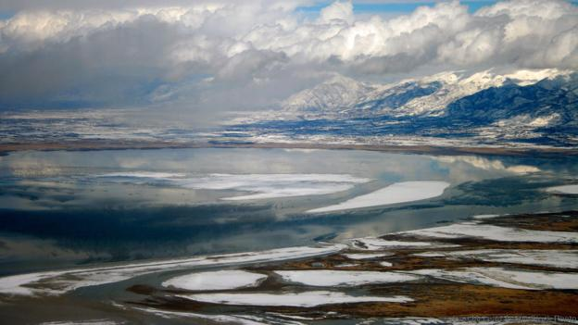
Great Salt Lake in Utah is home to brine shrimp (Credit: John McLean/Alamy Stock Photo)
Despite their brand name, sea monkeys do not live in the open ocean. They have been splashing around in salty pools and lakes, from the Great Salt Lake in Utah to the Caspian Sea, for over 100 million years.
Brine shrimp are also not shrimp, but they do belong to the same group, the crustaceans. They are tiny, just 15mm long. They eat algae, which they filter out of the water. They swim upside-down and breathe through their legs, and females do not need a male to reproduce. Crucially, they have a unique affinity for salt. They can tolerate concentrations up to 50%. Such water is far saltier than the ocean, which is only about 3.5% salt, and the salt will be on the verge of precipitating out as a solid. The brine shrimp are fine with this.
But there is a catch: if you live in a pond, there is always a risk that it will dry out. The pools and lakes brine shrimp inhabit frequently disappear for months, years or decades. This should be a gigantic problem, but the brine shrimp simply dry out.

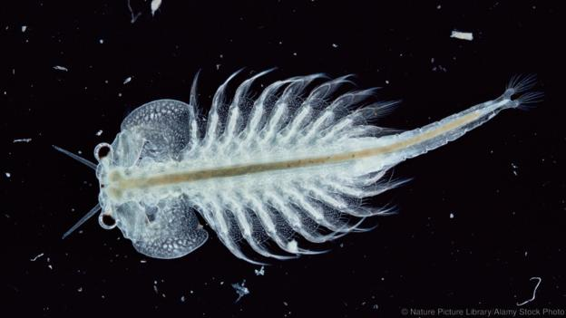
Male brine shrimp have claspers for holding onto females (Credit: Nature Picture Library/Alamy Stock Photo)
When conditions are favorable, female brine shrimp produce thin-shelled eggs that hatch immediately. But when food is scarce or salt levels are rising, they resort to plan B. They produce hard-shelled "cysts", each of which contains a near-fully-developed larva.
These cysts are able to withstand near-total dehydration, losing more than 97% of their water content. All their life processes stop and they enter a state of suspended animation called anhydrobiosis, a bizarre stopover between life and death.
As anyone who has kept sea monkeys as pets will know, to resurrect the embryos you just add water. The cysts take on 1.4 times their weight in less than 24 hours, before hatching into larvae the size of the full stop at the end of this sentence. When they first hatch they have just one primitive eye, though they add two more sophisticated eyes later.
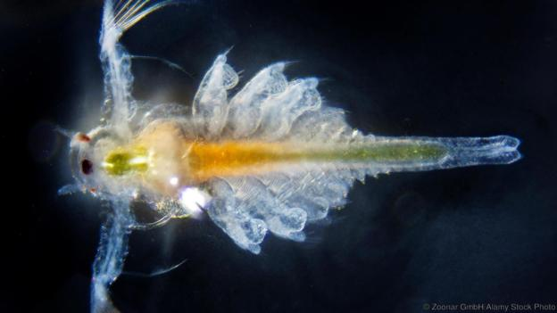
It is an aggressive strategy for an aggressive environment, and it works. In the 1990s, oil exploration crews were drilling near the Great Salt Lake when they dredged up a mat of cysts between two layers of salt. Wondering whether they would hatch, they put some in water and reportedly a few did. Radiocarbon dating estimated they had been lying there for 10,000 years.
How did they get away with it?
Water is the liquid in which the molecules inside our cells move and mix, giving rise to life-sustaining chemical reactions. So taking it away brings those processes to a halt.
Brine shrimp look fragile and feathery (Credit: Zoonar GmbH/Alamy Stock Photo)

But for most animals, losing too much bodily water doesn't just shut things down, it causes lethal damage. Humans can only lose 15% of our bodily water, and few animals can lose more than 50%. As water is removed, the molecules inside our cells lose the three-dimensional network that buoys them up. Proteins, sugars, and chromosomes become warped and break down.
Ice crystals act like tiny knives, ripping cells apart from the inside out.
The challenge is to allow molecules to keep their shape as they dry out. For this, brine shrimp have a sweet solution: they turn their cells into solid sugar. The cysts are loaded with an unusual sugar called trehalose, which makes up 15% of their dry weight. It forms a solid rather like the glass in windows. This "matrix" props up proteins and membranes, maintaining their structures, and freezes them in place.
Trehalose is the magic ingredient uniting most organisms capable of suspended animation, including the near-invincible tardigrades, certain nematode worms, and the larvae of an African fly called the sleeping chironomid. On its own, trehalose simply allows the brine shrimp to cope with dehydration. But that may be the key to many of their abilities. As it happens, giving up water has some surprising bonuses.
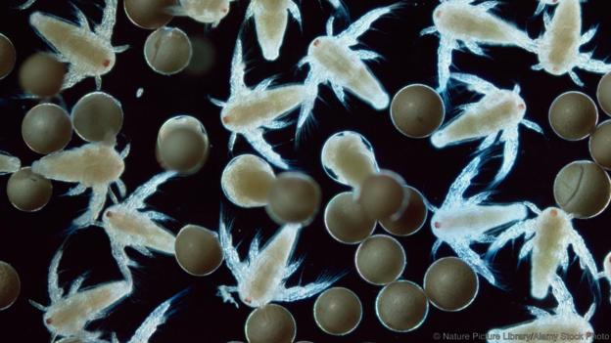
"Nauplius" larvae of Artemia salina (Credit: Nature Picture Library/Alamy Stock Photo)
In the warm temperatures humans tend to favour, water is famous for its life-giving properties. But if you chill it or heat it too much, it becomes deadly. Ice crystals act like tiny knives, ripping cells apart from the inside out. Liquid water also expands as it approaches its freezing or boiling point, with similarly lethal effects.

It seems that their willingness to live in toxic places actually means their lives are safer.
If you take away water, you take away all these threats. What's more, radiation does not pack much of a punch either. Normally, cosmic rays interact with water molecules in the body. This unleashes highly reactive forms of oxygen, including chemicals similar to bleach. These chemicals rampage through cells and tissues, destroying anything in their path. Dried-out brine shrimp embryos side-step this danger.
Still, dehydration is not a cure-all. It does not protect DNA from a direct hit by a cosmic ray, or stop proteins unravelling as they heat up. So brine shrimp cysts have evolved several other tricks, from DNA repair molecules to proteins that lack a fixed structure in the first place.
Why did evolution push brine shrimp to become so resilient? It seems that their willingness to live in toxic places actually means their lives are safer.

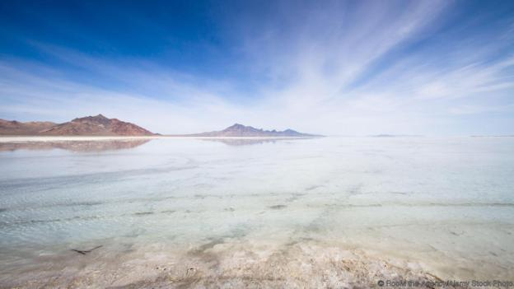
Great Salt Lake in Utah (Credit: RooM the Agency/Alamy Stock Photo)
Brine shrimp inhabit salt lakes, the conditions in which are so hostile that they are also known as "seas of death". For instance, the Great Salt Lake is between 5 and 27% salt, depending on how much water it holds.
Only a few animals can handle such extremes
The Lake sits at the bottom of a flat basin, which poses an additional challenge. If the water level drops by just a foot, the shoreline could move up to a mile. From 1963 to 1986, the lake swelled by nearly 60%.
If a shrinking shoreline and water saltier than bacon weren't enough, at the Great Salt Lake's high altitude creatures must be able to cope with 15% more ultraviolet light than there is at sea level. The final insult is the risk of suffocation, because salty water holds less dissolved oxygen.
As you might expect, only a few animals can handle such extremes. Apart from the larvae of two species of insectcalled brine flies, brine shrimp have the lake entirely to themselves. That means there are no predators hunting them.
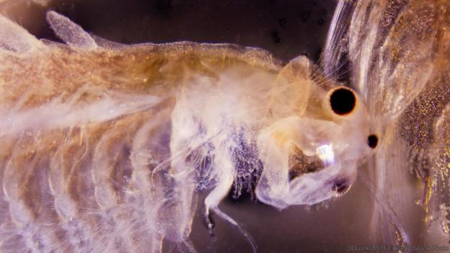
However, brine shrimp's relationship with salt is not entirely positive. Their cells cannot cope with too much salt, so they pump it out of their bodies and their hard exoskeletons stop it creeping back in. This is an energy-sapping process, so you could be forgiven for wondering why they bother to live in the salt lakes at all.

Brine shrimp filter algae from the water (Credit: 3QuarksMedia/Alamy Stock Photo)
Their diet seems to be the key. In order to survive on tough, toxic algae, brine shrimp have struck up a relationship with the bacteria in their guts, which help them to digest their meals. Odrade Nougué of the University of Montpellier in France wondered if it might be these microbial companions that like salt, not the brine shrimp themselves.
Every summer when females lay their eggs, thick "slicks" marble the lake's surface
In a study published in September 2015, Nougué and her colleagues raised brine shrimp larvae in sterile conditions to get rid of the gut bacteria, then exposed them to water with different concentrations of salt. She did the same with bacteria that still had their normal gut microbes.
It turned out that the sterile brine shrimp did better in low salt, while the bacteria-riddled batch needed lots of salt. To Nougué, this suggests that the brine shrimp are victims of their own symbiotic partners. They cannot live without their gut bacteria and the bacteria want salt, so the brine shrimp have to put up with salt too.
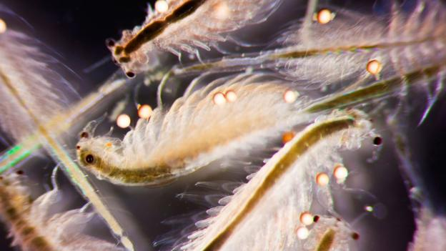
Despite the challenges, living in super-salty water offers big payoffs: it is rich in algae and low in competition. In the Great Salt Lake, brine shrimp number in the billions. Every summer when females lay their eggs, thick "slicks" marble the lake's surface and the shores are awash with their pink offspring. The next spring, as the salt lake warms, billions of tiny larvae begin to hatch.

A swarm of brine shrimp (Artemia salina) (Credit: 3QuarksMedia/Alamy Stock Photo)
All these eggs and brine shrimp mean big business for the region, which collects around 9,000 tonnes of eggs, larvae and adults between October and January. That is equivalent to 45 full-size blue whales.

Freeze-drying could keep vaccines fresh in remote areas where refrigeration is difficult
It is the brine shrimp's very resilience that makes them so appealing. Their cysts are vacuum-packed or canned, and sold around the world. After a 24-hour incubation, the larvae are fed to fish on commercial farms.
They can also be eaten directly, as they have been by Native Americans for thousands of years. They have even been suggested as a source of food for long-term space travel.
Their cysts are also of increasing interest to medicine, thanks to their use of "sugar glass" to survive dehydration. Freeze-drying could keep vaccines fresh in remote areas where refrigeration is difficult, deliver insulin to diabetics without the need for injections, or give blood products like platelets a longer shelf life. Many of these sugar-coated products have already reached clinical trials.
A 2009 study showed that human cells can be freeze-dried in a mixture of chemicals – including trehalose. In the long term, this sugar might even be used to protect human eggs.

Conclusion Questions:
1. Providing evidence from the article, create a list of adaptations or symbiotic relationships that brine shrimp have that increases their survival.

2. Using descriptive language and the list you just created, explain how adaptations have allowed brine shrimp to live up to 10,000 years. How did their adaptations lend to their survival?
An example of (an adaptation) is/ that led to their survival ______. This allows them to ___.
Characteristics of _____ include _____ and _____.
____ are widely acknowledged as ___ and exhibit ____
______________________________________________________________________________________________________________________________________________________________________________________________________________________________________________________________________________________________________________________________________________________________________________________________________________________________________________________________________________
3. Biomimicry is the design and production of materials that are modeled after biological processes or structures. What do we know about the adaptations of brine shrimp that could inform future biotechnology to positively benefit humans?

________________________________________________________________________________________________________________________________________________________________________________________________________________________________________________________________________
__________________________________________________________________________________________________

